Compass Group UK & Ireland Ltd
Speeding Policy
Aim
The aim of this policy is to remind drivers of their, and the companies’ legal obligations in relation to adhering to the UK and European speed limits.

Speed Limits
Speed limits are set for the safety of all road users, and they vary according to the class of vehicle and the type of road. The simple way to avoid speeding penalties is to know your limits and drive safely within them.

Please remember that the speed limit is not a target, and you should drive at an appropriate speed for the road and weather conditions.

Below are the national speed limits which apply to all roads unless signs show otherwise.

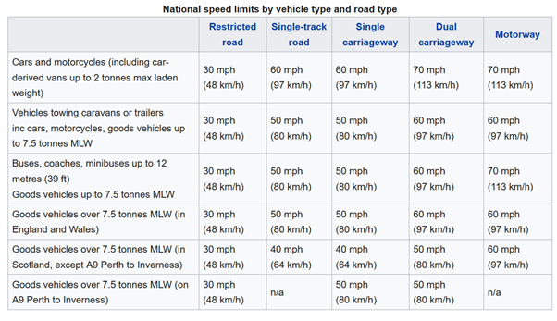

All speeds stated are in miles per hour and apply to all roads unless signs show otherwise.

- Street lighting means a 30-mph limit unless signs show otherwise. This applies to all traffic on all roads in England and Wales (only Class C and unclassified roads in Scotland) with street lighting.
- Built up areas generally have roads with streetlights. Unless signed otherwise, the speed limit is always 30mph, no matter the number of lanes.
- Single carriageway is an undivided road with no centre barrier.
- Dual carriageway is a two-way divided road with a central barrier that you are able to cross from side roads.
- Motorway is a two-way divided road with a central barrier containing slip roads. It is only possible to access a motorway via slip roads and there is no crossway traffic.

Fines and endorsements
Speed limits are set for a reason and exceeding them is illegal. The minimum penalty for speeding is £100 fine and three points added to your licence.

Receiving 12 or more points within three years may disqualify you from driving.

If you’re a newly qualified driver and receive six points during the first two years after passing your test, your licence will automatically be cancelled (revoked). To get it back you’ll need to apply and pay for a new provisional licence and pass both theory and practical tests again.

If you’re caught by a speed camera:
Within 14 days of your vehicle being caught speeding the registered keeper will be sent a;
- Notice of Intended Prosecution
- Section 172 notice
The company has an obligation to return the notice within 28 days advising the police who was driving the vehicle.

As the driver, depending on the speed, once you’ve responded to the notice you’ll be sent;
- an option for a speed awareness course
- a fixed penalty notice
- or a letter telling you to go to court

If you’re stopped by the police
They can:
- give you a verbal warning
- send you a fixed penalty notice
- offer a speed awareness course
- or order you to go to court – you’ll receive a letter explaining what to do

Driver obligations
You have an obligation as a vocational driver to inform the company of any traffic related offences, including speeding, whether that be in your own or someone else’s vehicle as well as driving a vehicle on behalf of the company. The company has an obligation to inform the Traffic Commissioner, who dependent on the seriousness of the offence may invite you to a driver conduct meeting and dependent on circumstances may suspend or revoke your vocational driving entitlement.

Issue No | Approved By | Signature | Date
1

I declare that I have read and understood the contents of this Speeding policy and agree to adhere to it at all times during my employment with Compass Group UK & Ireland Ltd.

 | Name | Signature | Date
Employee
Company representative

