Natasha’s Law

Guide To Source Label Printing

UPDATED – 13/10/21

## Set Up

Please ensure you have the following available within your unit:

* Access to the Source

Do all your key members of the team have individual access to the Source

* A live menu plan within the Source for the current week

**Note:** without a live menu plan for the current week you will be unable to print up to date PPDS labels with all the current ingredients and allergens listed, or create emergency recipes as this requires a ‘live’ recipe in your menu to start any modification to that recipe

* A working printer capable of printing A4 paper

Any make or model of printer will be acceptable as long as it can accommodate A4 sheets of Planglow labels

* A supply of black ink for the type of printer available
* A live account with Planglow via Foodbuy Online

Ensure you or your Regional Manager has access to Foodbuy Online and able to order labels via your live Planglow account

* A suitable supply of Natasha’s Law labels from Planglow

**Note:** please bear in mind that a selection of different label types and sizes may be required to cover the different type of Grab & Go food products you have on sale

## Label Types

It is important to review all the label options and understand which label type will work best with the type of PPDS products you sell within your grab & go menu offer. **Note:** the amount of sub-ingredients within each recipe will dictate the size of the label allowed to be used. Not all recipes will use the same label size therefore a range of label sizes and shapes is recommended.

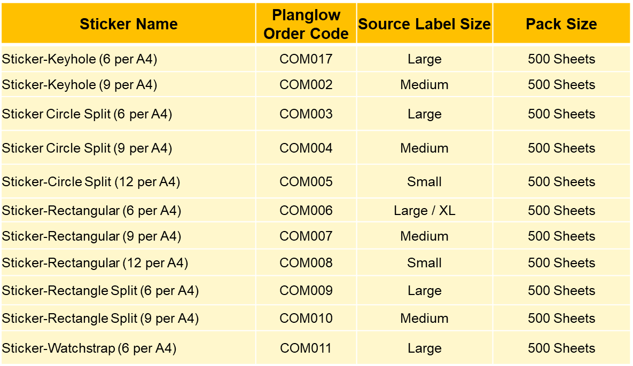

## Source Label Printing

First select the label printing tab in Source

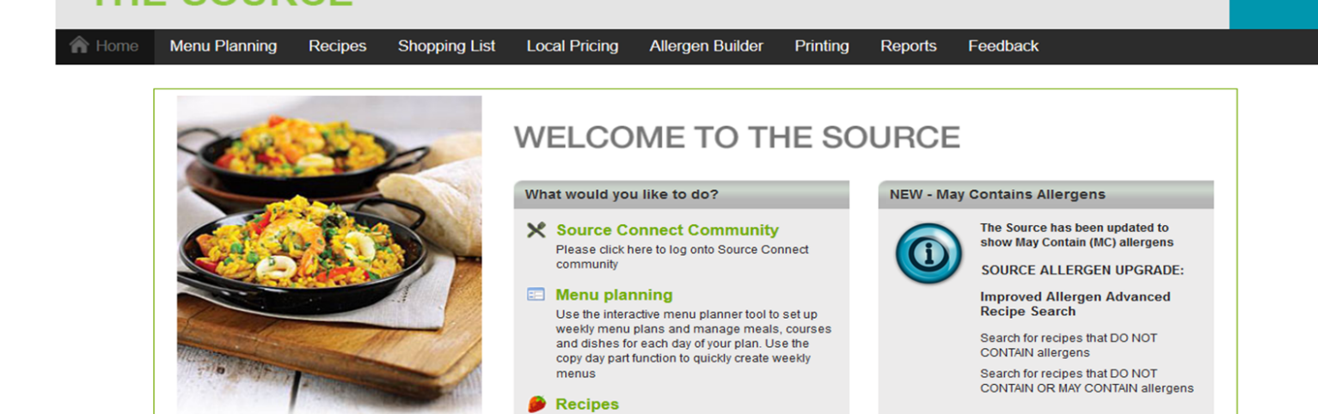

## 1.3.1 Select Menu Plan

Within the Label Print tab select:

* + Your **unit number**,
  + The **plan date**
  + The correct **menu plan date / week**

(Note: you cannot print labels or modify recipes from a menu plan date in the past)

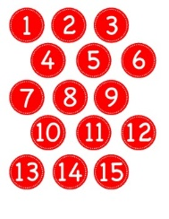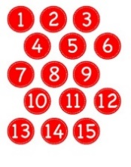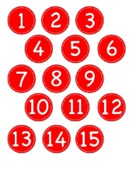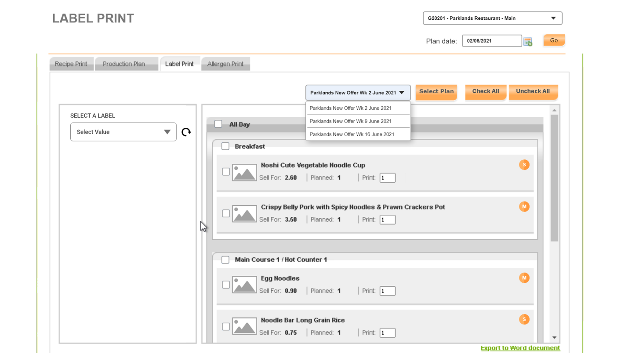

## 1.3.2 Select Recipes

Select the Uncheck All option and then highlight the recipes you want to print labels for

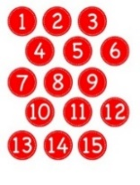 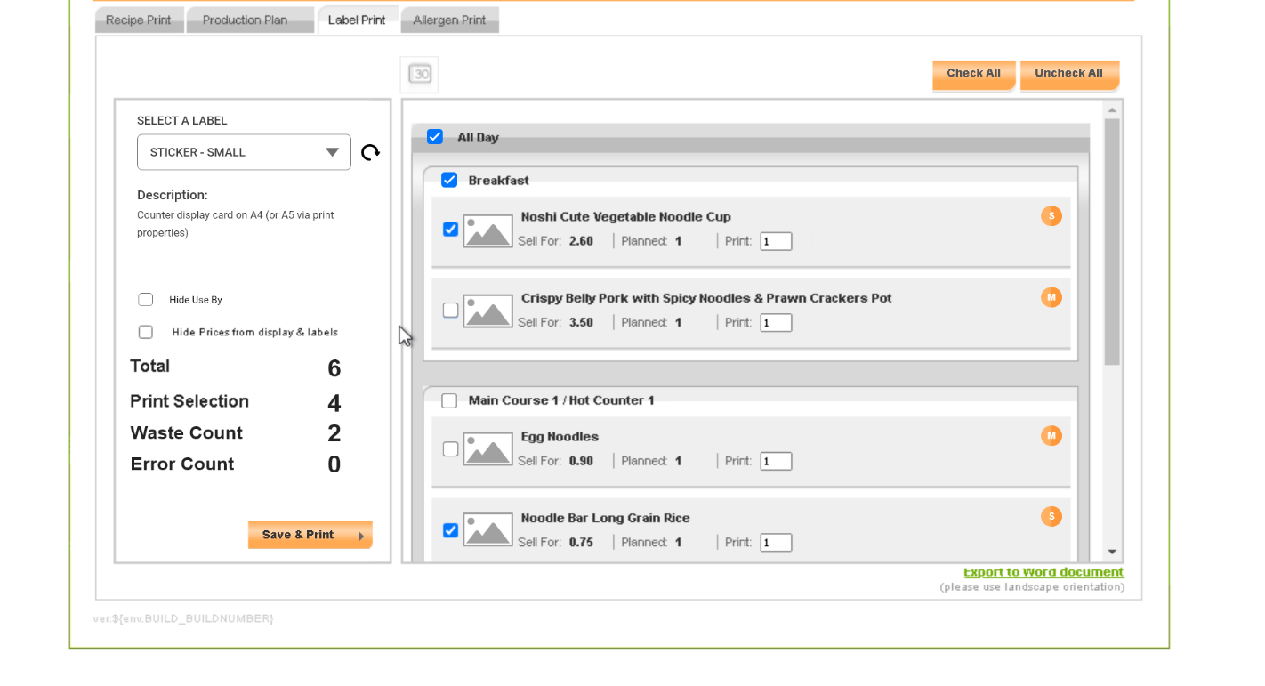

## 

## 1.3.3 Select Label Type

Use the drop-down menu on the left hand side of the page to select the type of sticker you wish to use for the recipe.

* + Labels will now appear in order of type
  + The size of the label will appear in the brackets e.g. (M) for Medium
  + The maximum character count will appear after the size. This indicates the maximum number of characters that particular label can hold. This can easily be cross checked with the recipe ingredient length as stated within the recipe tile – point 2 below.
  + The label selection will also reference the Planglow stock code – e.g. COM004 for Circle Split label (M)

Select the best label for your recipe by cross referencing the maximum character count from the selected label choice with the ingredient length indicated on the recipe.

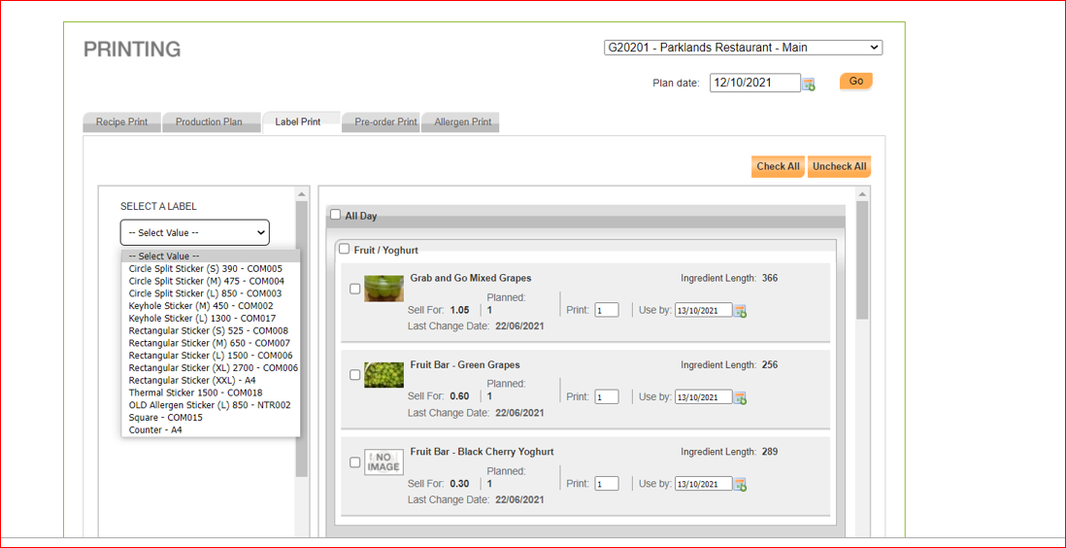

## Important:

Some sticker types will work better for certain products. Consider how the label may look on the product when you are selecting it to print

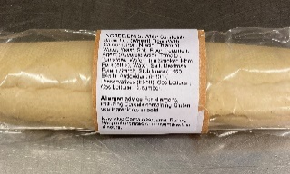

Split circle label

Separate top label with ingredients on side

Watchstrap label

Covering the top and side of the pot

L/XL Rectangle label

Placed across the front of the baguette

L/XL Rectangle label

Wrapped round the middle of the baguette

## 1.3.4 Select Label Attributes

* + Click on the check box if you want to hide the **Use By Date** and/or **Price**.
  + By checking these boxes the label will not show the price or use by date accordingly.
  + If you choose to show these then adjust the selling price and use by date in the box shown on that recipe

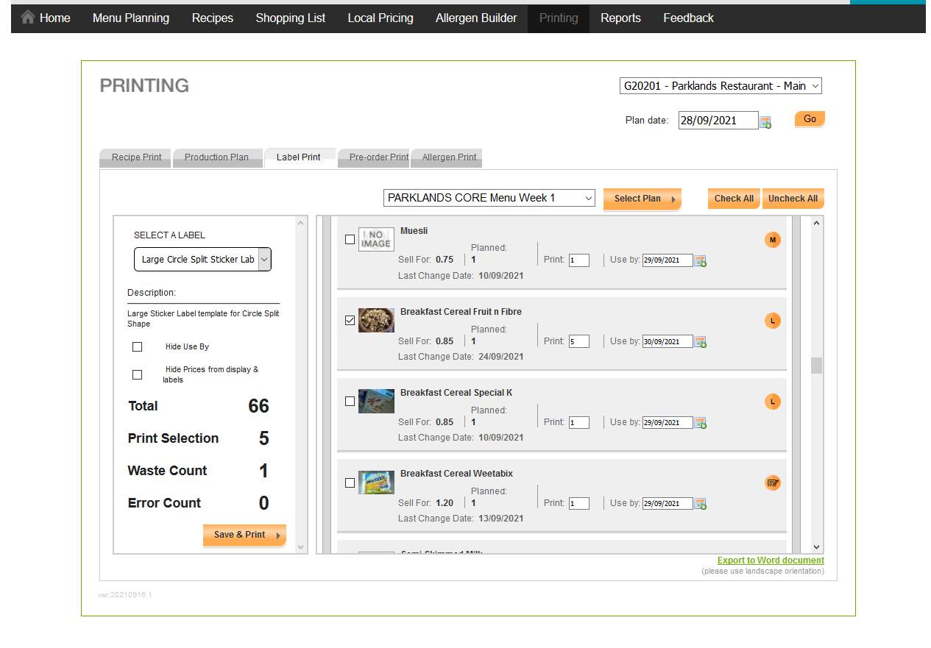

Small Circle Split label COM005 (12 to A4 page)

Small Circle Split

## 1.3.5 Checking Label Summary

* + Select the number of labels required for each recipe selected
  + Check the summary in the bottom left had corner of the page
  + The Print Selection indicates the number of labels you have chosen to print (4 in the example below).
  + The Total indicates the total number of labels on an A4 page (6 in the example below)
  + The Waste Count indicates the number of labels on the A4 page which will not be printed on therefore wasted (2 in the example below – 6 total minus 4 selected for print = 2 waste)

## Small Red Circle Number Labels 1 - 30 by Teachers&#39;LilHelpers | TpTSmall Red Circle Number Labels 1 - 30 by Teachers&#39;LilHelpers | TpTSmall Red Circle Number Labels 1 - 30 by Teachers&#39;LilHelpers | TpTSmall Red Circle Number Labels 1 - 30 by Teachers&#39;LilHelpers | TpTSmall Red Circle Number Labels 1 - 30 by Teachers&#39;LilHelpers | TpT

## 

## 1.3.6 Label Error Message

* + Any recipe indicating an error will be highlighted in red plus an error count indicated in the print summary.
  + The number appearing next to the error count will identify the number of recipes with an error.
  + The error message is created because the label size you have selected is too small for the number of ingredients and the size of the ingredient string.
  + In the example below the label size chosen is Cricle Splt (S) which has a maximum character count of 390 characters. The two recipes highlighted in red with an error message have ingredient lengths of 546 and 770 therefore greater than the 390 permissable on the Small Split Circle label.

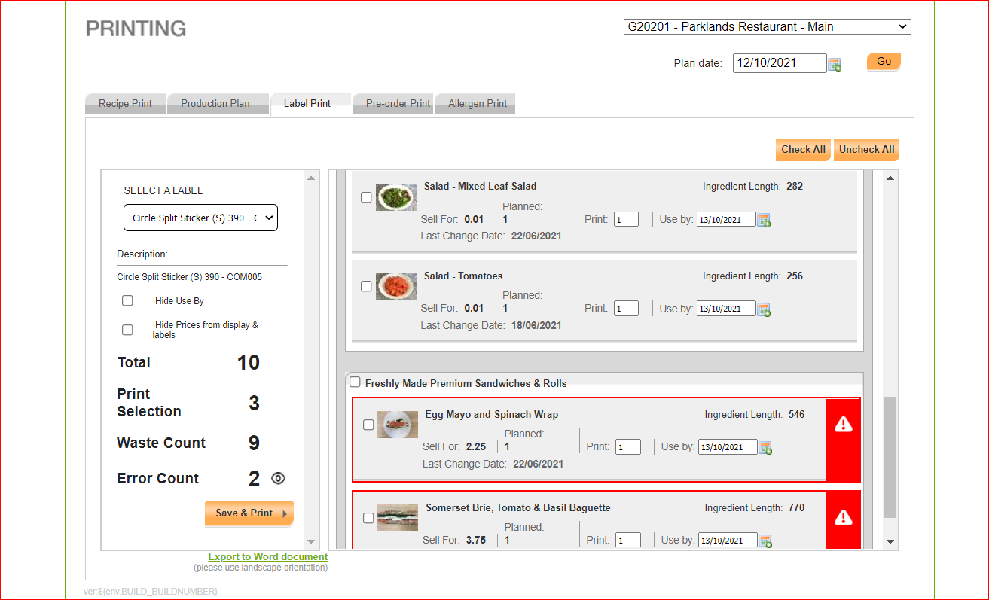

* + Select the recipe or recipes with error messages
  + Click on the drop down label selection again
  + This will then show a reduced menu list of those labels which can accommodate the ingredient length

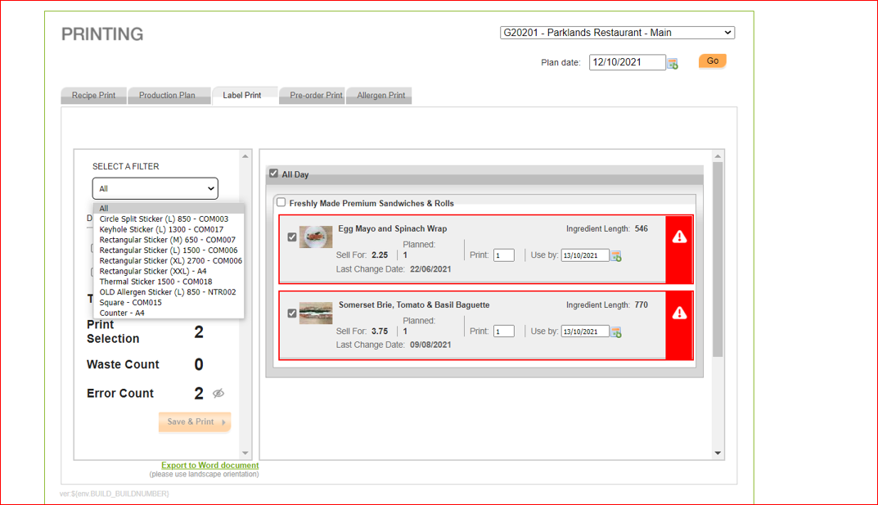





## 1.3.7 Check Before Printing

* Once you have selected an appropriate label and addressed any hazard errors you can click Save & Print and then should be presented with a PDF version of the labels as they will appear when printed onto the planglow label sheets.
* In some cases your system may ask you to **Cllick Here** before displaying this in your print preview settings
* Before you press OK to print ensure you have set up your printer correctly to align your printer with the Planglow A4 sheets of labels correctly – **A4 / Portrait / Fit to Page** or **Actual Size**

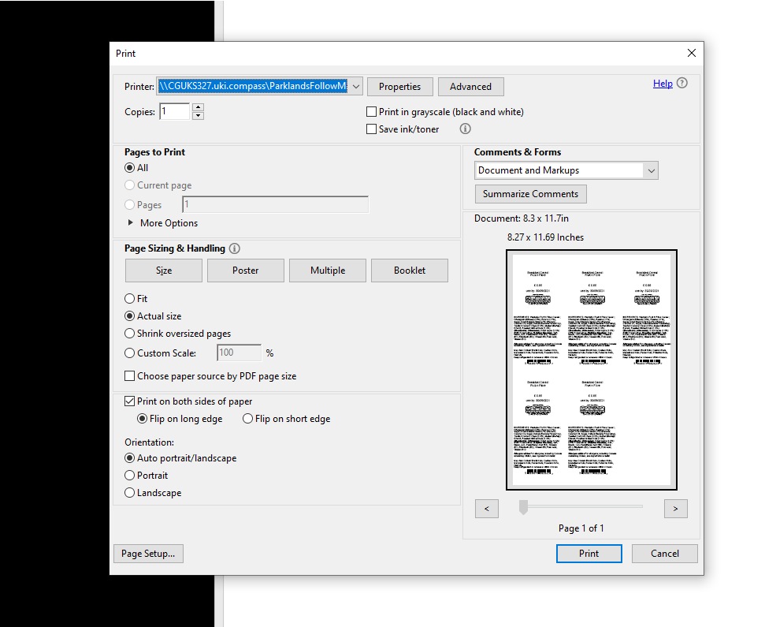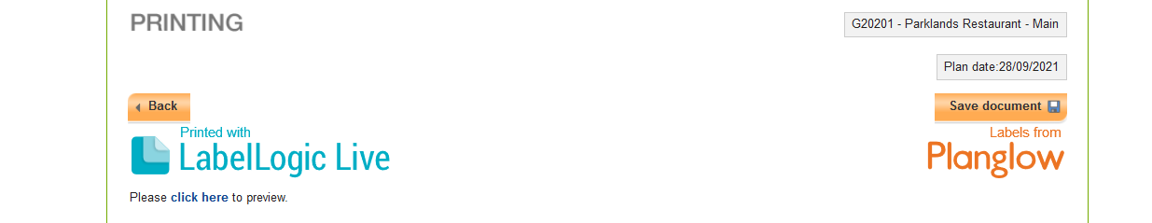



## 1.3.8 Daily Printing

## Note that the system will now remember the label type you last printed on as a guide to selection going forward

## If you have not printed a label for a particular recipe before the system will show a blank space

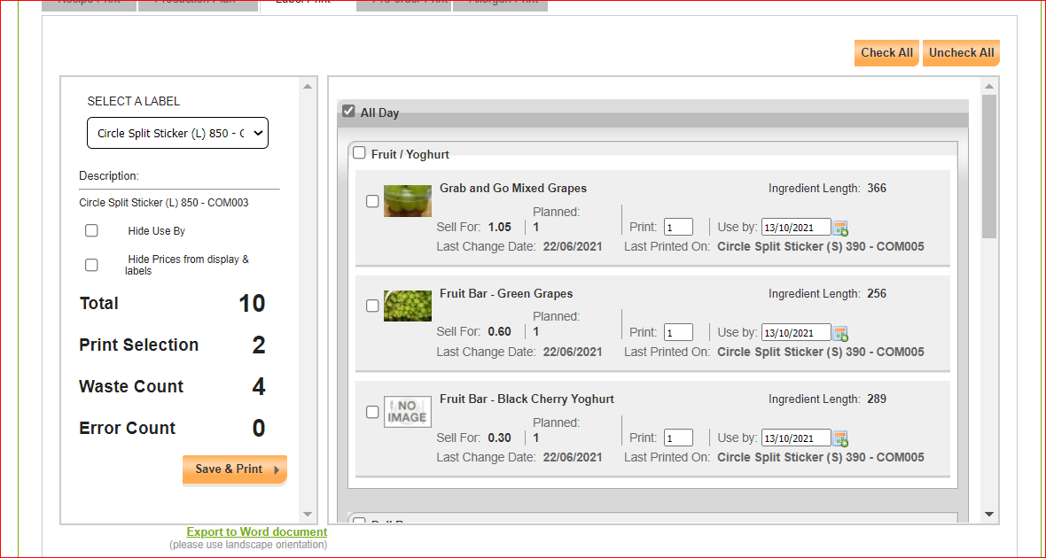







## Emergency Recipe Builder

Should a recipe need to be modified due to ingredient substitution then the Emergency Recipe Builder can be used to amend a current recipe within your menu plan by swapping out the ingredient you do not have and adding in the ingredient you have replaced it with. The following steps should be taken:

## 1.3.1 Select the recipe

* Ensure you have selected your unit number and the current menu plan. **Note:** you can not amend a recipe in a previous weeks menu plan – It has to be a recipe within your current daily or weekly menu plan
* Search for the recipe you want to amend using the tabs on the left to filter you menu by day part, cousre or recipe name
* Click on the E button (Create Emergency Recipe) within the recipe you want to change.

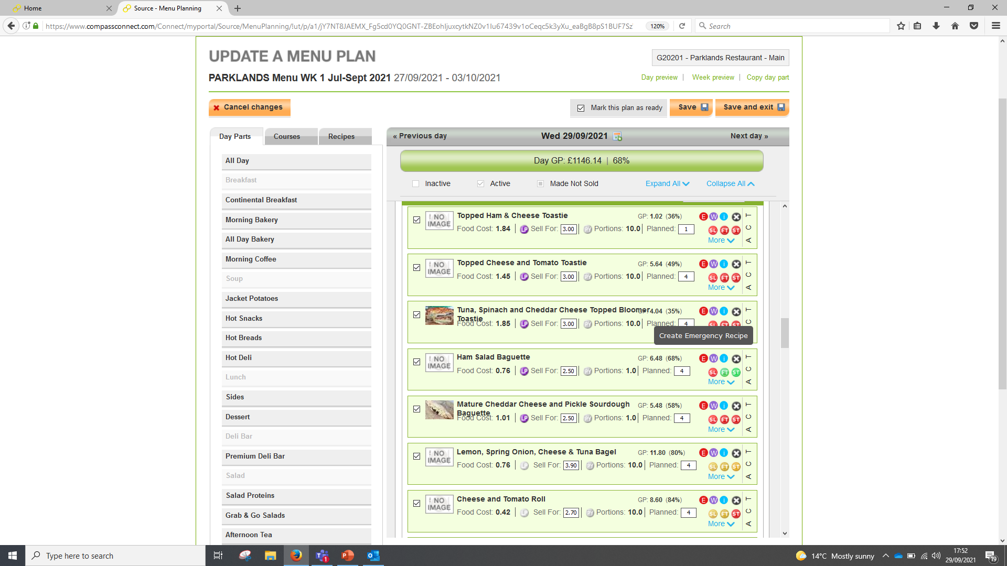

## 1.3.2 Swap out the ingredient

* By clicking on the small X circle delet the ingredient you want to replace
* Search for the replacement product using the Foodbuy product code or name
* Drag & drop the replacement product into your menu plan

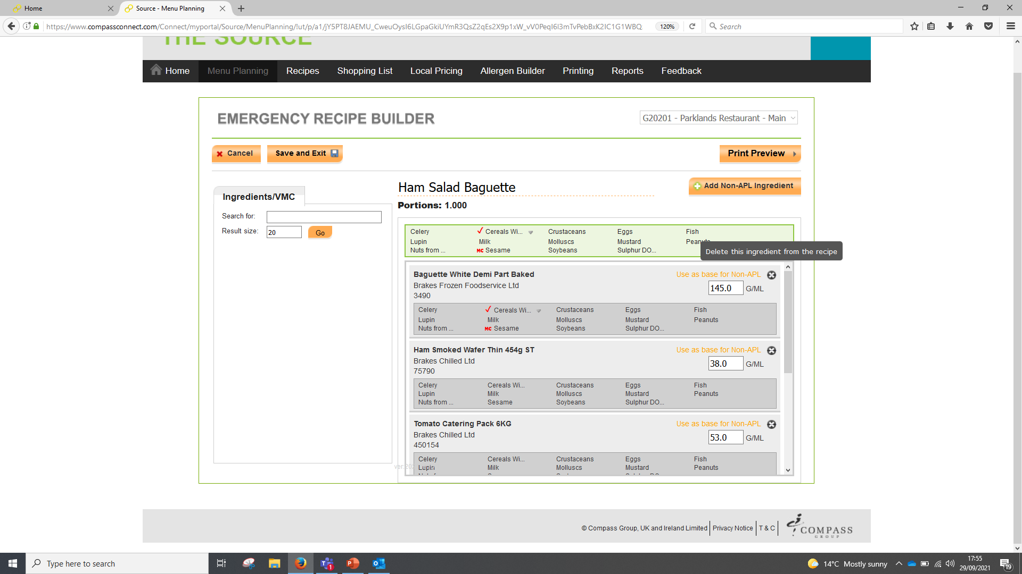

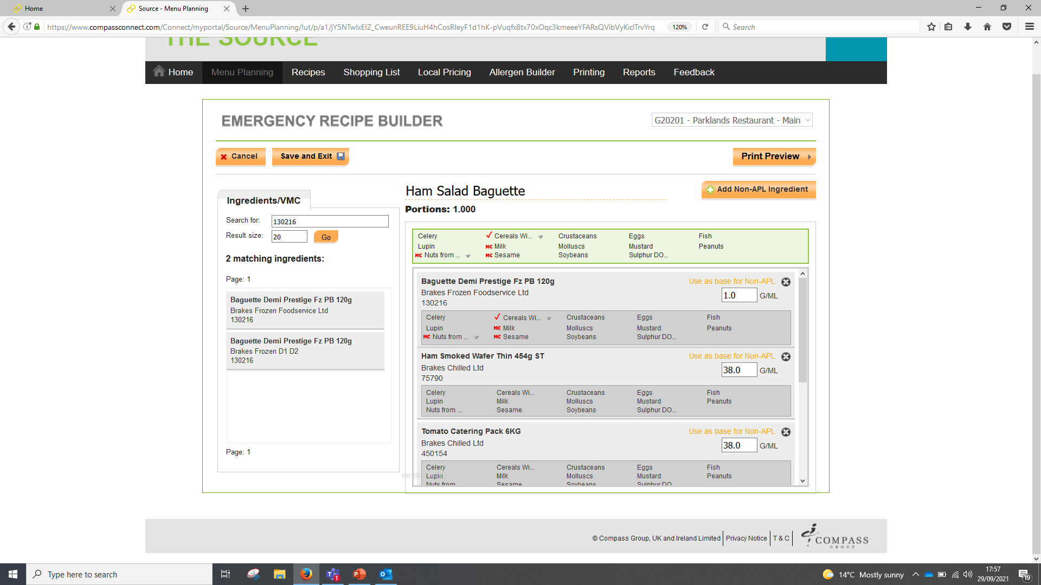







## 1.3.3 Save modified recipe

* Once you have made all the necessary changes to your recipe click the Save and Exit button at the top right hand side of the screen to save your recipe
* Note: You will NOT be able to make any further changes to this recipe once you confirm the changes.
* Your new modified recipe will now appear in your current day / week menu plan

**Note**: the old recipe will still show but be turned off to allow you to go back in at a later point and turn back on once your food ingredient supply returns to normal

* Select Confirm and Exit to save the changes to your menu plan

**Note:** you will not be able to print a label from the old recipe as this is now ‘switched off’ and will only show the new modified recipe within the lable printing function

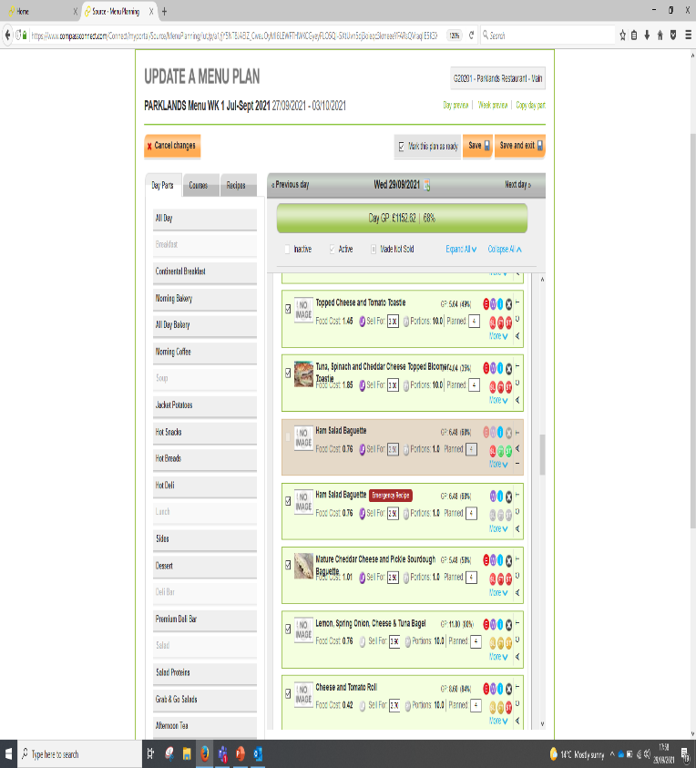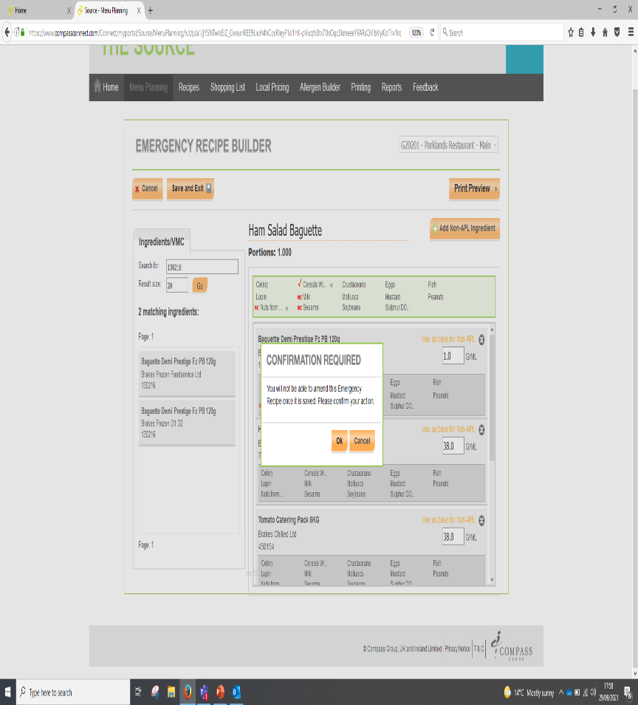

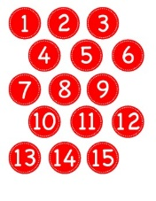





For further help and assistance please use one of the following resources available:

* Source user access issue - send employee name, number, unit number & unit name to BE Team
* System I.T. issues (Source / Symphony / Nexus etc.) contact IT support via Connect (<https://www.compassconnect.com/communities/community/ITHelp>)
* Printer replacement – IT Orders via Connect (<https://www.compassconnect.com/communities/community/IT.Orders>)
* Labels – Order via unit Foodbuy online accounts. Escalation to Foodbuy helpdesk ([foodbuyhelp@foodbuy.co.uk](mailto:foodbuyhelp@foodbuy.co.uk))
* Allergen data discrepancy – Escalate to Foodbuy helpdesk ([foodbuyhelp@foodbuy.co.uk](mailto:foodbuyhelp@foodbuy.co.uk))