ES09 | Floor Safety Risk Assessment
Unit Address
Risk Assessment Completed |  | Date | Signed
1st review |  | Date | Signed
2nd review |  | Date | Signed
3rd review |  | Date | Signed
Note – Risk assessments must be reviewed every 3 years, whenever there is a significant change in the floor surface or structure, and following any incident involving the activity. Assessments must be retained for a period of 6 years.

The purpose of this assessment is to help you to identify floor safety risks and to take preventive measures to reduce risk where necessary. It is Company Policy to provide employees with personal protective equipment (PPE) as a last resort measure’ where the risk remains high after all other preventive measures have been taken. PPE, may include safety footwear

In completing the assessment, all areas that staff access should be considered, including external areas such as waste areas, loading bays, service yards etc

Section 1 of the assessment identifies types of floor surfaces that are present within your site and assess their slip risk category – Low, Possible or High. All floor surfaces should be reviewed and recorded.

Section 2 of the assessment considers other floor safety hazards in and around the unit. Consider the factors shown in the left-hand column and complete the information requested in the shaded boxes; judge whether you consider that there is a significant hazard present and what action could be taken to reduce the risk of injury. Indicate in the right-hand column when remedial action has been completed or if there is a reason why action cannot be taken and a risk remains.

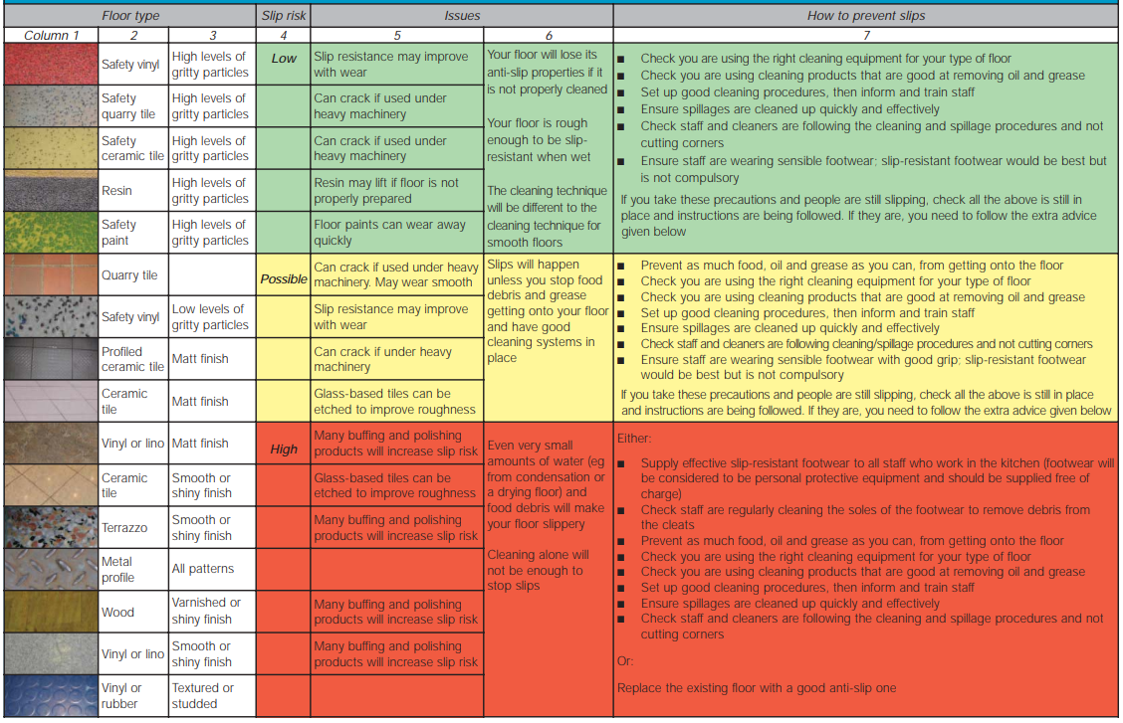

Section 1 – Identifying Floor Surfaces and Slip RIsk
Refer to the Slip Risk Table on page 2 above and identify the types of floor surface in the unit and their location on site. From the table identify the level of slip risk for each area of floor, as best described.

Referring to the ‘How to prevent slips’ in column 7 identify the precautions for the applicable slip risk level for each area of floor identified in the assessment. Confirm that these measures have been implemented, and identify further actions to be taken.

Location | Floor surface | Slip Risk |  |  | Slip prevention measures in place  Y/N | Additional Action Required
 |  | Low | Possible | High

Section 2 – Other factors
Hazard | Present  Y/N | Possible Management Action | Actions/Comments
Uneven floor surfaces or poorly marked changes in level. |  | Request in writing to Client or responsible person to remedy uneven floor area.  If not reasonably practicable to remove change in floor level, arrange for appropriate warning signs to be displayed or hazard marking to be put in place.
Poorly maintained floor surfaces. |  | Request in writing to Client or responsible person to repair defective floor surface.
Inadequately lit areas of the floor. |  | Request in writing to Client or responsible person to improve the level of lighting.
Areas of the floor obstructed by stored articles and equipment |  | Review storage arrangements to remove obstructions.  Request in writing to Client or responsible person to provide additional storage space.
Wet/greasy floor surface due to leaking equipment. |  | Request in writing to Client or responsible person to repair leaking equipment.
Slippery surfaces due to having just been cleaned |  | Review cleaning procedures to ensure that they are carried out at an appropriate time and floor is allowed to dry before access is permitted.  Ensure that “Wet Floor” signs are appropriately displayed.
Inherently wet/greasy floor surfaces, e.g. pot wash area |  | Examine working procedures to identify if improvements can be made to reduce wetting of the floor  Request in writing to Client or responsible person to improve the surface floor finish.  Consider provision of with slip resistant footwear.

Hazard | Present  Y/N | Possible Management Action | Actions/Comments
Slippery surfaces due to food debris and spillages. |  | Improve working procedures to reduce spillages.  Retrain employees not to overfill containers of liquids.  Retrain employees in “clean as you go” procedures.  Ensure that “Wet Floor” signs are appropriately displayed.
Employee tasks mainly involve working externally in conditions of inclement weather. |  | Consider provision of safety footwear with protective toecaps and slip resistant soles.
Where safety shoes are not provided employees are wearing sensible footwear. |  | Remind employees to wear sensible footwear.  Footwear should fit well, have low heels and stay on the feet.  Avoid footwear, such as open-toed shoes, sandals, flip-flops, high heels and shoes with smooth soles.
Footwear worn by employees in poor condition and the sole not kept clean. |  | Remind employees of the need to maintain footwear, particularly the soles, clean and in good condition.
Other observed hazards:

