Chef’s Health and Safety Event Pack

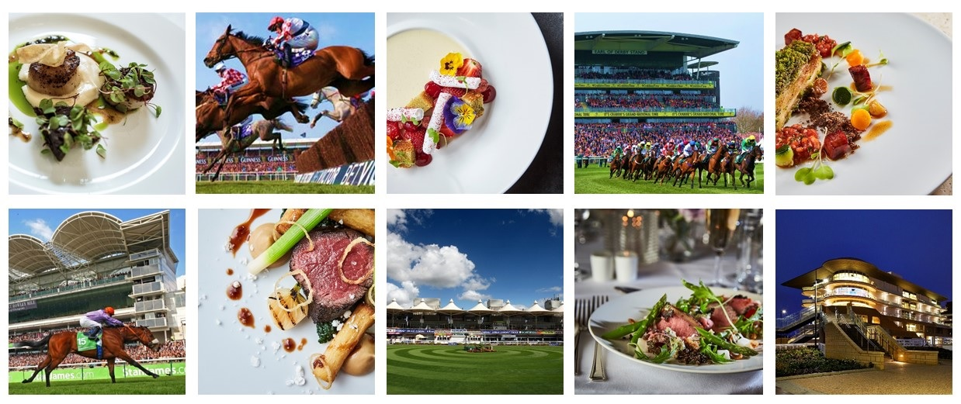
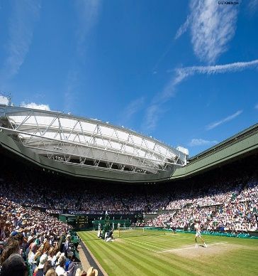
Unit Name:
Event Name:
Event Date:
Catering Location:

THIS PAGE IS LEFT INTENTIONALLY BLANK

Chefs Event Pack Contents and Instructions for Use

 |  | Document | Instructions | Page No:
1. | For information | Fridge/ Freezer Breakdown Procedure | Information only | 4
 |  | Date Labeling Information | Use for briefing the team | 5
 |  | Safe Use of Fire Extinguishers | Use for briefing the team | 6
 |  | Event HACCP Summary | Details key controls for Food Safety | 7 - 8
 |  | Cleaning Schedule | Provides guidance on cleaning within the kitchen | 9 - 10
2. | Complete Prior to the Event Starting | Lead Chefs Kitchen Checklist | Lead Chef to complete prior to the event to escalate any issues | 11 - 13
 |  | Safety Briefing Checklist | Brief your team and ensure all team members sign off the briefing record | 14
 |  | Safety Conversation: Chemical Safety, Infection Control, Food Safety Discussion: Allergens, Essentials of Food Hygiene, The Rules of Safety, Safety Systems of Work, |  | 15-19
 |  | Employee Record of Safety Briefing |  | 20
 |  | Hot Oil Quiz | To be completed by those using or cleaning deep fat fryers | 21 - 22
3. | Food Safety Compliance Records | Opening and Closing Checklist | Opening Checklist to be completed at the start of each day.  Closing Checklist to be completed at the end of each day. | 23
 |  | Production Sheets | Chefs to use to plan their food production for each day | 24 - 26
 |  | Fridge / Freezer Temperature Record | Record temperatures twice daily for fridges and once for freezers and keep the record within this pack | 27
 |  | Food Production Temperature Records | Use to record temperature of final cooking, hot holding and service. MUST be documented at time of monitoring | 28 - 31
 |  | Wastage Sheet | Complete daily to confirm any food wastage | 32
 |  | Shortages List and Repairs Log | To record any shortages and or equipment faults. To be reported to management as soon as possible | 33
4. | Feedback | Event De-Brief Record | Lead Chef to complete with feedback from the event | 34

 | REFRIGERATOR OR FREEZER BREAKDOWN
IMPORTANT
Do not overload refrigerators with transferred food and be very careful to maintain separation between raw and ready-to-eat food items. Airflow inside the refrigerator is very important to its efficiency.
IMMEDIATE ACTION
When a refrigerator or freezer breaks down due to mechanical or power failure, follow the steps below:
- Contact the client, the maintenance contractor or the refrigeration engineer to arrange repair
- Record the details on the unit Record of Repair and Maintenance
- Record the breakdown on the unit Refrigerator/Freezer Temperature Record
ACTIONS - REFRIGERATOR BREAKDOWN
Discovered within four hours:
- Check the temperature of a representative sample of food items using a probe thermometer.
- Check food from all areas of the refrigerator - top, middle and bottom shelves.
If the food temperature is… |  |  | then…
+8°C or cooler |  |  | transfer the food to an alternative refrigerator.
more than +8°C |  |  | for cooked or high-risk food:  - use immediately, or  - transfer to an alternative refrigerator and serve from there  - do not place on ambient display  for raw food:  - transfer the food to an alternative refrigerator
ACTIONS - REFRIGERATOR BREAKDOWN
More than four hours since breakdown or duration unknown
- Check the temperature of a representative sample of food items using a probe thermometer.
- Check food from all areas of the refrigerator, that is top, middle and bottom shelves.
If the food temperature is… |  |  | then…
+8°C or cooler |  |  | transfer the food to an alternative refrigerator.
more than +8°C |  |  | for cooked or high-risk food:  - discard  for raw food:  - assess the quality  - if acceptable, cook thoroughly  - use immediately, or cool rapidly and store in a refrigerator
ACTIONS - FREEZER BREAKDOWN
Check the condition of the food, but do not leave lids or doors open for prolonged periods of time. Provided the freezer lid/door is kept closed, food may stay frozen for up to 24 hours.
If the food temperature is… |  | then…
still frozen |  | transfer food to an alternative freezer as quickly as possible
defrosted, but below +8°C |  | for cooked or high-risk food:  - complete thawing  - use immediately or transfer to refrigerator and use within 72 hours  - follow manufacturer's label instructions if shelf life is less than 72 hours. Example: "use within 24 hours of thawing".  for raw food:  - complete thawing  - cook thoroughly and use immediately, or cook and cool rapidly then store in refrigerator for up to 72 hours
Above +8ºC |  | for cooked or high-risk food:  - discard  for raw food:  - assess the quality  - if acceptable, cook thoroughly  - use immediately, or cool rapidly and store in a refrigerator for up to 72 hours

DATE LABELING
INFORMATION
IMPORTANT
THE GUIDANCE BELOW IS HOW TO CORRECTLY COMPLETE THE FOOD LABELS
IN LINE WITH COMPANY POLICY.
COMPLETING THE LABEL CORRECTLY:
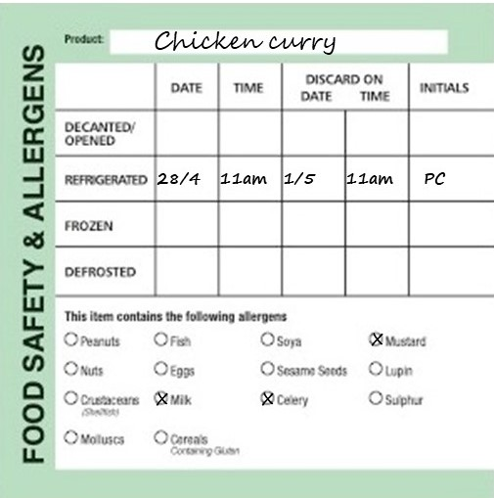
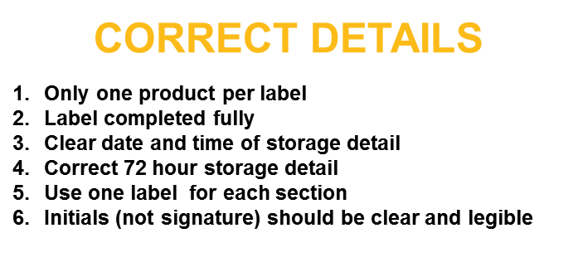

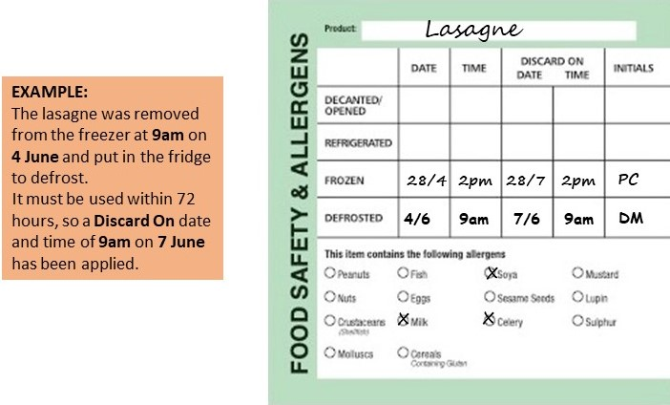

SHELF LIFE INFORMATION – DISCARD ON DATE AND TIME:
- Decanted dry foods – manufacturer’s original ‘Best Before’ date, unless otherwise instructed by the manufacturer e.g. once opened refrigerate and use within 4 weeks.
- Unit produced refrigerated foods – date and time of production plus 72 hours.
- Purchased refrigerated foods – date and time of opening plus 72 hours, unless manufacturer’s instructions are different. (Always follow any manufacturer’s specific instructions relating to shelf life)
- Sandwiches and filled rolls, yoghurt and fruit pots – day of production plus 1 day.
- Unit produced bakery goods –day of production plus 6 days (this would include scones, flapjacks, brownies etc. Any products with fresh cream should be date and time of production plus 72 hours.
- Unit frozen foods – no more than 3 months forward, including date of production/freezing. If freezing bought in chilled products this must be done at least 3 days prior to the manufacturers use by date.
- Defrosting foods – label with date and time of defrost (date/time taken out of freezer and put into fridge) then a ‘Discard on’ date and time of plus 72 hours
- Unit produced vacuum packed refrigerated foods – date and time the food was packed plus 168 hours (7 days)

 |  | Safe Use of Fire Extinguishers
When attempting to deal with a fire, the correct type of fire extinguisher should be used as specified below;
Personal safety should be observed at all times whilst attempting to extinguish a fire.
- Ensure the alarm has been raised
- Always make sure the main electric/gas supply has been isolated before attempting to extinguish the fire
- Ensure all employees and customers are evacuated from the immediate area
- When attempting to extinguish the fire make sure you have a clear escape route behind you whilst fighting the fire in front of you
- Only use one extinguisher. If once the extinguisher has depleted the fire is not extinguished evacuate the area and wait for the fire brigade
TYPES OF EXTINGUISHERS AVAILABLE
CO₂ (Black Label)
For electrical fires.
Direct the black nozzle towards the direction of the base of the fire prior to deploying the CO₂.
DO NOT TOUCH ANY PART OF THE BLACK NOZZLE
HIGH PRESSURE EXTINGUISHER – DO NOT spray at lightweight materials such as paper or dustbins.

FOAM (Cream Label)
For combustibles or burning liquids. Spray over the top of the fire in order to lay a blanket of foam over the combustible or burning liquid.
DO NOT point into the fire.
Always isolate the power source (electricity/gas) before use.

DRY POWDER (Blue Label)
Safe for use on all fires, except Class F fires (those involving cooking oils and fats, such as deep fat fryers).
This extinguisher should not be used in confined spaces.

WET CHEMICAL (Yellow Label)
The specialist wet chemical extinguishers are ideal for Class F fires, involving cooking oils and fats, such as deep fat fryers.
Apply the wet chemical using the extended applicator in slow circular movements, which give a gentle, yet highly effective application. Apply the fine spray onto the burning fat until the surface of the burning cooking oil changes into a soapy like substance, this prevents re-ignition. The gentle application helps prevent hot oil splashing onto the user.

FIRE BLANKETS
To be used to smother small fires. (DO NOT attempt to use on deep fat fryers, please use the WET CHEMICAL extinguisher for this purpose).
Can be used to save a person whose clothes have caught fire, always force them to the ground and then roll them in the blanket using the “Stop, drop and roll” technique.
You will not be able to make effective use of the blanket while they remain on their feet, and the burns will be much worse to the upper body and head.
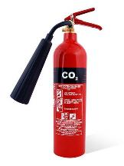 | 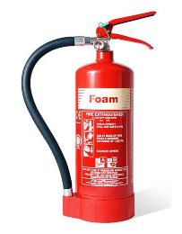 |  | 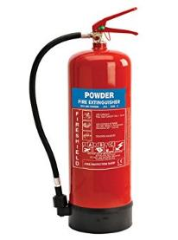 | 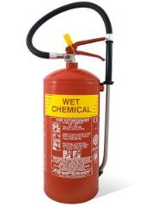 | 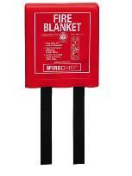

EVENT FOOD SAFETY MANAGEMENT - HACCP SUMMARY
PROCESS STEP | HAZARD | CONTROLS | MONITORING | CORRECTIVE ACTIONS
PLANNING FOOD SERVICE | Microbiological – inherent contamination  Physical contamination  Chemical contamination | Ensure adequate equipment and facilities for storage, preparation, production and service  Plan menus in advance | Check that facilities and equipment are in good order and well maintained  Review menus | Report repair & maintenance issues  Revise storage, prep & service as required
PURCHASE & FOOD DELIVERY | Microbiological – inherent contamination, bacterial growth, cross-contamination  Physical contamination  Chemical contamination | Use authorised suppliers  Check food deliveries on receipt  Temperature limits: chilled 8°C, frozen -15°C  Use a dedicated probe thermometer to check the temperature of all chilled and frozen food deliveries.  Visual inspection | Supplier audits and records  Check and record temperature of all chilled and frozen deliveries  Check and record condition of food and packaging | Reject deliveries of chilled food above 8°C and frozen foods above -15ºC  Reject any foods with expired shelf life  Reject foods with damaged packaging
CHILLED FOOD STORAGE | Microbiological – inherent contamination, bacterial growth, cross-contamination  Physical contamination  Chemical contamination | Food stored at 5°C or below  Raw and cooked foods kept separate  Food covered and labelled  Stock rotation – food used within shelf life dates  - Sandwiches/rolls – day of production plus 1 day  - Unit prepared food – 72 hours  - Opened product – manufacturer instructions or 72hrs  Use a dedicated probe thermometer and food simulant when checking the temperature of storage areas | Check and record refrigerated food temperatures twice daily using a food simulant  Visually check and record refrigerator food storage daily | Follow procedure for refrigerator breakdown in Chefs Event Pack  Discard any foods with expired shelf life
FROZEN FOOD STORAGE | Microbiological – inherent contamination, bacterial growth, cross-contamination  Physical contamination  Chemical contamination | Food stored -18°C or below.  Raw and cooked food kept separate  Food covered and labelled  Stock rotation – food used within shelf life dates  - Purchased product – manufacturer instructions  - Frozen in unit – use within 3 months | Check and record freezer temperatures daily by between-pack method  Visually check and record freezer food storage daily | Follow procedure for freezer breakdown in Chefs Event Pack  Discard any foods with expired shelf life
DRY FOOD STORAGE | Microbiological – inherent contamination, bacterial growth, cross-contamination  Physical contamination  Chemical contamination | Cover, wrap or package/contain all foods  Maintain separation of raw/unwashed foods from other product  Ensure all foods are labelled  Stock rotation – food used within shelf life dates | Visually check storage areas daily for correct storage, stock rotation, shelf life, pest activity and cleanliness | Review cleaning procedures  Discard any foods with expired shelf life
FOOD PREPARATION | Microbiological – bacterial growth, cross-contamination  Physical contamination  Chemical contamination | Observe personal hygiene standards  Hand washing  Sanitise equipment and surfaces  Separate raw and cooked food preparation  Avoid holding foods at ambient temperature for long periods | Supervise preparation procedures  Adhere to cleaning schedules | Revise cleaning and food handling practices as required
DEFROSTING FOOD | Microbiological – bacterial growth, cross-contamination  Physical contamination  Chemical contamination | Defrost in a refrigerator  Defrost in a container of adequate size to prevent juices from leaking.  Separate raw and cooked/ready to eat foods  Ensure adequate product labelling | Check foods are completely defrosted before using | Do not prepare food until fully defrosted  Take care not to exceed shelf life date.

EVENT FOOD SAFETY MANAGEMENT - HACCP SUMMARY
PROCESS STEP | HAZARD | CONTROLS | MONITORING | CORRECTIVE ACTIONS
COOKING | Microbiological – bacterial survival,  Physical contamination  Chemical contamination | Core temperature of at least 75°C must be achieved  Whole meat cuts, such as steaks, and some fish, such as salmon, may be cooked to lower than 75°C  Sanitise the probe thermometer before each use | Ensure food temperatures are checked and recorded on completion of cooking  Where foods are cooked to less than 75°C this must be recorded on the temperature record | Continue cooking until 75°C is achieved
CHILLING/FREEZING | Microbiological – bacterial survival and growth, cross-contamination  Physical contamination  Chemical contamination | Rapid chilling with blast chiller, where available  Commence blast chilling within 30 minutes of cooking and continue until core temperature of 5°C is achieved.  Where no blast chiller is available, cool to ambient within 90 minutes and transfer to refrigerator.  If to be frozen, transfer to freezer immediately.  Ensure product is adequately labelled  Shelf life chilled – 72 hours  Shelf life frozen – 3 months | Check and record food temperatures and timings  Check food labels are adequate and show shelf life | Continue with rapid chill until 5°C is attained.  Adjust process to assist with rapid temperature reduction e.g. reduce thickness and bulk of foods, increase surface area
REHEATING | Microbiological – bacterial survival and growth, cross-contamination  Physical contamination  Chemical contamination | Core temperature of at least 75°C must be reached  Never reheat foods more than once | Check and record food temperatures on completion of reheating | Continue heating until 75°C is achieved
HOT HOLDING & SERVICE | Microbiological – bacterial growth, cross-contamination  Physical contamination  Chemical contamination | Display/serve hot food at 63°C or hotter  Protect food on display from contamination risk  Use within 2 hours if no hot holding  Provide appropriate clean serving utensils | Check and record hot holding and service temperatures of food at commencement and during hot holding/display  Visually check and supervise food service standards. | Hot food at less than 63°C for more than 2 hours must be discarded
COLD FOOD SERVICE | Microbiological – bacterial growth, cross-contamination  Physical contamination  Chemical contamination | Display/serve cold food at 8°C or less  Protect food on display from contamination risk  Use within 4 hours if above 8°C  Provide appropriate clean serving utensils | Check and record cold food service temperatures of food at commencement and during display  Visually check and supervise food service standards | Cold food at above 8°C for more than 4 hours must be discarded
USE OF VACUUM PACKING MACHINE | Microbiological – inherent contamination, cross-contamination  Physical contamination  Chemical contamination | Clean and sanitise machine before and after each use  Observe personal hygiene standards  Dedicated use for cooked and ready-to-eat foods or for raw use only.  Signage to be displayed “For cooked and ready to eat foods only” or “For raw products only”  Cleaning schedule method and sign off to be displayed  Ensure food is adequately labelled once packed  Shelf life if to be stored chilled – 7 days  Shelf life if to be stored frozen – 3 months | Visually check condition of equipment  Check and record cleaning  Supervise use, ensuring there is no cross-use | Ensure cleaning and use processes are supervised and enforced  Revise cleaning processes as required
IMPORTANT: Always report repair and maintenance issues immediately

NOTE: Full HACCP is held in the Head Chef’s office.
Compass Food Safety Management System, including A to Z guidance and all Event packs can be accessed on the Compass HSE website on an on-line computer in the office.

Event Catering Cleaning Schedule

ITEM | PRODUCT | PPE REQUIRED | DOSE RATE | METHOD
Floors | Multi EL10 | Nitrile/Latex-free Gloves EN374* | 2 x 20ml pumps per 5l of warm water | Sweep up debris. Apply hot solution using clean mop or long handle scrubber, paying attention to floor/wall joins, around equipment and under and behind equipment. Rinse and mop with fresh clean water. Allow to air dry.
Work Surfaces/ Benches | Multi EL10 | Nitrile/Latex-free Gloves EN374* | 20ml via dispenser per 600ml trigger spray | Remove debris. Apply solution with a cloth or hand sprayer. Ensure that attention is given to legs and under edges. Rinse and allow to air dry or dry with paper towels.
Cutting Boards | Aseptopol or  Oasis  Pro20 | Nitrile/Latex-free Gloves EN374* | 20ml via dispenser per 600ml trigger spray | Remove debris. Apply sanitiser solution onto moistened board and scrub. Wipe surface and rinse. Allow to air dry.  Can be routinely washed in dishwasher if suitable, but additional weekly clean with sanitiser solution is required.  Cutting boards should be racked vertically with cutting surfaces separated after cleaning and sanitising.
Refrigerators / Blast Chillers | Aseptopol or  Oasis  Pro20 | Nitrile/Latex-free Gloves EN374* | 20ml via dispenser per 600ml trigger spray | Check and organise fridges daily. Check for spillages and wipe up [spillages should be wiped up immediately].
Deep Freezers | Aseptopol or  Oasis  Pro20 | Nitrile/Latex-free Gloves EN374* | 20ml via dispenser per 600ml trigger spray | Check and organise freezers daily. Wipe down external surfaces and door seals. [Wipe up spillages immediately. Do not allow to freeze]
Can Opener | Aseptopol | Nitrile/Latex-free Gloves EN374* | 20ml via dispenser per 600ml trigger spray | Remove from bench mounting. Soak in hot general-purpose detergent solution. Scrub cutter blade and assembly with a brush. Check for uneven blade wear or loose blade mount and report to supervisor as necessary. Scrub the base plate mount at the table. Rinse and air dry.
Fryer | Multi EL10 | Nitrile/Latex-free Gloves EN374* | 2 x 20ml pumps per 5l of warm water | After use - switch off appliance and allow oil to cool. Remove food particles with fine wire mesh web. Wipe outside of fryer to remove spilt oil. Wash frying baskets in general purpose detergent. Dry and replace. Top up oil to required level if necessary.

SAFETY PRECAUTIONS
- Before cleaning electrical machinery ensure it is switched off and isolated from the mains.
- Before cleaning gas appliances ensure they are turned off. Take care when cleaning hot items.
- Follow all safety precautions shown in COSHH Product Task Cards for the cleaning product being used and wear the correct PPE as advised especially when handling or dispensing concentrated chemicals.
Event Catering Cleaning Schedule

ITEM | PRODUCT | PPE REQUIRED | DOSE RATE | METHOD
Tea/Coffee Boiling Urns | Multi EL 10 | Nitrile Latex free Gloves EN374* | 2 x 20ml pumps per 5l of warm water | Ensure appliance is switched off. Fill with solution and leave to soak for 10 to 15 minutes. Scrub out and drain. Rinse thoroughly and allow to air dry.
Bain Marie and Hot Cupboards | Aseptopol or  Oasis Pro20 | Nitrile/Latex-free Gloves EN374* | 20ml via dispenser per 600ml trigger spray | After use - Switch off power supply and allow to cool. Remove containers and transfer to pan wash. Where a water bath is incorporated, drain to waste and clean out the bath. Wash down all surfaces and rinse. Remove deposits from door runners with a stiff brush. Brush floor under appliance and clean up spillages.
Equipment Racks and Shelving | Aseptopol or  Oasis Pro20 | Nitrile/Latex-free Gloves EN374* | 20ml via dispenser per 600ml trigger spray | Remove stock and utensils/equipment from shelves and racking. Sweep debris off surfaces and sweep floor underneath. Clean with solution, rinse and allow to air dry. Replace stock and utensils/equipment. Ensure equipment is stored inverted as far as practicable.
Sinks and Wash Hand Basins | Aseptopol or  Oasis Pro20 | Nitrile/Latex-free Gloves EN374* | 20ml via dispenser per 600ml trigger spray | Clean with the general-purpose detergent. Remove any tide marks from the bowl and drainer with a scouring pad or cloth. Include taps, waste outlets and splashbacks in cleaning programme. Rinse thoroughly with cold water. Apply sanitiser to all surfaces and leave to air dry.  Top up supply of towels and soap maintained at the wash hand basin as required.
Temperature Probes | Aseptopol,  Oasis Pro20 or Probe Wipes | Nitrile/Latex-free Gloves EN374* | 20ml via dispenser per 600ml trigger spray | Remove debris. Apply solution with a cloth. Ensure that attention is given to the full length of the probe needle. Rinse and allow to air dry or dry with paper towels.
Paper Towel & Soap Dispensers | Aseptopol or  Oasis Pro20 | Nitrile/Latex-free Gloves EN374* | 20ml via dispenser per 600ml trigger spray | Remove debris. Apply solution with a cloth or hand sprayer. Rinse and allow to air dry or dry with paper towels.

SAFETY PRECAUTIONS
- Before cleaning electrical machinery ensure it is switched off and isolated from the mains.
- Before cleaning gas appliances ensure they are turned off. Take care when cleaning hot items.
- Follow all safety precautions shown in COSHH Product Task Cards for the cleaning product being used and wear the correct PPE as advised especially when handling or dispensing concentrated chemicals.

LEAD CHEF’S KITCHEN CHECKLIST

- Please work your way through this checklist prior to the first day of an event.
- Some questions can only be completed after your initial staff briefing.
- Ensure that any action required is reported to the relevant person and sign when the actions are completed.
- Keep this checklist as a reminder during the event and hand to the event manager at the end.
KITCHEN:…………………………………………………………………  CHEF:……………………………………………………………... |  | DATE:…………………………………………………………………….  TIME:…………………………………
Tentage/Structure | Yes/No | Comments/ Action Required | Reported To | Completed
- Is flooring level and safe without obvious slip or tripping hazards?

- Are all access and exit points clear of obstructions?

Work Practices | Yes/No | Comments/ Action Required | Reported To | Completed
- Have all employees been instructed in the use of dangerous equipment in line with the safe system of work information?

- Have employees been made aware of manual handling procedures and displayed lifting safely diagrams?

- Are the Food Safety / Health and Safety posters displayed?

- Has a Health and Safety Briefing been given and have all colleagues signed the Briefing?

- Are employees wearing suitable footwear? (Shoe should fully cover the foot, have a low heel and a slip resistant sole)

Machinery and Equipment | Yes/No | Comments/ Action Required | Reported To | Completed
- Are the hot water boilers on stable bases/legs and at the appropriate height and is ‘Danger Hot Water’ safety signage in place?

- Is all dangerous equipment identified with a warning label/sign?

Liquefied Petroleum Gas (LPG) – if applicable | Yes/No | Comments/ Action Required | Reported To | Completed
- Are all cylinders clearly marked “Highly Flammable” and is a “No Smoking” sign clearly visible?

- Have all employees been made aware of the risks associated with LPG and what to do in an emergency: no smoking near cylinders, keeping gas cylinders free of combustibles, knowing the location of emergency isolation valve and how to isolate the gas, how to raise the alarm?

Chemical Safety | Yes/No | Comments/ Action Required | Reported To | Completed
- Have all employees been given a basic induction on chemical safety?

- Check that all hand spray bottles have the correct identification label on them and are used only for the correct purposes.

- Do you have adequate supply of gloves, goggles and face masks if required?

- Are all chemicals that are not in immediate use stored outside food preparation areas or under wash up sinks (with exemption of sanitiser solution)?

Electrical Safety | Yes/No | Comments/ Action Required | Reported To | Completed
- Are there any visible defects on the equipment, cables, plugs or sockets?

Fire Safety | Yes/No | Comments/ Action Required | Reported To | Completed
- Are escape routes from your unit clearly marked with green and white fire escape signage?

- Are escape doors/corridors unobstructed and unlocked?

- Are fire notices mounted on the wall?

- Do employees know how to raise the fire alarm, where exit routes are and where to assemble in the event of an emergency?

- Do you have appropriate fire extinguishers in the unit?

- Are all flammable items stored away from naked flames or a heat source?

Lighting and Ventilation | Yes/No | Comments/ Action Required | Reported To | Completed
- Is lighting sufficient to allow employees to work safely including at the event end?

- Is the temperature of the employee’s areas adequate to allow employees to work in comfort?

General Provisions | Yes/No | Comments/ Action Required | Reported To | Completed
- Have you checked that the Allergen Information is relevant to your menu and that allergens match your recipe specifications?

- Do you have a first aid kit?

- Do employees know where their nearest first aid point is?

- Are wash hand basins supplied with antibacterial hand soap and paper towels?

- Do sinks have a supply of hot and cold running water?

- Have the employees been instructed where to go for toilet, rest and meal breaks?

- Is there a designed bin for broken crockery?

- Are wet floor signs available?

ANY OTHER COMMENTS
(Include any comments on the design and layout for future events)

 | SAFETY BRIEFING CHECKLIST
Please Note: This document should be amended to reflect actual practices and procedures at your site
Unit Name: |  | Date:
Event Name:
Briefing Information
- First Aid Arrangements | You must report any accident to your supervisor / manager.  First aid facilities are available in the kitchens (1st Aid Box) or Event First Aid Locations: see Site Map or Handbook
- Fire and Emergency | Alarm sound is:  Exit by nearest fire exit. Assembly point is located at:
- Key Safety Behaviours | BE MINDFUL – Always think first before you carry out a task or activity: are there any risks or hazards and is it safe to carry on.
 | GET INVOLVED – Help your colleagues if they need it or if you see them in trouble.
 | SPEAK OUT – If you are unsure of anything ask your manager/ supervisor or if you see any unsafe environments or working activities then let them know.
- Personal Protective Equipment (PPE) | PPE such as waiters’ cloths, oven cloths, gloves and goggles, is provided to ensure risks to your safety are minimised. Ensure you use it.
- Manual Handling | Ensure any manual handling tasks are within your capabilities and if you need assistance, please ask a member of the team or your supervisor/manager. Always use lifting aids, such as trolleys, sack trucks and keg barrows, where provided.
- Slips, Trips and Falls | Ensure that any spillages are cleaned up immediately, keep walkways and working areas clear of obstructions, report any damaged floor surfaces to your supervisor/manager immediately and avoid running or rushing in your workplace.
- COSHH | You must not use any chemicals unless you have been trained to do so. Ensure you always follow instructions on the chemical safety task card.  Specific chemicals used on this site include Oasis Pro 20 or Aseptopol EL76 Surface Sanitiser (clear debris, spray surfaces, wipe down with clean paper towel, then re-spray and allow a 1-minute contact time before wiping off with a clean paper towel.)
- Working with Equipment | Only use equipment and machinery that you have been trained to do so. Never attempt to carry out any repairs or modifications to equipment.
- Burns and Scalds | Take particular care when working with hot materials and equipment and when carrying hot food and liquids. If you are using deep fat fryers, ensure you have been trained.
- Safety with Knives | Ensure the knives you use are sharp and in good condition. Store knives safely when not in use and always select the correct knife for the task. If in doubt, ask your supervisor / manager.
- Essentials of Hygiene and Rules of Safety | Ensure you read the “Essentials of Food Hygiene” and “Rules of Safety” located within this pack prior to commencing work.
- Allergens | Always follow recipe specifications and do not any other ingredients to a dish. Avoid allergen cross-contamination by regularly washing your hands, following correct cleaning procedures and by having dedicated equipment. Make sure all communication with the front of house team is clear. If you are unsure of any aspect, ask your Head Chef immediately.
- Violence at Work | If you feel threatened or intimidated at any time, or if you observe any aggressive or inappropriate behaviour, report this to your manager immediately and ensure you know how to raise the alarm.
- Infection Control | Follow good hand hygiene procedures and regularly wash your hands with soap and warm water. Report any suspected communicable illness, including COVID-19 and gastroenteritis to your manager.
- Additional Information

Infection Control
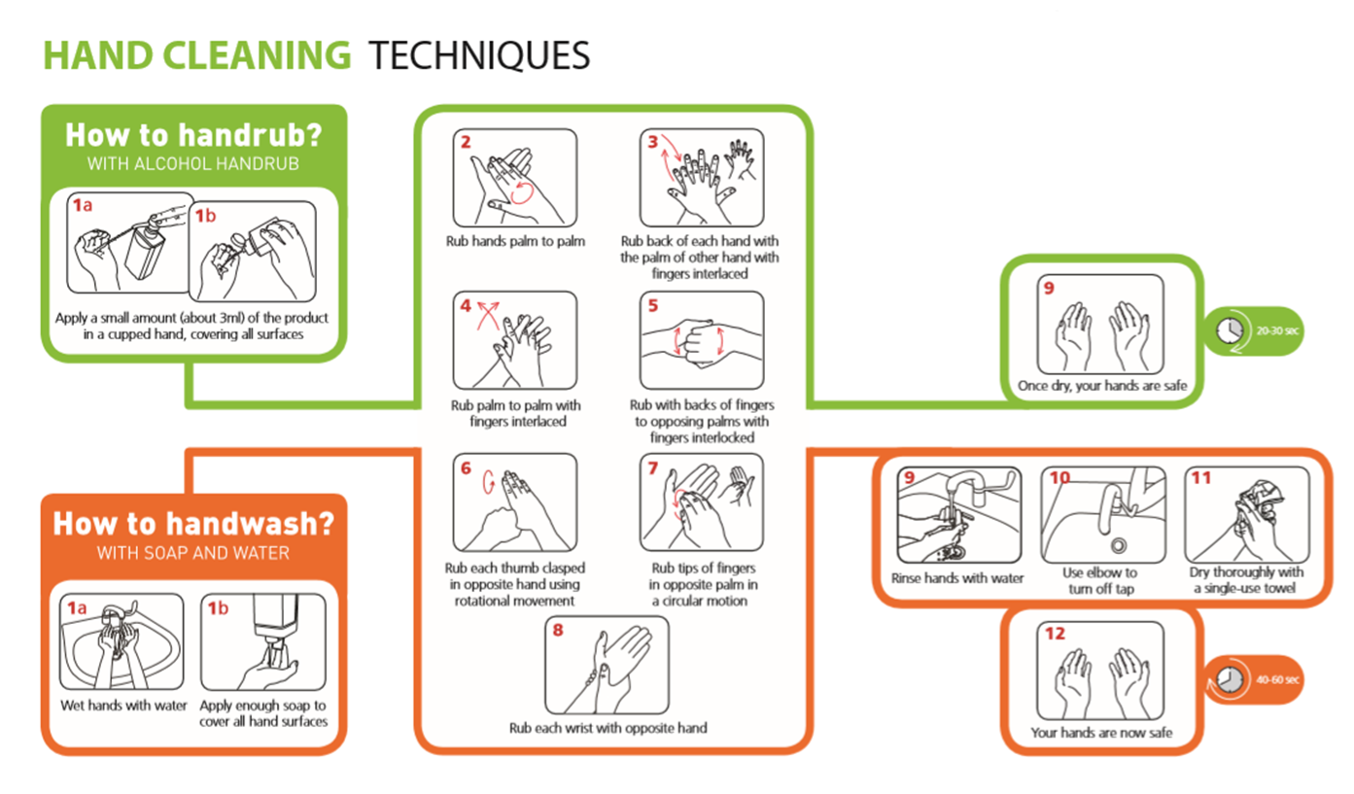

Personal infection control
- Good hand hygiene – Remember washing hands is more effective than using hand sanitiser – wash hands between tasks
- Cough & Sneezes
  - Cover mouth & nose with a disposable tissue
  - Promptly dispose of the tissue
  - Wash your hands
- Keep our work place clean & tidy
- Sanitise work surfaces and hand contact surfaces regularly
- Regularly launder your work clothing / uniform and ensure it is clean each day

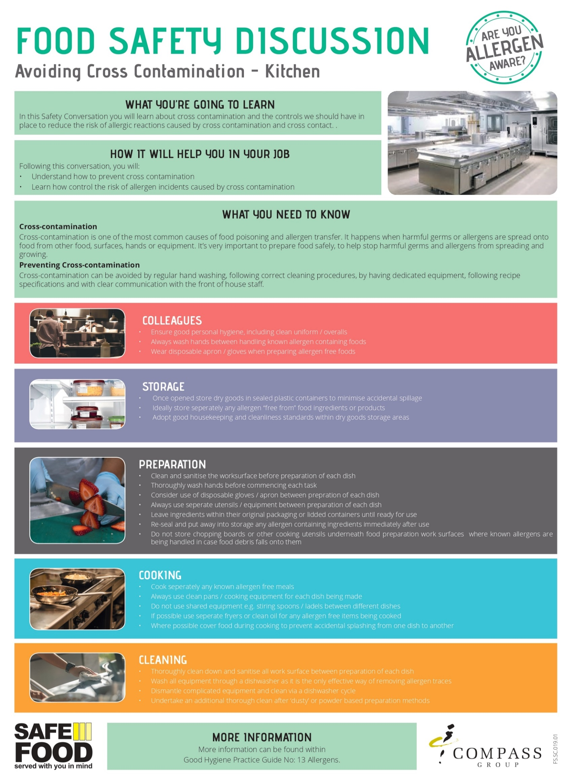

THE ESSENTIALS OF FOOD HYGIENE

FOOD HANDLER INDUCTION
SAFETY CONVERSATION
WHAT YOU MUST DO
Read the essentials of Food Hygiene to understand what is expected of you
as a food handler.

You are breaking the law and are in breach of company policy if you do not follow these rules.

Please ask your lead chef if you have any questions.
THE ESSENTIALS OF FOOD HYGIENE
Personal Hygiene
- Keep yourself clean and wear clean clothing.
- Tell your supervisor, before commencing work of any skin, nose, throat, stomach or bowel trouble or infected wound.
- Cover cuts and sores with a waterproof, high visibility dressing such as a blue plaster.
- Always at or drink away from a food room and never cough or sneeze over food.
- Follow the site’s no smoking policy.
- Wash your hands thoroughly, before handling ready to eat food, after using the toilet, after handling raw foods, after handling unwashed fruit and vegetables, after handling raw food packaging or waste, before starting work, after every break and after eating, smoking or blowing your nose.
- Always consider the potential for cross-contamination between raw meat, unwashed fruit and vegetables, their packing and ready-to-eat foods within the catering operation.
- Remember it only takes a few bacteria or viruses (germs) to make someone ill.
- Avoid unnecessary handling of food.

Safe Food Preparation
- Always follow food safety instructions on food packaging and from your supervisor.
- Check deliveries for damaged packaging and leaked meat juices to ensure ready to eat foods have not become contaminated. Reject the delivery and tell your supervisor if you suspect contamination has occurred.
- Prepare food as close to service time as possible.
- Keep handling, preparation, storage of raw meat, unwashed fruit and vegetables and ready to ready to eat food strictly separate. Follow the system at your site.
- Use separate complex equipment such as mincers, vac packers and slicers for raw and ready to eat foods.
- Keep perishable food either refrigerated or piping hot.
- Reheat food to ensure it gets piping hot.
- Make sure you know what to do if a customer asks you if a product contains something they are allergic to (check with your manager for your unit procedure).

Cleaning and Sanitising
- Clean as you go and only use the approved sanitisers.
- Use the 2-stage cleaning process to clean work surfaces, sinks and equipment after preparing raw foods and unwashed fruit and before preparing ready to eat foods.
- Follow the correct cleaning product instructions and where appropriate use the correct contact times.
- Wash food equipment used in the preparation of raw foods separately from equipment used to prepare ready to eat foods.
- Ensure food equipment and clean crockery cannot become contaminated from splashes during cleaning.
- Make sure cleaning equipment such as cloths used for raw food preparation areas are not used to clean ready to eat areas.

Safe Systems of Work – Kitchen Team

Safety Risk | Hazard | Related Risk Assessments | Key Control Measures
Burns and Scalds | Hot Containers  Hot Food and Liquids  Hot Kitchen Equipment  Steam  Hot Water | RA-CS  OPS03  ES06 | - When opening doors on ovens and dishwashers, only open partially at first to allow the steam to escape  - Where practical do not use shelves in the oven if they are above eye level  - Always use chefs’ cloths or oven gloves when handling hot trays/containers and when removing them from ovens  - Always inform the kitchen porter if putting a hot tray/container in the wash up area  - When removing covered items from ovens/steamers always tilt the container up and back towards the oven to allow any water/condensation to filter off  - Always wear non-latex marigold style gloves when washing up to protect your hands  - Be aware of your surroundings particularly in the kitchen where hot equipment is located
Cuts | Sharp Knives  Broken Glass and Crockery | RA-CS  OPS03 | - Always use the correct knife for the task and keep your fingers clear of the blade at all times  - Concentrate at all times and do not allow yourself to be distracted when using a knife; if someone needs to talk to you, stop what you are doing  - If any glassware or crockery shows signs of damage, remove it from service and alert your supervisor  - When clearing broken glass and crockery, always use a dust pan and brush; never pick it up with your bare hands  - Always dispose of breakages in a designated broken glass and crockery bin or wrap it securely in cardboard before placing in general waste.
Slips, Trips and Falls  (broken bones, bruises) | Wet Floors  Cables across walkways  Objects stored in walkways | RA-CS  OPS03  ES03 | - Always ensure spillages are cleared up immediately  - Make use of wet floor signs and verbally warn others around if you spot a spillage  - Ensure trailing cables are secured to prevent trip hazards  - If you spot something blocking a route, remove it and relocate it to a safer position if you can; alternatively warn others and report to your supervisor
Manual Handling  (back injuries and muscle strains) | Large items  Repetitive handling  Heavy crockery | ES04  OPS03 | - Ensure that you do not lift or handle anything you do not feel comfortable or capable of doing  - Always use trolleys or other aids where available  - Ask for assistance from a colleague when handling heavy or awkward items  - Check the route you are taking before manual handling to ensure it is clear and free of hazards
Chemicals  (burns and ingestion/ inhalation) | Concentrated chemicals | ES05  OPS03 | - Always wear googles and gloves when handling, decanting or dispensing concentrated (non-diluted) chemicals  - Never spray chemicals in the direction of colleagues or guests  - Ensure you read the label on the chemical to understand what it should be used for

Electrical Safety  (electric shock and fire) | Electrical Equipment | RA-CS  OPS03  ES07 | - Always ensure electrical equipment is switched off when not in use  - Always switch off equipment before cleaning it  - Never touch electrical equipment or sockets with wet hands  - Always conduct a visual check of equipment before use, check for:  • Obvious damage to equipment and loose or missing screws or other fixings  • Burn marks or staining on wires or around plugs and sockets  • Coloured wires being visible where the cable is fixed into the plug  • Damaged cables: cuts, abrasions or squashed/ trapped under or between heavy furniture or equipment or tape covering damage, bent plug pins  • Plug and socket have no signs of damage with cracked or broken casings  • Wires stored or laid n such a way that they are a trip hazard or can be pulled from the socket or equipment.  - Where equipment is damaged or defective it must be isolated and removed from use with a “Do not use” sign, until repaired by a competent person
LPG and Gas Safety  (fire and explosion) | LPG Cylinders | RA-CS  OPS03  ES14 | - When lighting gas equipment, you must use a long-handled match or taper; do not use a standard cigarette lighter  - If the appliance fails to light first time, turn the gas off to the appliance and allow it to ventilate for at least 3 minutes before attempting to relight it  - Ensure you know the location of the main gas isolation switch for your kitchen; if there is a suspected gas leak or other gas risk, then the gas should be isolated immediately, and a gas engineer called. You should then ventilate the area and if needed evacuate the kitchen until a gas engineer can investigate  - Under no circumstances should anyone smoke in the vicinity of the kitchen or LPG cylinders; designated smoking areas are available  - No combustibles or waste materials should be stored near to the LPG cylinders  - Under no circumstances should you attempt to interfere with the LPG cylinder installation, only a GAS SAFE Engineer is permitted to touch or modify the cylinder installation

 | EMPLOYEE RECORD OF SAFETY BRIEFING
Please Note: This document should be amended to reflect actual practices and procedures at your site
Unit Name: |  |  | Date of Briefing:
Event Name: |  |  | Briefing Conducted By:
By signing below, I confirm that I have been briefed on the above safety information covering Fire & Emergency, Chemical Safety, Allergens, Infection Control, Cleaning and Sanitising Contact Times, Safe Systems of Work relevant to my role for this venue. I understand it is my responsibility to follow instructions, to work safely and only to do work that I have been trained to do or that I am being trained on or supervised whilst doing. I also understand that I can ask my manager or supervisor at any time if I am unsure of what to do.

I also confirm the following:
that I have not been suffering from any sickness or diarrhoea in the last 48 hours
that I have not had any symptoms of COVID-19 in the last 5 days
that I am not currently experiencing any symptoms of COVID-19

COVID-19 symptoms include but are not limited to; a new and persistent cough, high temperature, loss of sense of taste or smell.
Name |  | Signature |  | Date

Hot Oil Quiz
Instructions: To be completed by those using or cleaning Deep Fat Fryers, answers to the quiz can be found in the safe systems of work pack for the job role.
Ref. STCCS 07/08 |  | Task/Activity: Use and Cleaning of Deep Fat Fryers
Event Name: |  |  |  | Date: 2222
Employee Name: |  |  | Employee Signature:
 | QUESTION |  |  | ANSWER
1 | What is the safe maximum temperature of oil to be manually drained or filtered from a deep fat fryer?
2 | How long does a deep fat fryer take (from cold) to heat the oil to this temperature?
3 | What is the normal operating temperature of a deep fat fryer?
4 | How long (from cold) does it take for the oil to heat to the normal operating temperature?
5 | How long does it take for oil to cool from operating temperature to the safe temperature for manual draining?
6 | What do you do if hot oil touches the skin?
7 | What do you do if a foreign object falls into the oil?
8 | What do you do if water or ice particles get into the oil?
 | WHAT IS YOUR SCORE FOR THE HOT OIL QUIZ?  Score 8 – you are authorised to use and clean the deep fat fryer once you are trained in the safe system of work.  If any of the answers are wrong - you are not yet competent to use or clean the deep fat fryer and must retake the quiz after further training in the safe system of work |  |  | YOUR SCORE
ADDITIONAL INFORMATION
The power output of an electrical deep fryer is equivalent to 6 - 8 electric kettles. If you burned 35% to 40% percent of your body skin area, this would leave you fighting for your life. 35% to 40% percent of your total body skin area is on your legs.

Hot Oil Quiz
Instructions: To be completed by those using or cleaning Deep Fat Fryers, answers to the quiz can be found in the safe systems of work pack for the job role.
Ref. CAT 18 |  | Task/Activity: Use and Cleaning of Deep Fat Fryers
Event Name: 1111 |  |  |  | Date: 2222
Employee Name: |  |  | Employee Signature:
 | QUESTION |  |  | ANSWER
1 | What is the safe maximum temperature of oil to be manually drained or filtered from a deep fat fryer?
2 | How long does a deep fat fryer take (from cold) to heat the oil to this temperature?
3 | What is the normal operating temperature of a deep fat fryer?
4 | How long (from cold) does it take for the oil to heat to the normal operating temperature?
5 | How long does it take for oil to cool from operating temperature to the safe temperature for manual draining?
6 | What do you do if hot oil touches the skin?
7 | What do you do if a foreign object falls into the oil?
8 | What do you do if water or ice particles get into the oil?
 | WHAT IS YOUR SCORE FOR THE HOT OIL QUIZ?  Score 8 – you are authorised to use and clean the deep fat fryer once you are trained in the safe system of work.  If any of the answers are wrong - you are not yet competent to use or clean the deep fat fryer and must retake the quiz after further training in the safe system of work |  |  | YOUR SCORE
ADDITIONAL INFORMATION
The power output of an electrical deep fryer is equivalent to 6 - 8 electric kettles. If you burned 35% to 40% percent of your body skin area, this would leave you fighting for your life. 35% to 40% percent of your total body skin area is on your legs.

RECORD OF OPENING AND CLOSING CHECKS
Event Name: Event Date:
OPENING Checklist to be completed at start of shift |  |  |  |  |  |  |  |  |  | CLOSING Checklist to be completed end of shift
Opening checks | Date | Date | Date | Date | Date | Date |  |  | Checks |  | Date | Date | Date | Date | Date | Date
Is the kitchen free of any evidence of pests? |  |  |  |  |  |  |  |  | Is all food stored correctly and within date?
Is the kitchen clean and tidy and are all food preparation surfaces sanitised? |  |  |  |  |  |  |  |  | Is the kitchen clean and tidy and are all food preparation surfaces sanitised?
Do you have a working probe and probe wipes? |  |  |  |  |  |  |  |  | Is all equipment switched off except for fridges and freezers?
Do you have sanitiser spray? (Ensure all chefs are aware of the contact time: 1 minute) |  |  |  |  |  |  |  |  | Have all maintenance issues been reported to your manager or the maintenance team?
Do hand wash basins have hot and cold running water? |  |  |  |  |  |  |  |  | Has all waste been removed to the relevant waste areas?
Do hand wash basins have soap and paper towels? |  |  |  |  |  |  |  |  | Have all chemicals been stored away safely?
Do you have the relevant allergen information sheets?  (check with front of house manager) |  |  |  |  |  |  |  |  | Have all food temperature records been completed for the day?
Is all equipment in good working order? |  |  |  |  |  |  |  |  | Corrective Actions or Comments to be recorded below:
Are your team in the correct uniform and supplied with relevant PPE as needed?
Are the relevant Fire Extinguishers available?
Are all fire exit routes and doors free from obstructions and are they accessible?
Have any new staff been fully briefed?
CHECKED BY: | DATE:

Head Chef to check the record form and sign before filing Retain for 6 months

PRODUCTION SHEET

DATE:
KITCHEN LOCATION:
HEAD CHEF:
Date | Product | Quantity | Allocated To | Signature

PRODUCTION SHEET

DATE:
KITCHEN LOCATION:
HEAD CHEF:
Date | Product | Quantity | Allocated To | Signature
PRODUCTION SHEET

DATE:
KITCHEN LOCATION:
HEAD CHEF:
Date | Product | Quantity | Allocated To | Signature
REFRIGERATOR / FREEZER TEMPERATURE RECORD
Event Name: |  |  |  |  |  |  | Event Date:
FRIDGE No. & DATE | TEMPERATURE ºC |  |  |  |  |  | COMMENTS  Action taken if temperature above accepted limits
FRIDGE 1 | A.M | Init. | P.M. | Init. | Night | Init
FRIDGE 2 | A.M | Init. | P.M. | Init. | Night | Init
FRIDGE 3 | A.M | Init. | P.M. | Init. | Night | Init
FRIDGE 4 | A.M | Init. | P.M. | Init. | Night | Init
FRIDGE 5 | A.M | Init. | P.M. | Init. | Night | Init
FREEZER 1 | A.M | Init. | FREEZER 2 |  | A.M | Init
Temp Range: Refrigerators: +1ºC to +5º C. Critical Limit +8 º C Twice per day (3 if night shift operation)
Freezers: -18ºC to –23ºC Critical Limit -15 º C Once per day Insert temperature and initial clearly.
CHECKED BY: | DATE:
Manager to check the record form and sign. Retain for 6 months

COMPASS GROUP UK & IRELAND – FOOD PRODUCTION TEMPERATURE RECORD
Event Name: |  |  |  |  |  |  | Event Date:
DATE | PRODUCTION DATE  (Copy production date from the product label if applicable) | FOOD ITEM | COOKING+75°C  RE-HEATING +75°C  (Temperature only to be recorded at Final Cook Time) |  |  |  | HOT HOLD  +63°C  (Ensure temperatures are recorded 90 minutes after final cook time) |  |  | SERVICE  Hot min +63°C  Chilled max +8 °C |  |  | COMMENTS  (If serving rare cuts of meat or fish ensure this is highlighted in this column)
 |  |  | Time | Temp | Init | Tick if reheated | Time | Temp | Init | Time | Temp | Init
Cooking: +75°C. Record time and temperature on completion of cooking. Hot Holding temperature to be taken every 90 minutes from final cook time.
Reheating: +75 ºC re-heating. Record time completed. Sign off after each process completed in the Initial column.
For whole cuts of meat required “rare” and fish dishes which may be cooked to a lower temperature, highlight this in the comments section. Never undercook rolled, minced, diced meat or poultry.
CHECKED BY: | DATE:
Head Chef to check the record form and sign before filing record. Retain for 6 months

COMPASS GROUP UK & IRELAND – FOOD PRODUCTION TEMPERATURE RECORD
Event Name: |  |  |  |  |  |  | Event Date:
DATE | PRODUCTION DATE  (Copy production date from the product label if applicable) | FOOD ITEM | COOKING+75°C  RE-HEATING +75°C  (Temperature only to be recorded at Final Cook Time) |  |  |  | HOT HOLD  +63°C  (Ensure temperatures are recorded 90 minutes after final cook time) |  |  | SERVICE  Hot min +63°C  Chilled max +8 °C |  |  | COMMENTS  (If serving rare cuts of meat or fish ensure this is highlighted in this column)
 |  |  | Time | Temp | Init | Tick if Re-Heated | Time | Temp | Init | Time | Temp | Init
Cooking: +75°C. Record time and temperature on completion of cooking. Hot Holding temperature to be taken every 90 minutes from final cook time.
Re-heating: +75 ºC re-heating. Record time completed. Sign off after each process completed in the Initial column.
For whole cuts of meat required “rare” and fish dishes which may be cooked to a lower temperature, highlight this in the comments section. Never undercook rolled, minced, diced meat or poultry.
CHECKED BY: | DATE:
Head Chef to check the record form and sign before filing record. Retain for 6 months
COMPASS GROUP UK & IRELAND – FOOD PRODUCTION TEMPERATURE RECORD

Event Name: |  |  |  |  |  |  | Event Date:
DATE | PRODUCTION DATE  (Copy production date from the product label if applicable) | FOOD ITEM | COOKING+75°C  RE-HEATING +75°C  (Temperature only to be recorded at Final Cook Time) |  |  |  | HOT HOLD  +63°C  (Ensure temperatures are recorded 90 minutes after final cook time) |  |  | SERVICE  Hot min +63°C  Chilled max +8 °C |  |  | COMMENTS  (If serving rare cuts of meat or fish ensure this is highlighted in this column)
 |  |  | Time | Temp | Init | Tick if Re-Heated | Time | Temp | Init | Time | Temp | Init
Cooking: +75°C. Record time and temperature on completion of cooking. Hot Holding temperature to be taken every 90 minutes from final cook time.
Re-heating: +75 ºC re-heating. Record time completed. Sign off after each process completed in the Initial column.
For whole cuts of meat required “rare” and fish dishes which may be cooked to a lower temperature, highlight this in the comments section. Never undercook rolled, minced, diced meat or poultry.
CHECKED BY: | DATE:
Head Chef to check the record form and sign before filing record. Retain for 6 months

COMPASS GROUP UK & IRELAND – FOOD PRODUCTION TEMPERATURE RECORD
Event Name: |  |  |  |  |  |  | Event Date:
DATE | PRODUCTION DATE  (Copy production date from the product label if applicable) | FOOD ITEM | COOKING+75°C  RE-HEATING +75°C  (Temperature only to be recorded at Final Cook Time) |  |  |  | HOT HOLD  +63°C  (Ensure temperatures are recorded 90 minutes after final cook time) |  |  | SERVICE  Hot min +63°C  Chilled max +8 °C |  |  | COMMENTS  (If serving rare cuts of meat or fish ensure this is highlighted in this column)
 |  |  | Time | Temp | Init | Tick if Re-Heated | Time | Temp | Init | Time | Temp | Init
Cooking: +75°C. Record time and temperature on completion of cooking. Hot Holding temperature to be taken every 90 minutes from final cook time.
Re-heating: +75 ºC re-heating. Record time completed. Sign off after each process completed in the Initial column.
For whole cuts of meat required “rare” and fish dishes which may be cooked to a lower temperature, highlight this in the comments section. Never undercook rolled, minced, diced meat or poultry.
CHECKED BY: | DATE:
Head Chef to check the record form and sign before filing record. Retain for 6 months

FOOD WASTAGE RECORD
EVENT NAME:

Date | Area | Description | Quantity | Individual Price | Total Value |  | Reasons/Comments | Signature
CHECKED BY: |  |  |  |  |  | DATE:

SHORTAGES LIST AND REPAIRS LOG
Event Name: |  |  |  |  |  | Catering Area:
SHORTAGES LIST
Date | Items |  | Date | Items |  | Date | Items |  |  | Date | Items
REPAIRS LOG
Date |  | Nature of Fault / Problem |  |  | Reported By | Reported to |  | Date of Follow Up Call | Action taken |  |  | Date Completed

EVENT DE-BRIEF RECORD
Event Name: | Event Date:
Location: | Head Chef:
Area | Comments
Equipment: is sufficient and working? List any issues or problems.
Kitchen layout and design: is it satisfactory/unsatisfactory? List any improvement suggestions.
Storage: is there sufficient refrigeration and dry goods storage?
Menu: is it appropriate for outlet size and equipment?
Back of House Staff – general comments
Chef ratings:  1 – Excellent, 2 – Good, 3 – Reasonable, 4 – Unsatisfactory  Name:  Name:  Name:  Name:  Name:  Indicate if student: * | Name:  Name:  Name:  Name:  Name:
Any other comments: for example, safety or welfare issues.
Signature: | Date:

Please return this completed form to the Head Chef

