Safety Task Card
CLN 20 | Use of Nano Edge Powerful Compact Floor Scrubber
Workplace Safety Hazards
What are the hazards? |  |  | How might they be harmed?
Electrical hazards  Wet floors  Trailing cables  Manual handling  Chemicals  Contact with moving parts  Vibration |  |  | Electric shock  Slips, trips and falls  Back and muscle strains  Irritation to skin and eyes  Cuts and abrasions  Impact injuries from moving parts
Safe System of Work
- Nano equipment only to be used by trained employees.
- Employees need to know the controls and emergency cut off switch.
- Follow manufacturer's user instructions where these are available.
- Equipment to be maintained by competent persons and in accordance with manufacturer's guidance where available
- Due to contact with water machine to be fitted with RCD.
- Due to potential release of residue chemicals from floor, PPE must be worn. As minimum safety slip resistant footwear, gloves and if risk of splashes face shield and apron.
- On charging of batteries ensure power sockets to be provided as close to the charger area to reduce risk of tripping. Batteries to be handled with dry hands.
- When connecting the charged batteries, hands must be clean and dry.
- Machine should be stored in upright position. Pad to be removed for cleaning.
- On cleaning of machine or removing blockages the batteries need to be removed to prevent accidental start up.
- Protective clothing and cloths etc. to be kept away from moving machine parts so that they cannot become entangled and drawn into the machine.
- Operator to carry out visual check prior to use that all fittings including the pad are in good working condition. Operator to stand with both hands on the handle to control the movement of the machine.
- “Unauthorised persons not to use this machine” to be positioned on machine
- The scrubbing machine to be used at times where the area is isolated (barrier) or quiet. Clear warning signage to be positioned at entrances to area being cleaned.
- Ensure cable is covered or warning signs positioned to prevent tripping hazard.
- On completion of cleaning designated area wet floor cones must be clearly displayed unit the floor is completely dry.
- A dry walkway /alternative route must be provided for other users in the area.
- Comply with exposure limits below and excessive vibration to be reported immediately and machine checked by competent engineer.
- On stopping machine operator must wait until the machine has fully stopped before attempting to remove the scrubbing pad.
- On cleaning of machine or removing blockages the batteries need to be removed to prevent accidental start up.
- Implementation of the Safe System of Work/Control Measures listed in the Electrical Safety.

Ref. MAN 05, including an annual PAT test,(charger only) Floor Safety Risk Assessments, COSHH Product Assessments and the manual handling safety precautions.
Site Specific Actions
List any actions required in addition to the above safe system of work
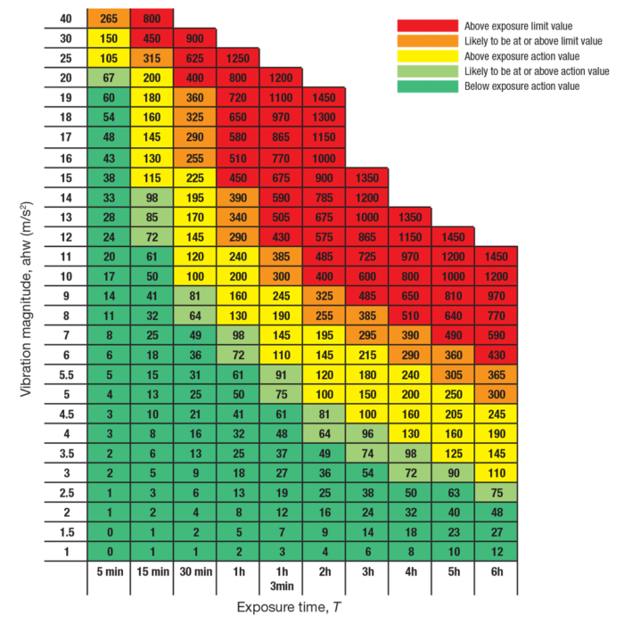

The machine has a vibration exposure of 2.13mms and therefore for time in use would need to exceed 6 hours at 1 time.
Machine used at site: Nano Edge ultimate oscillating floor scrubber
Chemicals used at site: Residue in flooring released during process
The above control measures are implemented within my unit. All relevant staff are aware of these control measures and this is recorded in the training record for this safety task card.

Unit Manager Name |  | Signed |  | Date

Safety Card Training Record
CLN 20 | Nano Edge Powerful Compact Floor Scrubber
I confirm that I fully understand the risks and control measures associated with the task
and that I will follow the Safe System of Work at all times.
Operative Name |  | Signature | Date

