Business Continuity Plan

ENTER CLIENT SITE
NAME AND ADDRESS

QUICK REFERENCE GUIDE
FIRST RESPONDER INCIDENT ASSESSMENT
- The nature of the incident?

- Location and geographical extent of the incident?

- Time incident commenced (if known)?

- Number of visitors & staff members affected?

- Any Injuries?

- Any Damage?

INITIAL ACTIONS

- Are Police, Fire, Ambulance required? if so call 999

- Evacuate where there is immediate danger to staff and visitors and proceed to your nearest Fire Assembly Point.

- Invoke the Incident Management Team Call Cascade.
ENSURE ALL INCIDENT MANAGEMENT TEAM MEMBERS HAVE PHONE NUMBERS STORED ON MOBILE

- Ensure all key clients key contacts a are informed.
ENTER CLIENT KEY CONTACTS

ENSURE ALL INCIDENT MANAGEMENT TEAM MEMBERS HAVE PHONE NUMBERS STORED ON MOBILE

- Identify urgent actions to maintain staff & visitor safety and to contain damage
- If access is denied to the main offices

Incident Management Team to assemble at the (Incident Management Team Centre)
ENTER LOCATION
- The dedicated Incident Management Team telephone conference number is:
ENTER NUMBER
- Compass Crisis Line
0800 011 4630

 | Table of Contents
1 | Introduction
2 | Objectives
3 | Plan Structure
4 | Incident Management Team
5 | Activation Procedures
6 | Crisis Management
7 | IMT Meeting Agenda
8 | Media
9 | Staff Welfare
10 | Resources
11 | Total Loss of kitchen facility (Temporary Kitchen)
12 | Total Loss of kitchen facility (Mutual Aid from other Compass Group Locations)
13 | Total Loss of kitchen facility (Spare capacity within other kitchens)
14 | Loss of Utilities
15 | Food Supply Chain
16 | Equipment/Repairs
17 | Document Owner and Approval
 | Appendix A Telephone Cascade
 | Appendix B Log of Events and Actions

1. Introduction
Business Continuity Management helps to plan for unforeseen circumstances and events which may disrupt or cease the services we provide at the CLIENT SITE NAME. The purpose of Business Continuity Management is to develop and maintain action plans in case these circumstances occur, to ensure we are always prepared and have the necessary equipment and resources available should and emergency or disruption occurs. Examples of disruptive events include:

Extreme weather e.g. flood/high winds

Loss of IT

Loss of utilities, electricity, gas, water

Loss of people

Loss of telecommunications

Industrial action

School/childcare closures

Transport disruption

Loss of access to site

Loss of key skills

Employee health & safety incident

Supply chain disruption

Our Business Continuity Plan is based upon the International Business Continuity Standard ISO22301:

2. Objectives

The BCM objectives are as follows:
- To ensure the safety and welfare of all employees and of any visitors who are at the CLIENT SITE NAME locations at the time of an incident
- To minimise the impact on the company of any interruption to normal activities, to an acceptable level.
- To contain any financial costs associated with interruptions or incidents to levels an acceptable level.
- To protect the company’s reputation as a reliable and resilient supplier of products and services, and to ensure that business following any interruption is not adversely affected by reduced levels of activity during an interruption
- To protect the company’s brand and image during and following any interruption, so that its ability to secure new business in the future is not prejudiced by the interruption or the response to it.
3. Plan Structure
This Tactical plan provides a coordinated response and specifies the key personnel, resources, services and actions required for effective recovery from an incident which is controlled by the Incident Management Team. At an Operational level each department has its own section, which contains the specific detail and processes required for recovery.

The plan integrates with the CLIENT SITE NAME Business Continuity Plan and also with the Compass Group Strategic Crisis Management Plan.

4. Site Incident Management Team

5. Activation Procedures

IMPORT NOTE. The CLIENT SITE NAME will have primacy in emergency response following an event which affects the affects the whole site.
In the assessment phase the first responder will use the quick reference guide to deal with:
- Safety and Evacuation
- Initial Assessment
- Notifications – Cascade

Once the Incident Management Leader (or Deputy) is notified, they will evaluate the incident. If the incident has been classified as a crisis (see next section) then the incident management team must call the Compass Crisis Line.
Compass Crisis Line: 0800 011 4630
The Central Compass Crisis Management team will then be mobilised to fully evaluate and respond to the crisis. Specialist support teams such as Communications, Legal and Foodbuy may be brought in to support the CMT along with the relevant operations director and sector management.
If the incident is a lower level incident that does not require central support from Compass Group then it can be dealt with by the onsite Incident Management Team.

6. Crisis Management
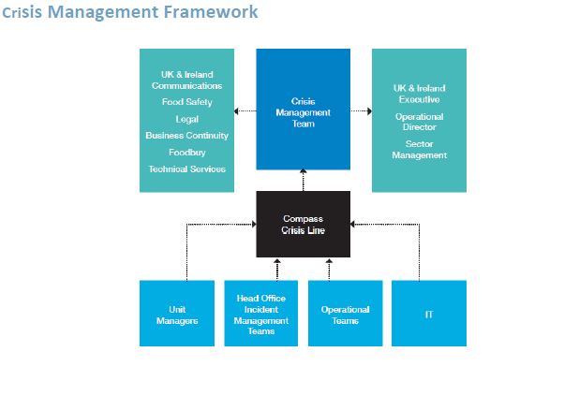Assessing the severity of the incident

Incidents are classified from level 0 to 4 and are graded according to complexity and impact. They are split into categories which cover all aspects of our central functions and business operations.

As you will see from the table below our crisis management procedures are formally activated when an incident is classified as level 2 (potential crisis) or above. The activation process starts with a call to the Crisis Line. The call can be made by a unit manager, head office team or operational team.

Level 0 | Incident is generally dealt with at a ‘business as usual’ managerial Level. Unit managers would refer to their Unit Managers Emergency Manual for the appropriate response and procedures.
Level 1 | Requires the support of the sector or regional management. They can be resolved without central support from the CMT.
Level 2 | Incident has reached potential crisis level and should be reported to the Crisis Line. The Crisis Line will instigate an Everbridge crisis communication to make the CMT aware. The situation will be closely monitored and consideration will be given to deploying central resources to support the response activity.
Level 3 | The situation has reached full crisis level. The Crisis Line will convene an immediate conference call with the CMT to fully evaluate and respond to the crisis. Specialist support teams such as Communications, Legal and Foodbuy may be brought in to support the CMT along with the relevant operations director and sector management.
Level 4 | The crisis is so severe that the CMT will deploy all necessary resources. This may mean suspending certain activities until the crisis has been resolved and the situation has stabilised.

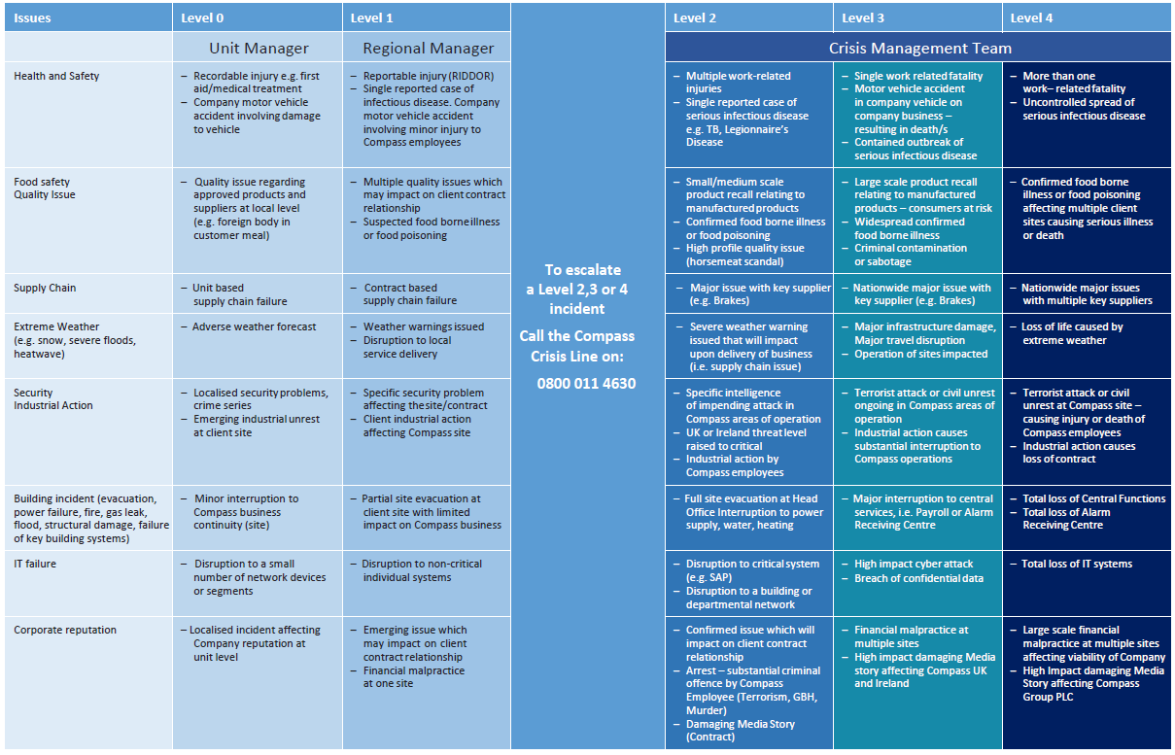
.

7. IMT Meeting Agenda
1. | Maintain Log of events and actions  Note it is essential that a comprehensive log of events and actions is kept so that all the issues and decisions are fully documented and justified. It also keeps track of outstanding actions for subsequent meetings.
2. | Brief team members of Incident:  - What/when/where  - Casualties/who/numbers involved  - Number of staff on site & location now.  - Extent of incident  - Damage Assessment  - Power Supply  - Water Supply  - Air-conditioning  - IT Network  - Telephones  - Building Infrastructure  - Site Access & Security
3. | Staff Welfare  - Locate & Support casualties at hospital  - Notify next of kin.  - Locate & Support other staff.  - Identify any immediate requirements i.e. travel, communication, food and drink, keys and belongings, safety & first aid, etc
4.. | Prepare Media briefing (Via Communications at Compass Group UK)  - Holding Statement for the media.  - Holding Statement for Key Customers & Stakeholders  - Remind all staff that all media communication should be channeled through the IMT.  - Engage with client on media communications
5. | Staff Briefing (Via Communications at Compass Group UK)  - Prepare and send regular updates for all staff.  - Ensure regular updates and consultation with client.
6. | Information Systems  Review availability of Critical Applications
7. | Client update and Emergency Services Liaison  Ensure that effective communication is maintained with client at all times and that an update is obtained on their emergency response and procedures.  .
8.. | Damage Limitation  Facilities to liaise with emergency services and building management for incident update  Identify urgent actions for damage limitation.  Salvage and Restoration
9. | Confirm time and location for next meeting.  Depending on the incident type, this should be within 1 hour of the end on the initial IMT meeting.
10. | Subsequent IMT meeting.  Review outstanding actions & repeat agenda.

8. Media
No member of staff is authorised to contact the media on any issue, or respond to any media call, without the knowledge and approval of the Communications Team and the client

Report all media enquiries to the communications team on 01895 554999

Internal Communications and Call cascade
All internal communications relating to the incident must be approved by the Incident Management Team and Communications Team (T 01895 554999)

Communications will send an overarching e-mail advising key stakeholders of the incident and temporary arrangements. Individual departments will this review this communication and consider supplementary communications to their own stakeholders if appropriate.

A list of emergency telephone numbers for all key staff must be maintained. Members of the IMT will keep up to date lists of key personnel and contacts for their areas of responsibility.

It is vital that these lists are accurately maintained and that the accuracy of the numbers frequently verified.

See Appendix A Call cascade and key contacts

9. Staff Welfare Plan
.
The Welfare Plan is coordinated by XXXXXXX on The Incident Management Team and is the focal point for Department Managers to report any staff welfare issues.

The Objectives of the Welfare Plan

- Locate & Support casualties at hospital

- Notify next of kin.

- Locate & Support other staff.

- Identify any immediate requirements i.e. travel, communication, food and drink, keys and belongings, safety & first aid, etc

10. Resources
.
Staff Shortages and resourcing issues
Dedicated relief team
INSERT DETAILS IF APPROPRIATE
MOVE RESOURCES FROM ONE KITCHEN TO ANOTHER WITHIN THE CONTRACT GIVING PRIORITY TO THE PRODUCTION KITCHENS
MUTUAL AID. RELEIF STAFF FROM THE CLIENT SITE NAME BROKKES CONTRACT??
Resource Network
Tel No: 0844 850 8000
Email: resourcenetworkuk@compass-group.co.uk

External Agency

INSERT DETAILS IF APPROPRIATE

11. Total Loss of kitchen facility (Temporary Kitchen)
.
Strategy Number 1 Provision of Temporary Kitchen.

In the event that there is a major incident such as a fire or flood resulting in the total loss of the kitchens at the main at Bradford Science Museum, then a portable temporary kitchen facility can be delivered to those locations.

The CLIENT SITE NAME insurers would have to be notified to recover the costs of this deployment. The provision of packed meals would have to be made whilst the temporary kitchen facility is established.

Compass Group work with PKL – the UK’s leading supplier of temporary kitchens and catering equipment for hire. They can supply the following units:
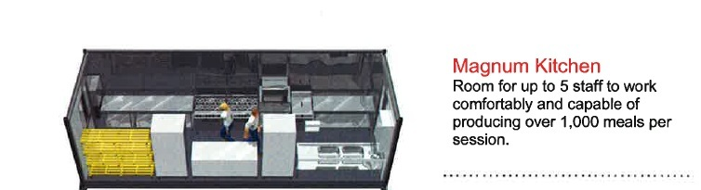

PKL operate a emergency response that operates 24 hours 7 days a week.

- Compass Vendor ID: 13716
- Tel: 0845 840 42 42
- email: postbox@pkl.co.uk
- Website: www.pkl.co.uk

Suggested location for temporary kitchen at Bradford

INSERT MAP OR ARIEL PHOTO OF TEMP KITCHEN LOCATION

12. Total Loss of kitchen facility (Mutual Aid from other Compass Locations in vicinity)
.

Explore the mechanics of reaching out to other Compass Locations in the vicinity

13. Total Loss of kitchen facility.(Spare capacity within hospitality kitchens)

.

Formalise a plan to switch production between production kitchen and other kitchens on site

14 Loss of Utilities

.

Enter Contact details

ELECTRICITY

GAS

MAINS WATER

15. Food Supply Chain
.
Buffer Supplies
The CLIENT SITE NAME always holds sufficient stocks of dry goods to last 15 days in Winter and 9 days in summer.

Brakes Emergency Supplies
In the event that further emergency supplies are required then contact should be made with Brakes who are the key suppliers from their CLIENT SITE NAME Depot.

- Operations Manager.
- Location
- Mobile number:,
- Depot Number

Brakes will be able to supply fast moving basic lines. They can deliver sufficient basic meals within 8 hours or the items can be collected from the Deport with 4 hours

Foodbuy Support Line
The Foodbuy Support team is here to help when you need to escalate a query regarding suppliers, products or services that's not been resolved in the first instance by the supplier or distributor.
Opening Times & Contact Details
Monday – Friday: 7am to 5pm
Contact Us
Tel: 0844 247 6000

16. EQUIPMENT/REPAIRS
.
ENTER CONTACT DETAILS FOR

- SMALL EQUIPMENT (REPLACEMENT/REPAIR)

- LARGE EQUIPMENT (REPLACEMENT/REPAIR

- DISPOSABLES

17. Document Owner and Approval

The Operations Director is the owner of this document and is responsible for ensuring that this procedure is reviewed in line with the requirements of The Compass Business Continuity Management Policy.

Quarterly Reviews of the Plan

Monthly Audit Staff Contact Information

Annual Test and Exercising

The current full version of this document is available to all Incident management Team members of staff.

There are 2 hard copies of the full version of the plan held by

Incident Management Team leader

Deputy Incident Management Leader

This document is approved by the Partnership Director on the issue date shown and is issued on a version controlled basis under their signature.

Signature: Date:

Change History Record
Issue | Description of Change | Approval | Date of Issue
1 | Review and update | M A Armstrong | 15/05/2023

Appendix A

Call Cascade and Key Contacts

Name | Role | Contact Information

Appendix B

Log of Events and Actions

Date | Time | Event | Action No.

