ES08 | First Aid Needs Assessment
Unit Address
Assessment Completed |  | Date | Signed
1st review |  | Date | Signed
2nd review |  | Date | Signed
3rd review |  | Date | Signed
Note - Assessments must be reviewed every 3 years, whenever there is a significant change in the activity, and following any incident involving the activity. Assessments must be retained for a period of 6 years.

The purpose of the first-aid needs assessment is to identify what first-aid facilities are required on site by considering the hazards that people may be exposed to and the possible injuries or ill health that may result.

Instructions on completing the First Aids Needs Assessment
- In Section 1 identify whether the work activities on site present a Low Hazard or Higher Hazard.
- In Section 2 determine the numbers and type of first aid personnel required.
- In Section 3 consider other factors relevant to first aid provision.
- In Section 4 identify and record whether first aid provision is the responsibility of the client or other building occupier.
- In Section 5 record the details of first aiders and training provision.

Section 1 – Site Hazard Level
Criteria | Tick  one only
Low risk
Does the workplace only have low-level hazards such as those that might be found in offices or retail outlets?
Higher risk
Does the workplace have higher-level risks such as catering operations, maintenance work, dangerous machinery, high level working at heights, construction work etc

Section 2 – Numbers and type of first aiders/equipment required
There are three different first aid roles that may ned to be identified:
- Appointed Person – a person responsible for taking charge of the first aid arrangements, maintain records, arrange training etc. This will typically be a Unit Manager.
- First Aider Emergency First Aid at Work (EFAW) – enables a first-aider to give emergency first aid to someone who is injured of becomes ill at work
- First Aider First Aid at Work (FAW) – in addition to EFAW a first-aider with additional training to apply first-aid to a wider range of injuries and illnesses
The exact numbers and types of first-aider for the workplace can be determined by referring to the flowchart below:
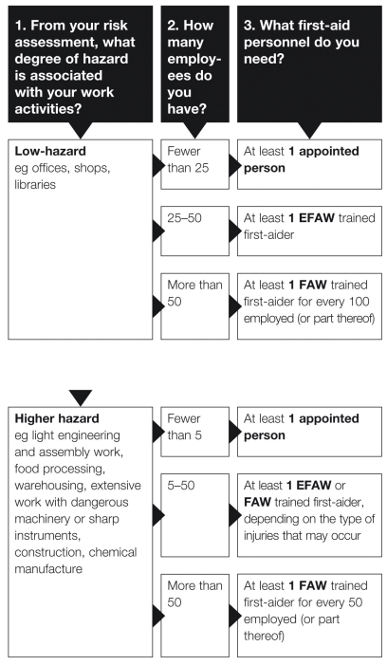

First-aid personnel | Required Y/N | Number needed
Appointed Person | Y
First-aider with EFAW
First-aider with FAW

First-aid equipment and facilities | Required Y/N | Number needed
Dust- and damp-proof first-aid container | Y
First-aid kit contents (see suggested contents list) | Y
Additional contents depending on risk e.g. foil blankets, eye wash bottles, shears, microporous tape, tourniquets, haemostatic dressings
Defibrillator (check client/building provision)
Travelling first-aid kit (for remote workers)
First-aid room (check client/building provision)
Suggested contents for standard first-aid kits,
- 20 individually wrapped sterile plasters (assorted sizes), blue catering type where used in food production and food service;
- two sterile eye pads;
- two individually wrapped triangular bandages, preferably sterile;
- six safety pins;
- two large, sterile, individually wrapped unmedicated wound dressings;
- six medium-sized sterile individually wrapped unmedicated wound dressings;
- at least three pairs of disposable gloves
Additional contents may be required for higher risk workplaces

Section 3 – Other factors
Matters to Consider | Y/N | Possible Management Action | Actions/Comments
Are there any specific injuries that may occur as a result of high-risk work activities (e.g. from hazardous substances, dangerous work equipment/tools, dangerous loads) that may require special first-aid equipment and facilities or first-aiders to undertake more specialised training? |  | If yes, identify the specific injuries and ensure that suitable first-aid equipment, facilities and training is provided.
Are there people with special needs e.g. the elderly, inexperienced employees, young persons, people with disabilities, etc? |  | If yes, consider any special needs when deciding what first-aid provision should be made
Where eye washing may be necessary, is clean potable water available? |  | If no, provide sterile water in suitable eye wash stations and ensure that arrangements for checking and renewal of eye wash bottles is adequate.

Matters to Consider | Y/N | Possible Management Action | Actions/Comments
Are Compass employees working in several locations on the site or on several floors within one building? |  | If yes, ensure that adequate first aiders (EFAW or FAW) and/or first-aid materials are provided in appropriate locations.
Is the unit remote from local medical, accident and emergency services? |  | If yes, consider training first aiders (EFAW or FAW) to cover all working hours.
Is there adequate first aid provision (appointed persons, EFAW or FAW) to cover absences due to sickness or holidays? |  | If no, ensure there are adequate numbers of first-aiders, (EFAW or FAW) to provide cover during absences/holidays.
Do employees work alone or travel extensively? |  | If yes, complete the Lone Workers Risk Assessment to identify requirement for personal or travelling first-aid kits

Section 4 – Client/Third Party Provision
Matters to Consider | Y/N | Possible Management Action | Actions/Comments
Is first aid provision the responsibility of the Client or other third party? | Y | Advise the client/third party in writing of the first aid needs identified in this assessment.  Obtain written confirmation from client/third party that their first provision includes the unit’s first aid needs.
 | N | Identify, appoint and provide appropriate training to first aiders (EFAW and FAW) in accordance with the needs identified in this assessment. Maintain records in Part 5.  Provide first aid equipment and facilities as identified in Part 2.

Section 5 - First Aider Appointment and Training Record
Name | Date of First Aid Certificate | Training Provider | EFAW or FAW | 1st Annual Refresher due by: | 2nd Annual Refresher due by: | Requalification  due by:

