Front of House Manager’s C&E Health and Safety
Briefing Pack

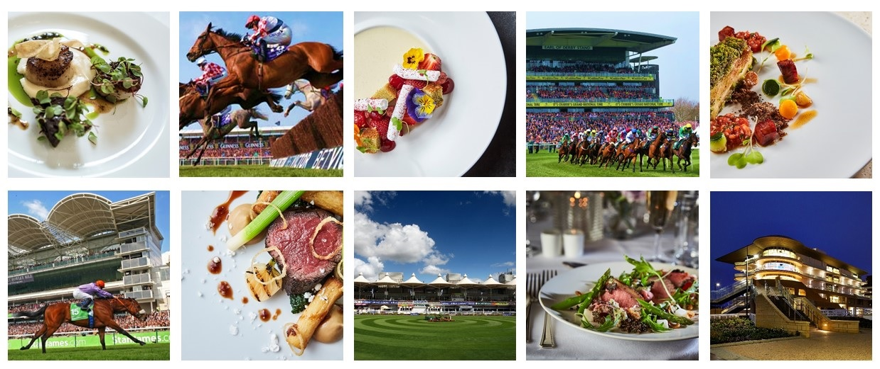

Unit Name:
Function Name:
Function Date:

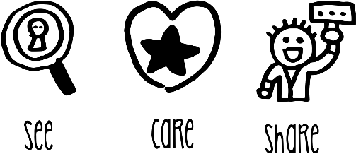

THIS PAGE IS LEFT INTENTIONALLY BLANK

 | SAFETY BRIEFING CHECKLIST
Please Note: This document should be amended to reflect actual practices and procedures at your site
Unit Name: |  | Date:
Function Name:
Briefing Information
- First Aid Arrangements | You must report any accident to your supervisor / manager.  First aid facilities are available in the kitchens (1st Aid Box)
- Fire and Emergency | Alarm sound is:  Exit by nearest fire exit. Assembly point is located at:
- Key Safety Behaviours | BE MINDFUL – Always think first before you carry out a task or activity - are there any risks or hazards and is it safe to carry on.
 | GET INVOLVED – Help your colleagues if they need it or if you see them in trouble.
 | SPEAK OUT – If you are unsure of anything ask your manager/ supervisor or if you see any unsafe environments or working activities then let them know.
- Personal Protective Equipment (PPE) | PPE such as waiters’ cloths, oven cloths, gloves and goggles, is provided to ensure risks to your safety are minimised. Ensure you use it.
- Manual Handling | Ensure any manual handling tasks are within your capabilities and if you need assistance, please ask a member of the team or your supervisor/manager. Always use lifting aids, such as trolleys, sack trucks and keg barrows, where provided.
- Slips, Trips and Falls | Ensure that any spillages are cleaned up immediately, keep walkways and working areas clear of obstructions, report any damaged floor surfaces to your supervisor/manager immediately and avoid running or rushing in your workplace.
- COSHH | You must not use any chemicals unless you have been trained to do so. Ensure you always follow instructions on the chemical safety task card.  Specific chemicals used on this site include Oasis Pro 20 or Aseptopol EL76 surface sanitiser (clear debris, spray surfaces, wipe down with clean paper towel, then re-spray and allow a 1-minute contact time before wiping off with a clean paper towel)
- Working with Equipment | Only use equipment and machinery that you have been trained to use. Never attempt to carry out any repairs or modifications to equipment.
- Burns and Scalds | Take particular care when working with hot materials and equipment and when carrying hot food and liquids. If you are using deep fat fryers, ensure you have been trained.
- Safety with Knives | Ensure the knives you use are sharp and in good condition. Store knives safely when not in use and always select the correct knife for the task. If in doubt, ask your supervisor / manager.
- Essentials of Hygiene and Rules of Safety | Ensure you read the “Essentials of Food Hygiene” and “Essentials of Safety and Hygiene” located within this pack prior to commencing work.
- Allergens | If a guest asks you about allergens within specific dish, provide them with a copy of the Allergy Information Folder and point out the allergy information sheet for that dish so they can make an informed choice, or alternatively direct them to the QR code or tablet where information is available electronically. If you are at all unsure, notify your Head Chef immediately.
- Violence at Work | If you feel threatened or intimidated at any time, or if you observe any aggressive or inappropriate behaviour, report this to your manager immediately and ensure you know how to raise the alarm.
- Infection Control | Follow good hand hygiene procedures and regularly wash your hands with soap and warm water. Report any suspected communicable illness, including COVID-19 and gastroenteritis to your manager.
- Additional Information

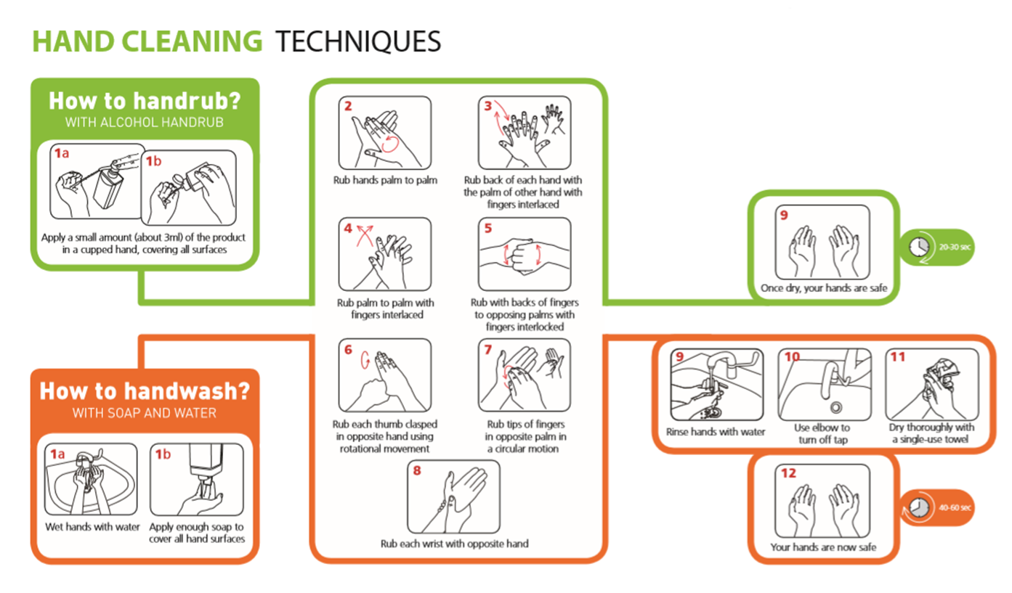
Infection Control

Personal infection control
- Good hand hygiene – Remember washing hands is more effective than using hand sanitiser – wash hands between tasks
- Cough & Sneezes
  - Cover mouth & nose with a disposable tissue
  - Promptly dispose of the tissue
  - Wash your hands
- Keep our workplace clean & tidy
- Sanitise work surfaces and hand contact surfaces regularly
- Regularly launder your work clothing / uniform and ensure it is clean each day

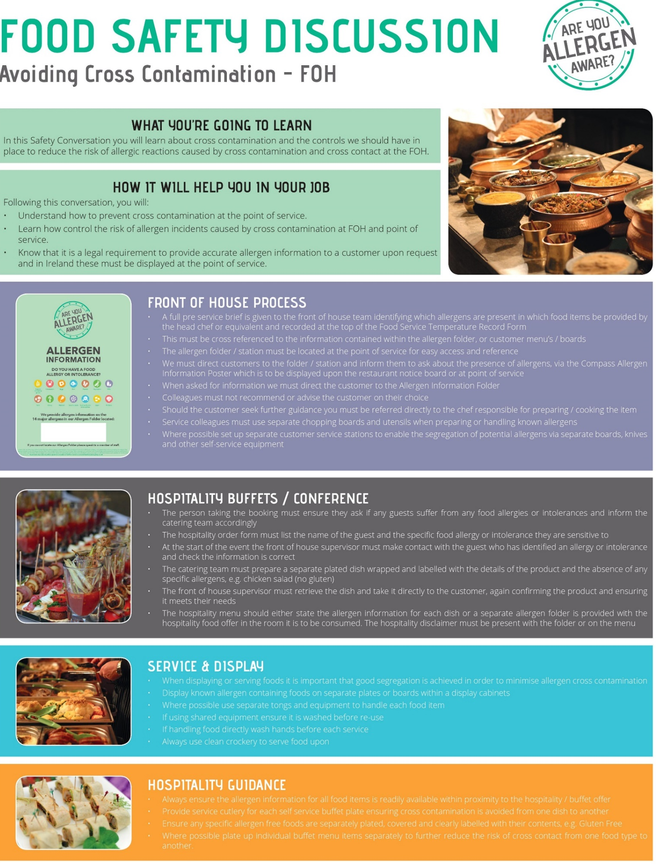

THE ESSENTIALS OF FOOD HYGIENE

FOOD HANDLER INDUCTION
SAFETY CONVERSATION
WHAT YOU MUST DO
Read the essentials of Food Hygiene to understand what is expected of you as a food handler.

You are breaking the law and in breach of company policy if you do not follow these rules.

Please ask your ask manager if you have any questions.
THE ESSENTIALS OF FOOD HYGIENE
Personal Hygiene

- Keep yourself clean and wear clean clothing.
- Tell your supervisor, before commencing work, of any skin, nose, throat, stomach or bowel trouble or infected wound.
- Ensure cuts and sores are covered with a waterproof, high visibility dressing such as a blue plaster.
- Always eat and drink away from a food room and never cough or sneeze over food.
- Follow the sites no smoking policy.
- Wash your hands thoroughly before handling ready to eat food, after using the toilet, after handling raw foods, after handling unwashed fruit and vegetables, after handling raw food packaging or waste, before starting work, after every break, after eating and after blowing your nose.
- Always consider the potential for cross contamination between raw meat, unwashed fruit and vegetables, their packing and ready-to-eat foods within the catering operation.
- Remember it only takes a few bacteria or viruses (germs) to make someone ill.
- Avoid unnecessary handling of food and use utensils where possible.

Safe Food Preparation

- Follow any food safety instruction provided on food packaging or given by your supervisor.
- Check deliveries for damaged packaging and leaked meat juices to ensure ready to eat foods have not become contaminated. Reject the delivery and tell your supervisor if you suspect contamination has occurred.
- Prepare food as close to service time as possible.
- Keep the handling, preparation, storage of raw meat, unwashed fruit and vegetables and ready to ready to eat food strictly separate. Follow the system at your site.
- Use separate complex equipment such as mincers, vac packers and slicers, for raw and ready to eat foods.
- Keep perishable food either refrigerated or piping hot.
- Always reheat food to ensure it gets piping hot.
- Make sure you know what to do if a customer asks you if a product contains something they are allergic to (Check with your manager for your unit procedure).

Cleaning and Sanitising

- Always clean as you go and only use the approved sanitisers.
- Use the 2-stage cleaning process to clean work surfaces, sinks and equipment after preparing raw foods and unwashed fruit and before preparing ready to eat foods.
- Follow the correct cleaning product instructions and where appropriate use the prescribed contact times.
- Wash food equipment used in the preparation of raw foods separately from equipment used to prepare ready to eat foods.
- Ensure food equipment and clean crockery cannot become contaminated from splashes during cleaning.
- Make sure cleaning equipment such as cloths used for raw food preparation areas are not used to clean ready to eat areas.

THE ESSENTIALS OF SAFETY & HYGIENE
BAR INDUCTION SAFETY CONVERSATION
WHAT YOU MUST DO
Read the essentials of Safety and Hygiene to understand what is expected of you as a bar worker.
You are breaking the law and in breach of company policy if you do not follow these rules.
Please ask your ask manager if you have any questions.
THE ESSENTIALS OF SAFETY AND HYGIENE
Personal Hygiene
- Wash your hands thoroughly before handling glasses, drink and food, after using the toilet, after handling waste, before starting work, after every break, after eating, smoking and blowing your nose.
- Tie long hair back.
Food Hygiene
- Drinks, bar fruit, ice etc are considered to be food and general food hygiene requirements apply when storing, handling and serving them.
- Make sure ice wells and ice buckets are clean and sanitised before filling them with ice.
- Don’t throw bags of ice on the floor to break the ice up.
- Always use scoops or tongs to serve ice and bar fruit and make sure that the utensils handles are kept away from the ice and fruit.
- If you are required to cut fruit, this must be done with a clean knife and on a clean chopping board.

Housekeeping
- Keep all walkways, including behind the bar and in cellars clear of obstructions to reduce the risk of trip injuries.
- Clean up spillages immediately, as any spillage creates a slip hazard.

Personal Protective Equipment (PPE)
- Always wear rigger gloves when changing or handling CO₂ cylinders and when moving kegs.
- If moving CO₂ cylinders is a significant part of your role you must wear reinforced toe capped shoes.
- You must wear reinforced toe capped shoes if moving kegs.

Manual Handling
- Apply manual handling techniques when lifting, lowering, carrying, pushing or pulling items.
- This includes using a mechanical aid wherever possible, working from a stable base, bending your knees when lifting or lowering, avoiding twisting or leaning, keeping your head up, knowing your limits, and pushing rather than pulling.
- When moving full kegs manual aids, such as trolleys, must be used.
- If it is necessary lift a keg to reposition it, this must be done by a team of two people.
  - Plan the movement together
  - Ensure weight is distributed evenly between the team
  - Communicate throughout the movement
- If you have to reposition a keg by yourself, do not attempt to lift it, but use the tilt and roll method.
- Ensure your manager is aware of any health problems, disabilities or pregnancy.

CO₂ Safety
- Only change CO₂ cylinders if you have been trained to do so.
- If you suspect a CO₂ leak report this to your manager immediately.

Safe Systems of Work – Front of House

Safety Risk | Hazard | Related Risk Assessments | Key Control Measures
Burns and Scalds | Hot Plates  Hot Liquids  Hot Kitchen Equipment | RA-CS  ES06 | - Always use waiters’ cloths when handling hot plates  - Do not overfill hot beverage jugs, flasks or cups  - When filling hot beverage jugs, flasks or cups always give it your full attention do not be distracted by others  - Be aware of your surroundings particularly in the kitchen where hot equipment is located
Cuts | Broken Glass and Crockery  Sharp Knives | RA-CS | - If you have to polish glasses, take extra care with wine glasses and hold the glass by the top of the stem at the point it connects to the bowl of the glass, do not exert excess pressure and always check glassware for cracks or chips before polishing  - If any glassware or crockery shows signs of damage, remove it from service and alert your supervisor  - When clearing broken glass and crockery, always use a dustpan and brush, never pick it up with your bare hands  - Always dispose of the breakages in a designated broken glass and crockery bin or wrap securely in cardboard before placing in general waste.  - If you have to cut fruit on bars, only use a small knife suitable for the task, and keep your fingers clear of the blade at all times
Slips, Trips and Falls | Wet Floors  Cables across walk ways  Objects stored in walk ways | RA-CS  ES03 | - Always ensure spillages are cleared up immediately  - Make use of wet floor signs and verbally warn others around if you spot a spillage  - Ensure trailing cables are secured to prevent trip hazards  - If you spot something blocking a route, remove it and relocate it to a safer position if you can, alternatively warn others and report to your supervisor
Manual Handling | Large items  Repetitive handling  Heavy crockery | ES04 | - Ensure that you do not lift or handle anything you do not feel comfortable or capable of doing  - Always use trolleys or other aids where available  - Always ask for assistance from a colleague  - Check the route you are taking before manual handling to ensure it is clear and free of hazards
Chemicals | Concentrated chemicals | ES05 | - Always wear googles and gloves when handling/ decanting or dispensing concentrated (non-diluted) chemicals  - Never spray chemicals in the direction of colleagues or guests  - Ensure you read the label on the chemical to understand what it should be used for
Electrical Safety  (Electric Shock and fire) | Electrical Equipment | RA-CS  ES07 | - Always ensure electrical equipment is switched off when not needed  - Always switch off equipment before cleaning it  - Never touch electrical equipment or sockets with wet hands  - Always conduct a visual check of equipment before use, check for;  • No obvious damage to the equipment and no loose or missing screws or other fixings  • No burn marks or staining on the wires or around the plugs and sockets  • No coloured wires are visible where the cable is fixed into the plug  • Cables are not damaged with cuts, abrasions or squashed/ trapped under or between heavy furniture or equipment or have tape covering damage and no bent pins of the plug  • Plug and socket have no signs of damage with cracked or broken casings  • All the wires are stored in such a way that they do not cause a trip hazard or can be pulled from the socket or equipment.  - Where equipment is damaged or defective it must be isolated and removed from use with an “Do not use” sign, until repaired by a competent person
HS/LEVY HSE/JAN 19
 | EMPLOYEE RECORD OF SAFETY BRIEFING
Please Note: This document should be amended to reflect actual practices and procedures at your site
Unit Name: |  |  | Date of Briefing:
Event Name: |  |  | Briefing Conducted By:
By signing below, I confirm that I have been briefed on health and safety information covering Fire & Emergency, Chemical Safety, Allergens, Infection Control, Cleaning and Sanitising Contact Times, Food Safety and Safe Systems of Work relevant to my role for this venue. I understand it is my responsibility to follow instructions, to work safely and only to do work that I have been trained to do or that I am being trained on or supervised whilst doing. I also understand that I should ask my manager or supervisor at any time if I am unsure of what to do.

I also confirm the following:
- that I have not been suffering from any sickness or diarrhoea in the last 48 hours
- that I have not had any symptoms of COVID-19 in the last 5 days
- that I am not currently experiencing any symptoms of COVID-19
COVID-19 symptoms include but are not limited to; a new and persistent cough, high temperature, loss of sense of taste or smell.
Name |  | Signature |  | Date

RECORD OF OPENING AND CLOSING CHECKS

Function Name: Function Date:

OPENING Checklist to be completed at start of shift |  |  |  |  | CLOSING Checklist to be completed end of shift
Opening checks | Date | Date | Date |  | Checks | Date | Date | Date
Is the area free of any evidence of pests? |  |  |  |  | Is all food stored correctly and within date?
Is the area clean and tidy and are all food preparation surfaces sanitised? |  |  |  |  | Is the area clean and tidy and are all food preparation surfaces sanitised?
Do you have a working probe and probe wipes? |  |  |  |  | Is all equipment switched off except for fridges and freezers?
Do you have sanitiser spray? (Ensure all staff are aware of the contact time: 1 minute) |  |  |  |  | Have all maintenance issues been reported to your manager or the maintenance team?
Do hand wash basins have hot and cold running water? |  |  |  |  | Has all waste been removed to the relevant waste areas?
Do hand wash basins have soap and paper towels? |  |  |  |  | Have all chemicals been stored away safely?
Do you have the relevant allergen information sheets?  (check with lead chef) |  |  |  |  | Have all food temperature records been completed for the day?
Is all equipment in good working order? |  |  |  |  | Corrective Actions or Comments to be recorded below:
Are your team in the correct uniform and supplied with relevant PPE as needed?
Are the relevant Fire Extinguishers available?
Are all fire exit routes and doors free from obstructions and are they accessible?

CHECKED BY: | DATE:
Manager to check the record form and sign before filing

