Front of House Manager’s Event Health and Safety Pack

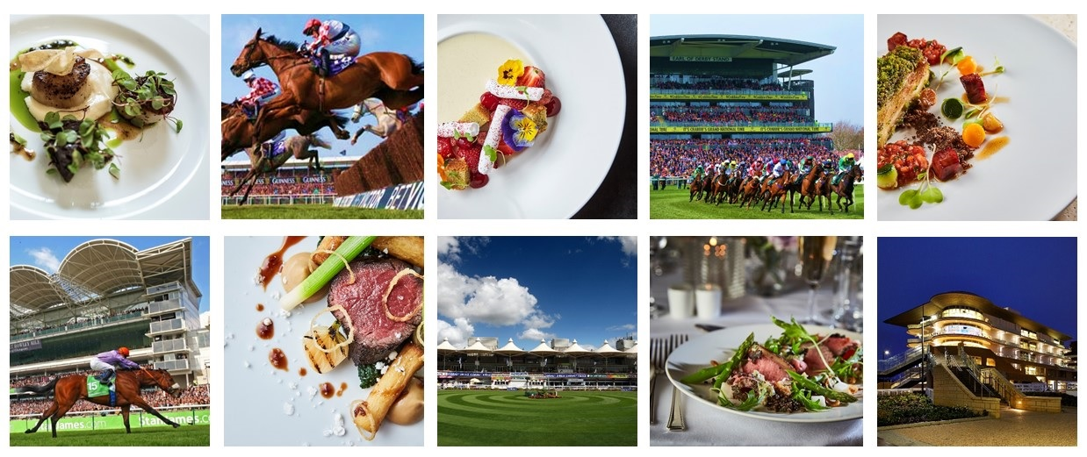
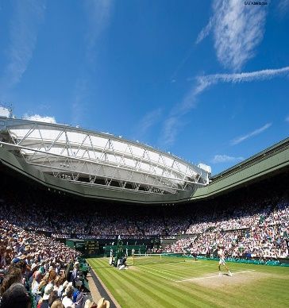

Unit Name:
Event Name:
Event Date:
Catering Location:

THIS PAGE IS LEFT INTENTIONALLY BLANK

Front of House Manager’s Event Pack
Contents and Instructions for Use
 |  | Document | Instructions | Page
1 |  | 1.01 Introduction |  | 4
2 | Health and Safety Arrangements | - Employees Conduct & Consultation |  | 5
 |  | - Fire Safety & Evacuation Procedure |  | 5
 |  | - Gas Safety |  | 5
 |  | - Beverage Gas Cylinders |  | 5
 |  | - Electrical Safety |  | 6
 |  | - Manual Handling |  | 6
 |  | - Personal Protective Equipment |  | 6
 |  | - Incident Reporting |  | 6
 |  | - Hazard and Near Miss Reporting |  | 7
 |  | - First Aid |  | 7
 |  | - Violence at Work |  | 7
 |  | - Risk Assessment and Safe Systems of Work |  | 8
 |  | - Control of Substances Hazardous to Health |  | 8
 |  | - Young Person Risk Assessments |  | 8
 |  | - Waste Disposal |  | 8
 |  | - Foreign Body Complaint Procedure |  | 9
 |  | - Allegations of Food Poisoning |  | 9
 |  | - Food Allergies |  | 9
 |  | - Responsible Service of Alcohol |  | 10
 |  | - Maintenance |  | 10
 |  | - Pest Control |  | 10
 |  | 2.20 Vehicle and Pedestrian Separation |  | 11
 |  | 2.21 Use of Company Vehicles |  | 11
 |  | 2.22 Forklifts |  | 11
 |  | 2.23 Noise |  | 12
3 | Information Purposes | Safe Use of Fire Extinguishers | Use for briefing the team | 13
 |  | Fridge and Freezer Breakdown Procedure | For information | 14
 |  | Event HACCP Summary | Details key controls for Food Safety | 15
 |  | Cleaning Schedule | Provides guidance on cleaning | 16
4 | Checks | H&S Event Checklist | Complete prior to event | 17-18
 |  | Opening and Closing Checks | Complete daily | 19
5 | Staff Briefing Pack | Briefing Checklist | Tailor and use to brief team | 20
 |  | Briefing Documents: Infection Control, Food Safety Discussion: Allergens, Essentials of Food Safety, Essentials of Safety and Hygiene, Safe Systems of Work | Use to brief team | 21-25
 |  | Employee Briefing Record | All staff to sign after briefing | 26
6 | Feedback | Shortages List and Repairs Log | To record shortages and/or equipment faults. | 27
 |  | Event De-Brief Record | Manager to complete with feedback from the event | 28

- INTRODUCTION

This HSE Event Reference Pack has been specially developed to assist Compass Event Management teams in the safe running of our functions. The overall Compass Health and Safety operating standards are detailed in our main company Workplace Safety Management System (WSMS) which is available in the Catering Office and on the Compass HSE Website.
This manual is a shortened version of the WSMS, containing a summary of the essential information that Event Managers will need. In addition to this manual, you will need a FOH Event Manager’s Records Pack, which needs to be completed and returned to the Catering Office at the end of the function.
It is your responsibility as a manager to ensure that all employees receive a safety briefing as well as relevant instruction on dangerous equipment and work practices. This pack gives you what you need to operate safely.
Ensure that you give each member of your team a Safety Induction covering all aspects of their role, using the information provided in Section 3 of this pack and in the separately provided Event Briefing Pack. Please ensure every employee signs off the briefing record.
The other key responsibility you need to fulfil is a health and safety check of your area before and after service, using the Opening and Closing Checklist contained in this pack. This is a methodical way for to you check your area for any hazards and the checklist also acts as a reminder to ensure that all key tasks are undertaken.
Don’t be frightened of showing this pack to local Environmental Health Officers and/or Fire Officers, as it demonstrates due diligence. Conformance with the standards outlined in this pack will ensure compliance with national legislation.

- HEALTH & SAFETY ARRANGEMENTS

2.01 EMPLOYEES CONDUCT AND CONSULTATION
Employees must be reminded of their own moral and legal responsibility to conduct themselves in such a manner in their work, as not to expose themselves or others to risk. To this end, this Manager’s EVENT Pack is a document that should be read by at least all managers and the contents communicated to the employees under their control.
All employees must be taken through the Safety Induction Pack that is provided in this pack, and both the employees and the manager must sign the Employee Record of Safety Briefing to confirm the briefing has taken place. All signed briefing records must be returned to the Staffing Team at the end of the function.
It is recognised that full and frank employee involvement is essential in improving Health & Safety. For this purpose, the HSE Team is available to discuss any grievances or identified hazards, and to ensure that all steps are taken to ensure employee safety and welfare.
Employees are actively encouraged to carry out hazard spot checks and to bring any problems found to the attention of the person responsible. The limited time scale of the event makes the holding of safety committees impractical, but safety issues are discussed daily at the management review.
2.02 FIRE SAFETY & EVACUATION PROCEDURE
It is the Event Manager’s responsibility to either obtain the fire safety procedures for the event from the overall event organisers or, if the event is run entirely by Compass, to ensure that fire procedures are drawn up and that the fire procedures are communicated to employees.
Employees must be directed to study the fire precaution notices posted at their place of work and have regard to the information given during induction briefing training. They must learn the location of fire alarms, fire escapes, firefighting equipment and assembly points.
Managers must ensure that there are adequate numbers of fire extinguishers in their units and that employees are instructed that any fire extinguishers which are missing or empty must be reported to the Event Manager.
Employees should be instructed to never tamper with, move or misuse a fire extinguisher and not to wedge open any fire door and to never lock or obstruct a fire exit.
2.03 GAS SAFETY
Due to the temporary nature of many of the outdoor events we are providing hospitality at we are reliant on portable energy sources. Please be extra careful when using gas and do not touch anything that you and are not trained to. Do not move or alter the location of any gas supplied equipment. If there is a need to move equipment, please contact the Event Manager or Event Control Office. Maintenance work on gas should only be carried out by approved contractors who are registered through the Gas Safe Registration Scheme. Do not change LPG cylinders unless you have been trained to do so.

2.04 BEVERAGE GAS CYLINDERS
Gas cylinders are heavy, even when empty and must be secured to prevent them from falling or rolling, can potentially causing injury. When upright ensure the bottom of the cylinder is flat against a solid surface and chained or clamped to a stable structure. Where cylinders are stored on horizontally on the ground, they must be chocked to prevent rolling.
Ensure that suitable securing points are provided at temporary bars.
CO2 can cause asphyxiation. It is odourless and a leak may not be detected straight away. CO2 is heavier than air and if there is a leak the CO2 will gradually displace the air at the bottom of a cellar. Frost on the outside of the cylinders or valves may be an indicator of a leak. If this occurs, turn of the cylinder, ventilate the area immediately and report the issue.
All cellars should have a CO2 monitor. Where there is no monitor the cellar door should be left open when staff are in the cellar and lone working should not be permitted.

2.05 ELECTRICAL SAFETY
Compass recognises the potentially fatal hazards associated with electricity and the need to take appropriate preventative precautions.
All employees must ensure that electrical faults and hazards are immediately reported to their manager/supervisors who must report the hazard to the Event Manager immediately. Employees should not alter the layout of their units without permission from the Event Manager. Moving equipment without permission, you may cause a serious safety hazard.
If a faulty piece of equipment is identified it must not be used under any circumstances and, if possible (without risk to personal safety), it should be isolated from the mains supply. The equipment should be labelled ‘Do Not Use’ and if there is any likelihood of the equipment being reconnected by mistake, the plug should be removed.
All portable electrical equipment supplied will have undergone regular testing and every portable electrical appliance should have a sticker showing its PAT status.
No person is to attempt to repair any faulty electrical appliances or carry out any electrical work without being ‘competent’.
2.06 MANUAL HANDLING
Measures have been taken to limit the opportunities for injury as a result of manual handling. It is however, not possible to eliminate all manual handling risks, especially within catering areas where the jobs involve constantly handling objects.
Managers must not ask their employees to do too much and must also be aware of the ‘enthusiasm’ of employees – stress to employees that if they do not think they can manage a task safely, they must ask for help.
2.07 PERSONAL PROTECTIVE EQUIPMENT (PPE)
It is essential that staff members are provided with the correct PPE to complete certain tasks safely. This includes rigger gloves and reinforced toe capped safety shoes for manual handling activities, goggles and nitrile gloves when handling chemicals, and waiters’ gloves to protect from hot surfaces etc.
Ensure that staff wear the PPE they have been issued with and understand that it is their responsibility to use PPE and report any damage or loss to their manager.
2.08 INCIDENT REPORTING
All incidents, however minor, to employees, customers and contractors must be recorded. It is the responsibility of the Event Manager to ensure that every accident is logged on the Compass Online Incident Reporting System (AIR3)
An Incident Investigation Pack can be obtained from the Catering Office and must be completed for all accidents on site. Completed Incident Investigation Packs must be returned to the Catering Office.
In the case of any serious accident, dangerous occurrence (i.e. gas incident or fire) or an act of violence against employees the Event Manager MUST request assistance with the investigation and reporting procedures by immediately contacting the:
- Catering Office or
- HSE Department on 0121 457 5194
The details of all accidents must be logged on the Compass Online Incident Reporting System AIR3.

2.09 HAZARD and NEAR MISS REPORTING
Reporting hazards and near misses helps prevent incidents from happening. If you identify a hazard and can safely remove it, please do so. To report a hazard that you can’t remove or to report a near miss just scam the below QR code and complete the form to ensure that the Event Manager is made aware and appropriate action can be taken.

2.10 FIRST AID
There should be adequate First Aid provisions at every location. Signage should be displayed informing employees where the First Aid kit is located. Additional first aid information is available on the Health and Safety Posters.
2.11 VIOLENCE IN THE WORKPLACE
Any form of violence, including verbal abuse, bullying and violence towards our staff are unacceptable. Action must be taken where any inappropriate behaviour by customers to staff members or by a staff member to another is observed or reported. Encourage staff to report concerns to you and how to behave when they experience this kind of behaviour.
Aggressive, Rude or Violent Customers
- Watch out for early signs of aggressive behaviour.
- Try to stay calm, keeping control of your tone of voice and being careful with the words you use - it is usually best to say nothing and not engage.
- If possible, defuse the situation by changing the subject or walking away.
- Create a physical barrier between yourself and the individual to reduce the risk of physical harm; this could be a table, bar or service counter.
- Report all incidents to the event manager regardless of how minor the situation might appear.
Unacceptable Behaviour from Colleagues
Unfortunately, staff members can be subjected to unacceptable behaviour, including verbal abuse, bullying, exclusion sexual harassment, physical assaults and violence by their colleagues. Whilst this is rare in our workplaces it is important that all team members know what to do and how to report this behaviour:
- Any such behaviour must be reported to either the event manager or staffing team immediately.
- If team members are uncomfortable or unable to report these situations to the management within their unit then this should be reported via Compass Speak Up by either calling 0800 041 8157 or visiting www.letintegritybeyourguide.com/speakup.

2.12 RISK ASSESSMENT and SAFE SYSTEMS OF WORK
Compass has carried out risk assessments for reasonably foreseeable hazards. These are available from the Catering Office if required.
The key controls and safe systems of work from these risk assessments which are appropriate to your individual area need to be communicated to all employees under your control as part of their safety briefing. This is covered in Section 3 of this document and the separate EVENT Briefing Pack.
Managers are also required to carry out a local risk assessment of their units using the Managers HSE Checklist contained in the Event Briefing Pack. The findings of the assessments must be reported to the Event Manager who will take the appropriate action to eliminate or control any identified hazards.
The Event Manager and the Health and Safety Managers will also carry out periodic safety walks during the event.
Employees must be encouraged to report hazards when they occur, and managers must ensure any hazards reported or concerns raised are dealt with in a timely manner to ensure the safety of all persons on site.
2.13 CONTROL OF SUBSTANCES HAZARDOUS TO HEALTH (COSHH)
Compass recognises its responsibility regarding hazardous substances and the need to ensure all chemicals used on site have been assessed to ensure they are appropriate to the task for which they are intended and that they are the safest available product. The Company will also ensure that where an element of risk is present a set of measures have been taken to control that risk.
Employees should be briefed on any hazards associated with cleaning chemicals
The Event Manager has ensured that all chemicals provided by Compass have been assessed in line with the COSHH Product Assessments and that Task Cards for these chemicals are available. The information on the COSHH Product Assessments and Task Cards are designed to make employees aware of:
- What products to use
- How to use them safely
- The First Aid requirements should an incident occur
COSHH information is available in the Catering Office and Task Cards are available throughout the site and on the Compass HSE website.
2.14 YOUNG PERSONS ASSESSMENT
Where the Company employs young persons (under 18) a risk assessment must be carried out in order to ensure that any risks to those young persons are identified and addressed.
If you are made aware that one of your employees is under the age of 18, then you are required to carry out additional training with the young person. You should receive copies of the Risk Assessment Training Record – Young Persons for any employees under the age of 18 working with you. If you do not have enough copies, you should contact the Catering Office immediately. All completed copies of the Young Person’s Risk Assessment Record must be returned to the Staffing Team.
2.15 WASTE DISPOSAL
Adequate facilities for waste disposal must be provided and waste must regularly be removed from kitchens and other catering areas. No waste products should be disposed of anywhere other than in approved areas.
The Event Manager will ensure all waste bins are collected by the event waste contractors. The Event Manager will ensure the waste contractors provide the company with the appropriate Waste Transfer Notes as required by environmental legislation.
All waste should be separated in the bins provided for food waste, glass, mixed recyclables and general waste in-line with Compass’ Climate Net Zero Toolkit.

2.16 FOREIGN BODY COMPLAINT PROCEDURE
If a complaint of foreign material in food is received, the following action must be taken IMMEDIATELY:
- If possible, retain the foreign body and assure the customer that a full investigation into the incident will be carried out. Take the customer’s name, address and a contact telephone number.
- Inform the Event Manager.
- Obtain all packaging or transport containers used for the meal prior to the incident and retain until contacted.
- Get the Head Chef to detail the procedures involved in the production of the meal and establish if there is any way the contaminant could have got into the food whilst in your area.
- Complete the Alleged Foreign Body Form which is available in the Catering Office or on the Compass HSE website
- Return the completed form to the Event Manager so that the incident can be logged on the Online Incident Reporting System AIR3.
2.17 ALLEGATIONS OF FOOD POISIONING
Should anyone complain that food consumed during the function has caused illness, the following course of action must be taken IMMEDIATELY:
- Inform the Event Manager and Head Chef.
- Liaise with the person affected or the person who reported the incident to assure them a thorough investigation into the incident will be carried out.
- Complete the Alleged Food Poisoning Form, which is available in the Catering Office or on the Compass HSE Website.
- Return the completed form to the Event Manager so that it can be logged on the Online Incident Reporting System AIR3.
- Retain any implicated food. Keep samples in a sealed, sterile container, in a refrigerator or a deep freezer. Clearly mark the container “LAB SAMPLE – DO NOT DESTORY”. Additionally, label the sample with the following information: function name, food item, date and time.
- Retrieve packet labels and any date codes. Establish the time of delivery of the food to the event and then to the area, its initial storage temperatures, the method of preparation and service. Try to build a temperature control audit chain for the product using the temperature records.
- Full and accurate temperature records from food delivery and storage through cooking to service are vital to the investigation. Without full and comprehensive records, we cannot show ‘due diligence’.
- A Compass Health and Safety Manager will complete a thorough investigation.
2.18 FOOD ALLERGIES
The Food Information Regulations (FIR) require all food suppliers, including caterers, to be able to provide accurate information to customers on the food they are serving and must provide information on any of the 14 common allergens present in their food.
Managers must ensure that the allergen information for all food they are providing is available in their area. This should be made easily accessible for customers so that they can make an informed decision on what foods to eat. Managers should also ensure all team members have been briefed on the Allergen Safety Conversation in the Event Briefing Pack.
If you suspect a customer is suffering from an allergic reaction the following action must be taken IMMEDIATELY:
- Call 999 or the appointed first aider immediately to take charge of the situation.
- The Unit Manager must be informed immediately.
- Enquire (if possible) whether the customer has any self-medication and help them administer it.
- Do not move the customer and ensure someone stays with them at all times.
- If possible, obtain the following information:
- The customer’s name and contact details
- Their specific allergy or intolerance
- Details of the food consumed
- The amount they have eaten
- Whether the customer enquired about the presence of allergens before they ordered/purchased it.
- Complete the Alleged Food Allergen Form, which is available from the Catering Office or from the Compass HSE Website.
- Return the completed form to the Catering Manager so that it can be logged on the Online Incident Reporting System AIR3.
- Retain any implicated food. Keep samples in a sealed, sterile container, in a refrigerator or a deep freezer. Clearly mark the container “LAB SAMPLE – DO NOT DESTORY”. Additionally, label the sample with the following information: function name, food item, date and time.
- Retrieve packet labels and any date codes. Establish the time of delivery of the food to the event and then to the unit, the method of preparation and service.
The Unit Manager must contact a Compass Health and Safety Manager, who will complete a thorough investigation.
2.19 RESPONSIBLE SERVICE OF ALCOHOL
Levy UK recognises its responsibility to provide an enjoyable and safe environment for all of its guests. We operate a challenge 25 policy, and we have a 4-drink limit per transaction per ID in place at this venue.
As part of our activities, we must promote the four licensing objectives:
1. Prevention of crime & disorder
2. Public safety
3. Prevention of public nuisance
4. Protection of children from harm
You are, as part of your match day briefing, required to confirm and acknowledge you and your team full understanding of the Responsible Service of Alcohol. All staff members must be briefed and included in the Responsible Service of Alcohol training. All staff members under the age of 18 must notify the team leader and complete the relevant section of the Responsible Service of Alcohol form.
2.20 MAINTENANCE
Good maintenance is essential to allow effective cleaning, to avoid foreign body contamination and to help prevent pest infestations. If you see any damage or a defect, report it to your Event Manager at once.
Do not allow visiting maintenance people to place their equipment on work surfaces and tables. Do not allow them to sit or stand on tables or preparation surfaces. Any maintenance carried out during operational status should be segregated off and barriers put in place to separate the area.
Make sure that areas where maintenance has been carried out are thoroughly cleaned before any food handling takes place. This is especially important if any glass has been broken or there are any small bits and pieces resulting from the work such as bits of electrical wiring, small screws, nails etc.
2.21 PEST CONTROL
Report any sightings of vermin or insects to the Event Manager immediately.
Always cover food and put it away. Do not leave refuse, especially wet waste, lying around or uncovered. External skips, dustbins and other rubbish containers must be kept covered at all times.
Remove refuse from food handling areas without delay. Bag all rubbish securely and take it to the refuse compound.

2.22 VEHICLE & PEDESTRIAN SEPARATION
Events usually involve large numbers of deliveries or movement of articles around a site as well as a large number of people. Often the site will not have well defined areas in which pedestrians should walk and vehicles should not enter, and vice versa.
Think carefully about how you can practically reduce the risk of pedestrians colliding with vehicles in your area. For example:
- Get deliveries made at quiet times
- Restrict pedestrian access to loading / unloading areas
- Always assist reversing vehicles by standing to the driver’s side and helping them manoeuvre (do not stand behind the reversing vehicle)
2.23 USE OF COMPANY VEHICLES (cars, vans and light goods vehicles)
At some events the company will provide vehicles for moving goods and equipment around the site. In this instance anyone who is designated to use the vehicles should complete a Driving Whilst on Company Business Risk Assessment Form if the vehicle is to be used on a public highway. This can be obtained from the Event Office.
Ensure that pre-use checks are carried out on vehicles using the Vehicle Safety Checklist which is also available from the Event Office.
Anyone who is required to use a light utility vehicle such as a golf buggy or similar, should sign off on the OP07 Use of Light Utility Vehicles Safe Risk Assessment before operating a vehicle. They must hold a valid full UK driving licence and be over the age of 21.
2.24 FORKLIFTS
Forklift trucks (FLTs) are used at many of our events. It is important that all forklift truck operations are managed safely at events.
FLTs should only be operated by trained employees who have been trained to the required standard to operate these competently. The training received should be to an accredited standard which is generally recognised within industry. Currently there are five such accredited bodies recognised by the Health and Safety Executive (HSE) for FLT training in the UK:
- Association of Industrial Truck Trainers (AITT)
- Construction Industry Training Board (CITB)
- Lantra National Training Organisation Ltd
- National Plant Operators Registration Scheme Ltd
- RTITB Ltd (formerly the Road Transport Industry Training Board)
Upon successful completion of a theory and practical assessment an Authorised User License will be awarded. This will identify the class of FLT the license holder is authorised to operate. Refresher training should be carried out on a 3-yearly basis.
FLT drivers must all sign off on the OP08 Forklift Trucks Risk Assessment.
Pre-Event Checklist: A pre-event Forklift Truck Audit should be carried out prior to the initial use of any FLT at an event. This will consider location of use, who will be using the FLTs and what can be done to ensure operations are kept as safe as practicable. This checklist is available from the Event Office.
Pre-Use Checks: Each operator should undertake a daily visual inspection of the vehicle before it is put into operation. A full checklist can be obtained from the Event Office, and this must be completed daily for each Forklift Truck.
Any deficiencies must be reported to the Event Manager so that appropriate action can be taken to rectify the issues raised.
When FLTs are not in use, they should be parked in a safe area with the forks lowered. The keys should be removed to prevent unauthorized use. On gas powered FLTs the gas should be turned off.

2.25 NOISE
Some events can be ‘noisy’, particularly if there is continuous amplified noise from music systems, but also as a result of crowds cheering or use of generators. The Control of Noise at Work Regulations require employers to prevent or reduce risks to health and safety from exposure to noise at work.
Employees have duties under the Regulations, too. If you feel there is an issue with noise in your working environment, then you should inform your manager.
A good test to test if there may be a noise issue is as follows:
Stand approximately 2 meters apart from a colleague and try to have a conversation; if you need to raise your voice to make yourself heard or have difficulty hearing the whole conversation then you may have a noise issue.
The Regulations set out action values, which state what actions must be taken when the noise reaches a certain level. These are as follows:

Action level | Action value | Action to be taken
Below Lower Exposure Action Value | Daily or weekly exposure less than 80 dB(A)  Peak sound pressure less than 135 dB(C) | - Record the findings of the assessment and inform employees of the level of risk  - Consider low cost noise reduction measures
Lower Exposure Action Values | Daily or weekly exposure of 80 dB(A)  Peak sound pressure of 135 dB(C) | - Record the findings of the assessment and inform employees of the level of risk  - Ensure suitable hearing protection is available and inform employees  - Provide hearing protection to staff who ask for it  - Consider noise control measures
Upper Exposure Action Values | Daily or weekly exposure of 85 dB(A)  Peak sound pressure of 137 dB(C) | - Record the findings of the assessment and inform employees of the level of risk  - Prepare an Action Plan, i.e. a programme of noise control measures, including dealing with immediate risks.  - Identify hearing protection zones, i.e. where the use of hearing protection is compulsory, and mark the zones with appropriate signs  - Provide suitable hearing protection and ensure employees wear them when noise exposure exceeds the Upper Exposure Value  - Provide employees with training and information on how to use and care for hearing protectors  - Ensure that hearing protectors are properly used and maintained  - Provide health surveillance (hearing checks) if required
Maximum Exposure Values | Daily or weekly exposure above  87 dB(A)  Peak sound pressure above 140 dB(C) | As in Upper Exposure Action Values above; and  - Take all necessary actions to ensure employees are not exposed to noise exposure above these levels  - Provide health surveillance (hearing checks) to anyone who has been regularly exposed to noise above these levels

 |  | Safe Use of Fire Extinguishers
When attempting to deal with a fire, the correct type of fire extinguisher, as specified below, should be used
Personal safety should be observed at all times whilst attempting to extinguish a fire.
- Ensure the alarm has been raised
- Always ensure the main electric/gas supply has been isolated before attempting to extinguish the fire
- Make sure all employees and customers are evacuated from the immediate area
- When attempting to extinguish the fire ensure you have a clear escape route behind you whilst fighting the fire in front of you
- Only use one extinguisher; if once the extinguisher has depleted the fire is not extinguished evacuate the area and wait for the fire brigade
TYPES OF EXTINGUISHERS AVAILABLE
CO₂ (Black Label)

For electrical fires.
Ensure that you direct the black nozzle towards the direction of the base of the fire prior to deploying the CO₂.
DO NOT TOUCH ANY PART OF THE BLACK NOZZLE.
HIGH PRESSURE EXTINGUISHER – DO NOT spray at lightweight materials such as paper or dustbins.

FOAM (Cream Label)

For combustibles or burning liquids.
Spray over the top of the fire in order to lay a blanket of foam over the combustible or burning liquid.
DO NOT point into the fire.
Always isolate the power source (electricity/gas) before use.

DRY POWDER (Blue Label)

Safe for use on all fires except Class F fires (those involving cooking oils and fats, such as deep fat fryers).
This extinguisher should not be used in confined spaces.

WET CHEMICAL (Yellow Label)

The specialist wet chemical extinguishers are ideal for Class F fires involving cooking oils and fats, such as deep fat fryers.
Apply the wet chemical using the extended applicator in slow circular movements, which give a gentle, yet highly effective application. Apply the fine spray onto the burning fat until the surface of the burning cooking oil changes into a soapy like substance, this prevents re-ignition. The gentle application helps prevent hot oil splashing onto the user.

FIRE BLANKETS

To be used to smother small fires. (DO NOT attempt to use on deep fat fryers, please use the WET CHEMICAL Extinguisher for this purpose)
Can be used to save a person whose clothes have caught fire, always force them to the ground and then roll them in the blanket using the “Stop, Drop and Roll” technique. You will not be able to make effective use of the blanket while they remain on their feet, and the burns will be much worse to the upper body and head.

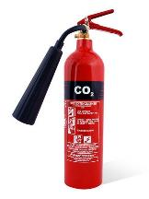 | 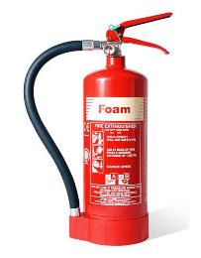 |  | 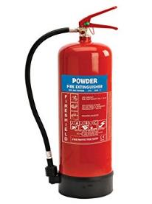 | 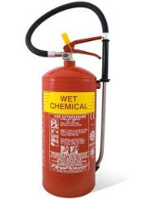 | 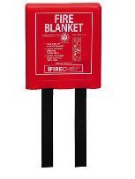

 | REFRIGERATOR OR FREEZER BREAKDOWN
IMPORTANT
Do not overload refrigerators with transferred food and be very careful to maintain separation between raw and ready-to-eat food items. Airflow inside the refrigerator is very important to its efficiency.
IMMEDIATE ACTION
When a refrigerator or freezer breaks down due to mechanical or power failure, follow the steps below:
- Contact the client, the maintenance contractor or the refrigeration engineer to arrange repair
- Record the details on the unit Record of Repair and Maintenance
- Record the breakdown on the unit Refrigerator/Freezer Temperature Record
ACTIONS - REFRIGERATOR BREAKDOWN
Discovered within four hours:
- Check the temperature of a representative sample of items using a probe thermometer.
- Check food from all areas of the refrigerator i.e. top, middle and bottom shelves.
If the food temperature is… |  |  | then…
+8°C or cooler |  |  | transfer the food to an alternative refrigerator.
above +8°C |  |  | for cooked or high-risk food:  - use immediately, or  - transfer to an alternative refrigerator and serve from there  - do not place on ambient display  for raw food:  - transfer the food to an alternative refrigerator
ACTIONS - REFRIGERATOR BREAKDOWN
Time of breakdown not known or more than four hours before time of discovery:
- Check the temperature of a representative sample of food items using a probe thermometer.
- Check food from all areas of the refrigerator i.e. top, middle and bottom shelves.
If the food temperature is… |  |  | then…
+8°C or cooler |  |  | transfer the food to an alternative refrigerator.
above +8°C |  |  | for cooked or high-risk food:  - discard  for raw food:  - assess the quality  - if acceptable, cook thoroughly  - use immediately, or cool rapidly and store in a refrigerator
ACTIONS - FREEZER BREAKDOWN
Check the condition of the food. Do not leave lids or doors open for prolonged periods of time. Provided the freezer lid or door is kept closed, food may stay frozen for up to 24 hours.
If the food temperature is… |  | then…
still frozen |  | transfer food to an alternative freezer as quickly as possible
defrosted, but below +8°C |  | for cooked or high-risk food:  - complete thawing  - use immediately or transfer to refrigerator and use within 72 hours  - follow manufacturer's instructions if shelf life is less than 72 hours, for example: "use within 24 hours of thawing".  for raw food:  - complete thawing  - cook thoroughly and use immediately, or cook and cool rapidly then store in refrigerator for up to 72 hours
above +8°C |  | for cooked or high-risk food:  - discard  for raw food:  - assess the quality  - if acceptable, cook thoroughly  - use immediately, or cool rapidly and store in a refrigerator for up to 72 hours

FOOD SAFETY MANAGEMENT - HACCP SUMMARY
PROCESS STEP | HAZARD | CONTROLS | MONITORING | CORRECTIVE ACTIONS
CHILLED FOOD STORAGE | Microbiological – inherent contamination, bacterial growth, cross-contamination  Physical contamination  Chemical contamination | Food stored at 5°C or below  Raw and cooked food kept separate  Food covered and labelled  Stock rotation – food used within shelf life dates:  - Sandwiches/rolls – day of production plus 1 day  - Unit prepared food – 72 hours  - Opened product – manufacturer instructions or 72hrs  Use a dedicated probe thermometer when checking the temperature of storage areas | Check and record refrigerated food temperatures twice daily using a food simulant  Visually check and record refrigerator food storage daily | Follow procedure for refrigerator breakdown  Reject any foods with expired shelf life
FOOD PREPARATION | Microbiological – bacterial growth, cross-contamination  Physical contamination  Chemical contamination | Observe personal hygiene standards  Hand washing  Sanitise equipment and surfaces  Separate raw and cooked preparation  Avoid holding foods at ambient temperature for long periods | Supervise preparation procedures  Adhere to cleaning schedules | Revise cleaning and food handling practices as required
COOKING | Microbiological – bacterial survival,  Physical contamination  Chemical contamination | Core temperature of at least 75°C must be achieved  Sanitise the probe thermometer before and after each use | Ensure food temperatures are checked and recorded on completion of cooking  Whole meat cuts such as steaks and some fish such as salmon, may be cooked to less than 75°C; this must be recorded on the temperature record | Continue cooking until 75°C is attained
HOT HOLDING & SERVICE | Microbiological – bacterial growth, cross contamination  Physical contamination  Chemical contamination | Display/serve hot food at 63°C or above  Protect food on display from contamination risk  Use within 2 hours if no hot holding  Provide appropriate clean serving utensils | Check and record hot holding and service temperatures of food at commencement and during hot holding/display  Visually check and supervise food service standards | Hot food at less than 63°C for more than 2 hours must be discarded
COLD FOOD SERVICE | Microbiological – bacterial growth, cross contamination  Physical contamination  Chemical contamination | Display/serve cold food at 8°C or less  Protect food on display from contamination risk  Use within 4 hours if above 8°C  Provide appropriate clean serving utensils | Check and record cold food service temperatures of food at commencement and during display  Visually check and supervise food service standards | Cold food at above 8°C for more than 4 hours must be discarded
IMPORTANT: Always report repair and maintenance issues immediately

NOTE: Full HACCP is held in the Head Chef’s office. The Compass Food Safety Management System, including A to Z guidance can be accessed on the Compass HSE website.

CLEANING SCHEDULE
ITEM | PRODUCT | PPE REQUIRED | DOSE RATE | METHOD *
Floors | Multi EL10 | Nitrile/Latex-free Gloves EN374* | 2 x 20ml pumps per 5l of warm water | Sweep up debris. Apply hot solution using clean mop or long handle scrubber, paying attention to floor/wall joint, around equipment, under and behind equipment. Rinse and mop over with fresh clean water. Allow to air dry.
Work Surfaces | Oasis Pro20 or Aseptopol | Nitrile/Latex-free Gloves EN374* | 20ml via dispenser per 600ml trigger spray | Remove debris. Apply sanitiser solution with a cloth or hand sprayer. Ensure that attention is given to legs and under edges. Wipe and then re-apply sanitiser and allow a 5-minute contact time. Wipe and Rinse and allow to air dry or dry with paper towels.
Refrigerators / Freezers | Oasis Pro20 or Aseptopol | Nitrile/Latex-free Gloves EN374* | 20ml via dispenser per 600ml trigger spray | Check and organise fridges daily. Check for spillages and wipe up [spillages should be wiped up immediately].
Hot Food Display Equipment | Oasis Pro20 or Aseptopol | Nitrile/Latex-free Gloves EN374 | 20ml via dispenser per 600ml trigger spray | After use - switch off power supply and allow to cool. Remove containers and transfer to pan wash. Wash down all surfaces and rinse. Remove deposits from door runners with a stiff brush. Brush floor under appliance and clean up spillages.
Temperature Probes | Oasis Pro20, Aseptopol or Probe Wipes | Nitrile/Latex-free Gloves EN374* | 20ml via dispenser per 600ml trigger spray | Remove debris. Apply solution with a cloth or hand sprayer. Ensure that attention is given to the entire length of the probe needle, reapply solution and allow a 1-minute contact time. Rinse and allow to air dry or dry with paper towels.
Sinks and Wash Hand Basins | Oasis Pro 20 or Aseptopol | Nitrile/Latex-free Gloves EN374* | 20ml via dispenser per 600ml trigger spray | Clean with the general-purpose detergent. Remove any tide marks from the bowl and drainer with a scouring pad or cloth. Include taps, waste outlets and splash-backs in cleaning record. Rinse thoroughly with cold water. Apply sanitiser to all surfaces and leave to air dry. Ensure sufficient supply of towels and soap are maintained at the wash hand basin.
Equipment Racks and Shelving | Oasis Pro20 or Aseptopol | Nitrile/Latex-free Gloves EN374* | 20ml via dispenser per 600ml trigger spray | Remove stock and utensils/equipment from shelves and racking. Sweep debris off surfaces and sweep floor under. Clean with solution, rinse and allow to air dry. Replace stock and utensils/equipment. Ensure equipment is placed inverted as far as practicable.
Waste Bins | Multi EL10 | Nitrile/Latex-free Gloves EN374* | 2 x 20ml pumps per 5l of warm water | Empty bins frequently throughout the day. Do not allow contents to overflow. Wash out empty bin or bin liner holder with solution. Clean external casing and the lid, paying attention to underside of lid and the handle [if fitted]. Rinse and allow to air dry.

SAFETY PRECAUTIONS
- Before cleaning electrical machinery ensure it is switched off and isolated from the mains.
- Before cleaning gas appliances ensure they are turned off. Take care when cleaning hot items.
- Follow all safety precautions shown in COSHH Product Task Cards for the cleaning product being used and ensure you wear the correct PPE when handling concentrated chemicals.
FOH Managers HSE EvENT Checklist
- Please work your way through this checklist prior to the first day of an event.
- Some questions can only be completed after your initial staff briefing.
- Ensure that any action required is reported to the relevant person and sign when the actions are completed.
- Keep this checklist as a reminder during the event and hand to the event manager at the end.
AREA:…………………………………………………………………….. DATE:…………………………..
MANAGER:……………………………………………………………... TIME:…………………………..
Tentage/Structure | Yes/No | Comments/ Action Required | Reported To | Completed
- Is flooring level and safe without obvious slip or tripping hazards?

- Are all access and exit points clear of obstructions?

Work Practices | Yes/No | Comments/ Action Required | Reported To | Completed
- Have all employees been instructed in the use of dangerous equipment in line with the safe system of work information?
- Have employees been made aware of manual handling procedures and displayed lifting safely diagrams?
- Are the Food Safety/ Health and Safety posters displayed?
- Has a Health and Safety Briefing been given and have all colleagues signed the Briefing Sheet?
- Are employees wearing suitable footwear? (Shoe should fully cover the foot, have a low heel and slip resistant sole)
Liquefied Petroleum Gas (LPG) – if applicable | Yes/No or N/A | Comments/ Action Required | Reported To | Completed
- Have all employees been made aware of the risks associated with LPG and what to do in an emergency: no smoking near cylinders, keeping gas cylinders free of combustibles, knowing the location of emergency isolation valve and how to isolate the gas, how to raise the alarm?
Chemical Safety | Yes/No | Comments/ Action Required | Reported To | Completed
- Have all employees been given a basic induction on chemical safety?
- Check that all hand spray bottles have the correct identification label on them and are used only for the correct purposes.

FOH MANAGERS HSE EVENT CHECKLIST
Electrical Safety | Yes/No | Comments/ Action Required | Reported To | Completed
- Are there any visible defects on equipment, cables, plugs or sockets?
Fire Safety | Yes/No | Comments/ Action Required | Reported To | Completed
- Are escape routes from your unit clearly marked with green and white fire escape signage?
- Are escape doors/corridors unobstructed and unlocked?
- Are the relevant fire extinguishers available?
- Do employees know how to raise the fire alarm, where exit routes are and where to assemble in the event of an emergency?
General Provisions | Yes/No | Comments/ Action Required | Reported To | Completed
- Have you checked the Allergen Information is relevant to your menu and that allergens match the recipe specifications?
- Do you have a first aid kit?
- Do employees know where their nearest first aid point is?
- Are wash hand basins supplied with antibacterial hand soap and paper towels?
- Do all sinks have a supply of hot and cold running water?
- Have the employees been instructed where to go for toilet, rest, smoking and meal breaks?
- Have you got a bin for broken crockery?
- Are wet floor signs available?

ANY OTHER COMMENTS (Include any comments on the design and layout for future events)

RECORD OF OPENING AND CLOSING CHECKS

Event Name: Area Name:

OPENING Checklist to be completed at start of shift |  |  |  |  |  | CLOSING Checklist to be completed end of shift
Opening checks | Date | Date | Date | Date |  | Checks | Date | Date | Date | Date
Is the area free of any evidence of pests? |  |  |  |  |  | Is all food stored correctly and within date?
Is the area clean and tidy and are all food contact surfaces sanitised? |  |  |  |  |  | Is the area clean and tidy and are all food contact surfaces sanitised?
Do you have a working probe and probe wipes? |  |  |  |  |  | Is all equipment switched off except for fridges and freezers?
Do you have sanitiser spray? (Ensure all staff are aware of the contact time: 1 minute) |  |  |  |  |  | Have all maintenance issues been reported to your manager or the maintenance team?
Do hand wash basins have hot and cold running water? |  |  |  |  |  | Has all waste been removed to the relevant waste areas?
Do hand wash basins have soap and paper towels? |  |  |  |  |  | Have all chemicals been stored away safely?
Do you have the relevant allergen information sheets?  (check with the lead chef) |  |  |  |  |  | Have all food temperature records been completed for the day?
Is all equipment in good working order? |  |  |  |  |  | Corrective Actions or Comments to be recorded below:
Are your team in the correct uniform and supplied with relevant PPE as needed?
Are all fire exit routes and doors free from obstructions and are they accessible?
Have any new staff been fully briefed?

CHECKED BY: | DATE:
Manager to check the record form and sign before filing

 | SAFETY BRIEFING CHECKLIST
Please Note: This document should be amended to reflect actual practices and procedures at your site
Unit Name: |  | Date:
Function Name:
Briefing Information
- First Aid Arrangements | You must report any accident to your supervisor / manager.  First aid facilities are available in the kitchens (1st Aid Box) Event First Aid Locations: see Site Map or Handbook
- Fire and Emergency | Alarm sound is:  Exit by nearest fire exit. Assembly point is located at:
- Key Safety Behaviours | BE MINDFUL – Always think first before you carry out a task or activity - are there any risks or hazards and is it safe to carry on.
 | GET INVOLVED – Help your colleagues if they need it or if you see them in trouble.
 | SPEAK OUT – If you are unsure of anything ask your manager/ supervisor or if you see any unsafe environments or working activities then let them know.
- Personal Protective Equipment (PPE) | PPE such as waiters’ cloths, oven cloths, gloves and goggles, is provided to ensure risks to your safety are minimised. Ensure you use it.
- Manual Handling | Ensure any manual handling tasks are within your capabilities and if you need assistance, please ask a member of the team or your supervisor/manager. Always use lifting aids, such as trolleys, sack trucks and keg barrows, where provided.
- Slips, Trips and Falls | Ensure that any spillages are cleaned up immediately, keep walkways and working areas clear of obstructions, report any damaged floor surfaces to your supervisor/manager immediately and avoid running or rushing in your workplace.
- COSHH | You must not use any chemicals unless you have been trained to do so. Ensure you always follow instructions on the chemical safety task card.  Specific chemicals used on this site include Oasis Pro 20 or Aseptopol EL76 surface sanitiser (clear debris, spray surfaces, wipe down with clean paper towel, then re-spray and allow a 1-minute contact time before wiping off with a clean paper towel)
- Working with Equipment | Only use equipment and machinery that you have been trained to use. Never attempt to carry out any repairs or modifications to equipment.
- Burns and Scalds | Take particular care when working with hot materials and equipment and when carrying hot food and liquids. If you are using deep fat fryers, ensure you have been trained.
- Safety with Knives | Ensure the knives you use are sharp and in good condition. Store knives safely when not in use and always select the correct knife for the task. If in doubt, ask your supervisor / manager.
- Essentials of Hygiene and Rules of Safety | Ensure you read the “Essentials of Food Hygiene” and “Rules of Safety” located within this pack prior to commencing work.
- Allergens | If a guest asks you about allergens within specific dish, provide them with a copy of the Allergy Information Folder and point out the allergy information sheet for that dish so they can make an informed choice, or alternatively direct them to the QR code or tablet where information is available electronically. If you are at all unsure, notify your Head Chef immediately.
- Violence at Work | If you feel threatened or intimidated at any time, or if you observe any aggressive or inappropriate behaviour, report this to your manager immediately and ensure you know how to raise the alarm.
- Infection Control | Follow good hand hygiene procedures and regularly wash your hands with soap and warm water. Report any suspected communicable illness, including COVID-19 and gastroenteritis to your manager.
- Additional Information

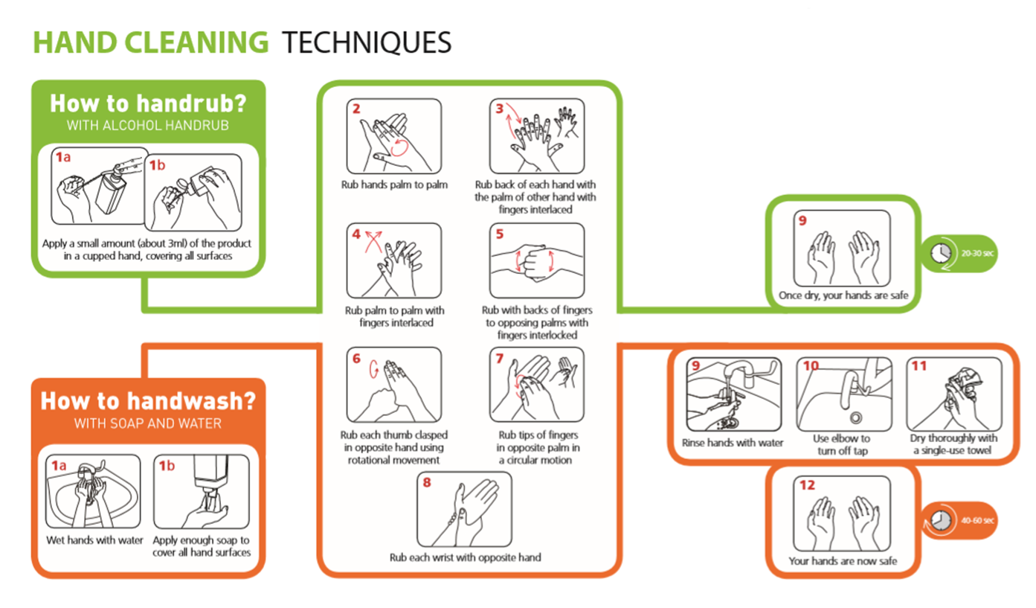
Infection Control

Personal infection control
- Good hand hygiene – Remember washing hands is more effective than using hand sanitiser – wash hands between tasks
- Cough & Sneezes
  - Cover mouth & nose with a disposable tissue
  - Promptly dispose of the tissue
  - Wash your hands
- Keep our workplace clean & tidy
- Sanitise work surfaces and hand contact surfaces regularly
- Regularly launder your work clothing / uniform and ensure it is clean each day

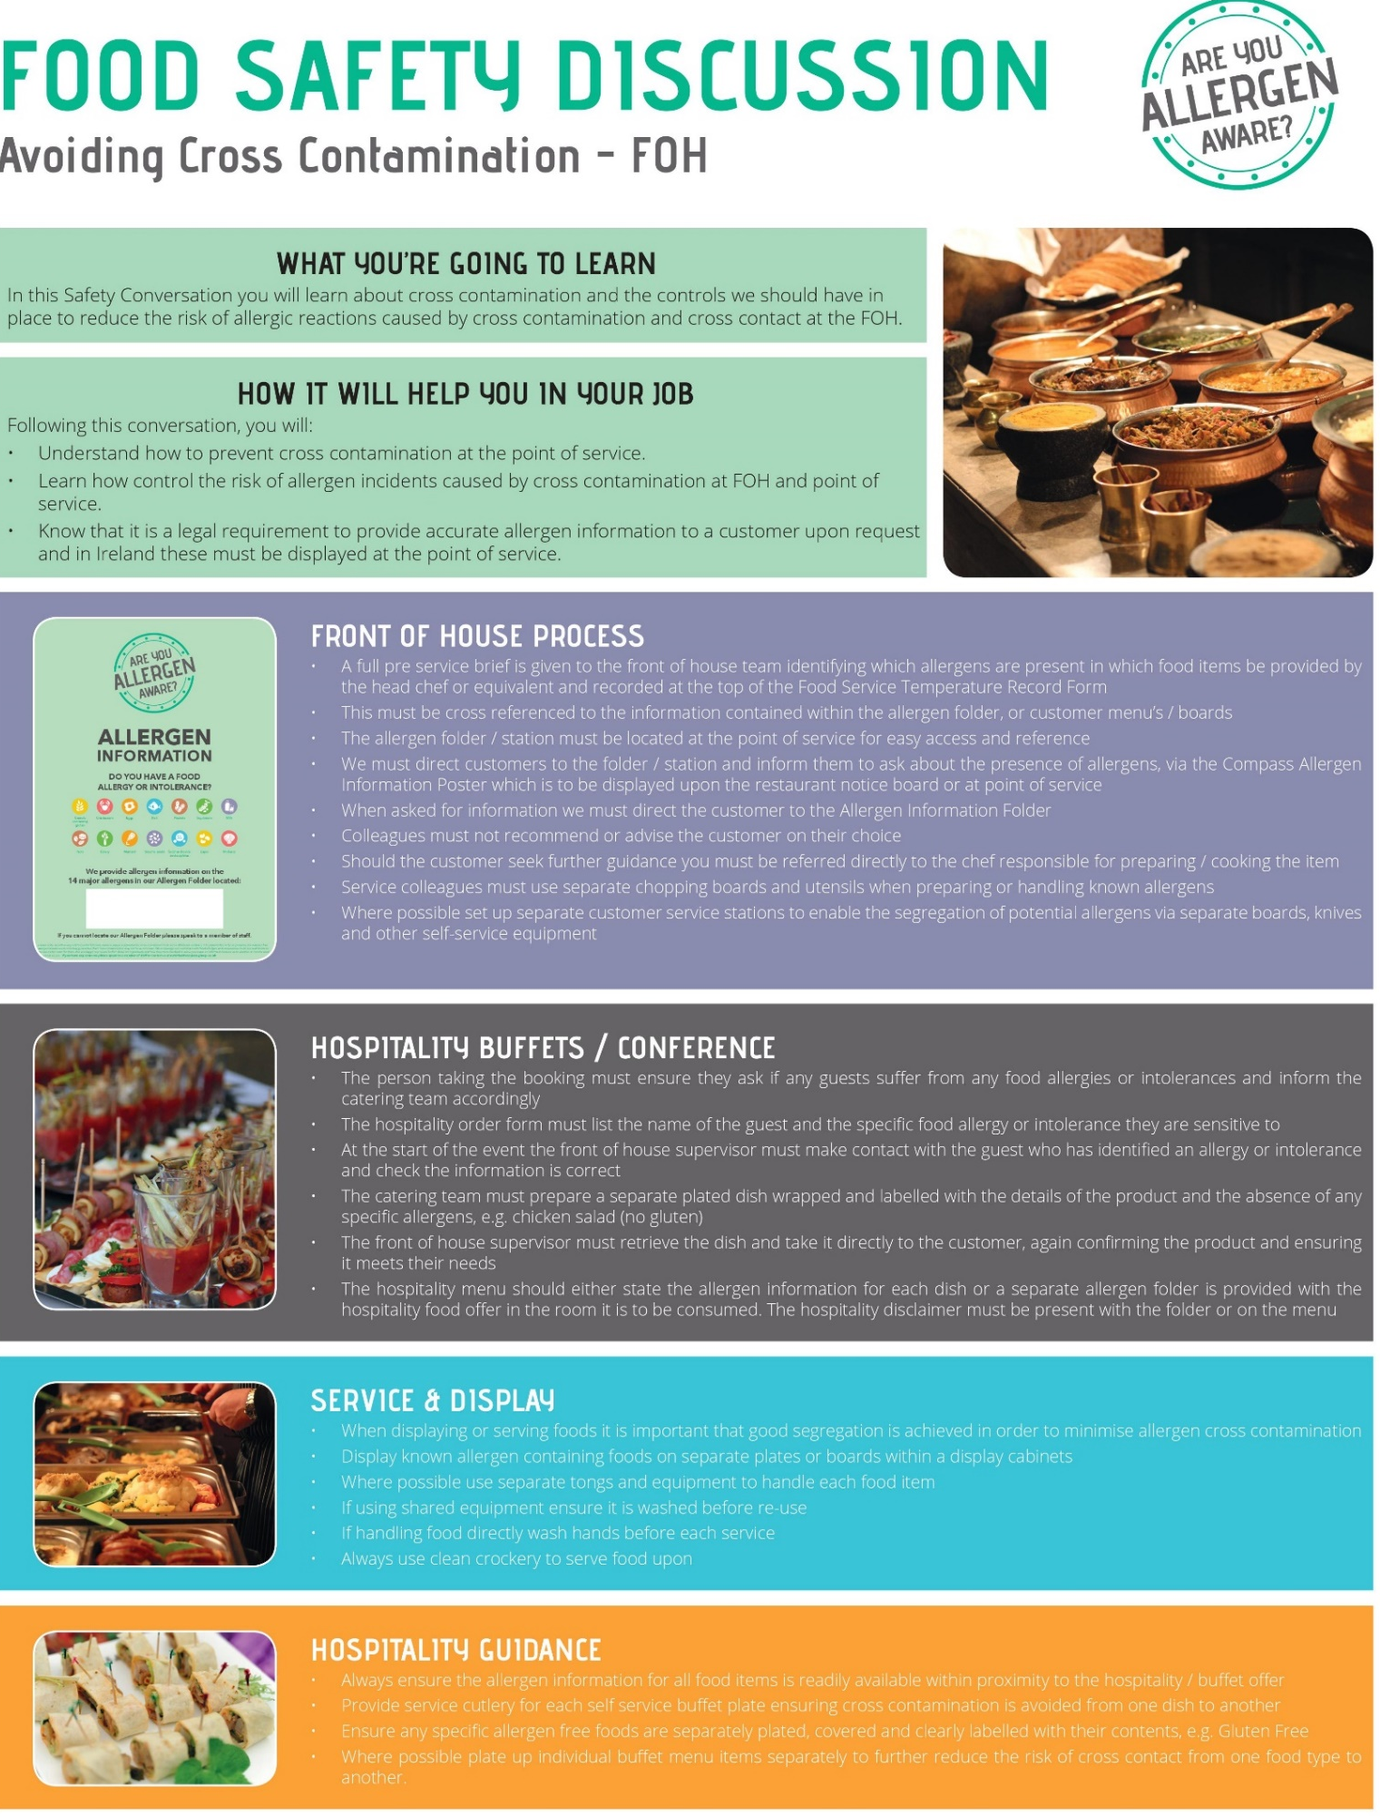
THE ESSENTIALS OF FOOD HYGIENE

FOOD HANDLER INDUCTION
SAFETY CONVERSATION
WHAT YOU MUST DO
Read the essentials of Food Hygiene to understand what is expected of you as a food handler.

You are breaking the law and in breach of company policy if you do not follow these rules.

Please ask your ask manager if you have any questions.
THE ESSENTIALS OF FOOD HYGIENE
Personal Hygiene

- Keep yourself clean and wear clean clothing.
- Tell your supervisor, before commencing work, of any skin, nose, throat, stomach or bowel trouble or infected wound.
- Ensure cuts and sores are covered with a waterproof, high visibility dressing such as a blue plaster.
- Always eat and drink away from a food room and never cough or sneeze over food.
- Follow the sites no smoking policy.
- Wash your hands thoroughly before handling ready to eat food, after using the toilet, after handling raw foods, after handling unwashed fruit and vegetables, after handling raw food packaging or waste, before starting work, after every break, after eating and after blowing your nose.
- Always consider the potential for cross contamination between raw meat, unwashed fruit and vegetables, their packing and ready-to-eat foods within the catering operation.
- Remember it only takes a few bacteria or viruses (germs) to make someone ill.
- Avoid unnecessary handling of food and use utensils where possible.

Safe Food Preparation

- Follow any food safety instruction provided on food packaging or given by your supervisor.
- Check deliveries for damaged packaging and leaked meat juices to ensure ready to eat foods have not become contaminated. Reject the delivery and tell your supervisor if you suspect contamination has occurred.
- Prepare food as close to service time as possible.
- Keep the handling, preparation, storage of raw meat, unwashed fruit and vegetables and ready to ready to eat food strictly separate. Follow the system at your site.
- Use separate complex equipment such as mincers, vac packers and slicers, for raw and ready to eat foods.
- Keep perishable food either refrigerated or piping hot.
- Always reheat food to ensure it gets piping hot.
- Make sure you know what to do if a customer asks you if a product contains something they are allergic to (Check with your manager for your unit procedure).

Cleaning and Sanitising

- Always clean as you go and only use the approved sanitisers.
- Use the 2-stage cleaning process to clean work surfaces, sinks and equipment after preparing raw foods and unwashed fruit and before preparing ready to eat foods.
- Follow the correct cleaning product instructions and where appropriate use the prescribed contact times.
- Wash food equipment used in the preparation of raw foods separately from equipment used to prepare ready to eat foods.
- Ensure food equipment and clean crockery cannot become contaminated from splashes during cleaning.
- Make sure cleaning equipment such as cloths used for raw food preparation areas are not used to clean ready to eat areas.

THE ESSENTIALS OF SAFETY & HYGIENE
BAR INDUCTION SAFETY CONVERSATION
WHAT YOU MUST DO
Read the essentials of Safety and Hygiene to understand what is expected of you as a bar worker.
You are breaking the law and in breach of company policy if you do not follow these rules.
Please ask your ask manager if you have any questions.
THE ESSENTIALS OF SAFETY AND HYGIENE
Personal Hygiene
- Wash your hands thoroughly before handling glasses, drink and food, after using the toilet, after handling waste, before starting work, after every break, after eating, smoking and blowing your nose.
- Tie long hair back.
Food Hygiene
- Drinks, bar fruit, ice etc are considered to be food and general food hygiene requirements apply when storing, handling and serving them.
- Make sure ice wells and ice buckets are clean and sanitised before filling them with ice.
- Don’t throw bags of ice on the floor to break the ice up.
- Always use scoops or tongs to serve ice and bar fruit and make sure that the utensils handles are kept away from the ice and fruit.
- If you are required to cut fruit, this must be done with a clean knife and on a clean chopping board.

Housekeeping
- Keep all walkways, including behind the bar and in cellars clear of obstructions to reduce the risk of trip injuries.
- Clean up spillages immediately, as any spillage creates a slip hazard.

Personal Protective Equipment (PPE)
- Always wear rigger gloves when changing or handling CO₂ cylinders and when moving kegs.
- If moving CO₂ cylinders is a significant part of your role you must wear reinforced toe capped shoes.
- You must wear reinforced toe capped shoes if moving kegs.

Manual Handling
- Apply manual handling techniques when lifting, lowering, carrying, pushing or pulling items.
- This includes using a mechanical aid wherever possible, working from a stable base, bending your knees when lifting or lowering, avoiding twisting or leaning, keeping your head up, knowing your limits, and pushing rather than pulling.
- When moving full kegs manual aids, such as trolleys, must be used.
- If it is necessary lift a keg to reposition it, this must be done by a team of two people.
  - Plan the movement together
  - Ensure weight is distributed evenly between the team
  - Communicate throughout the movement
- If you have to reposition a keg by yourself, do not attempt to lift it, but use the tilt and roll method.
- Ensure your manager is aware of any health problems, disabilities or pregnancy.

CO₂ Safety
- Only change CO₂ cylinders if you have been trained to do so.
- If you suspect a CO₂ leak report this to your manager immediately.

Safe Systems of Work – Front of House

Safety Risk | Hazard | Related Risk Assessments | Key Control Measures
Burns and Scalds | Hot Plates  Hot Liquids  Hot Kitchen Equipment | RA-CS  OPS03  ES06 | - Always use waiters’ cloths when handling hot plates  - Do not overfill hot beverage jugs, flasks or cups  - When filling hot beverage jugs, flasks or cups always give it your full attention do not be distracted by others  - Be aware of your surroundings particularly in the kitchen where hot equipment is located
Cuts | Broken Glass and Crockery  Sharp Knives | RA-CS  OPS03 | - If you have to polish glasses, take extra care with wine glasses and hold the glass by the top of the stem at the point it connects to the bowl of the glass, do not exert excess pressure and always check glassware for cracks or chips before polishing  - If any glassware or crockery shows signs of damage, remove it from service and alert your supervisor  - When clearing broken glass and crockery, always use a dust pan and brush, never pick it up with your bare hands  - Always dispose of the breakages in a designated broken glass and crockery bin or wrap securely in cardboard before placing in general waste.  - If you have to cut fruit on bars, only use a small knife suitable for the task, and keep your fingers clear of the blade at all times
Slips, Trips and Falls | Wet Floors  Cables across walkways  Objects stored in walkways | RA-CS  OPS03  ES03 | - Always ensure spillages are cleared up immediately  - Make use of wet floor signs and verbally warn others around if you spot a spillage  - Ensure trailing cables are secured to prevent trip hazards  - If you spot something blocking a route, remove it and relocate it to a safer position if you can, alternatively warn others and report to your supervisor
Manual Handling | Large items  Repetitive handling  Heavy crockery | ES04  OPS03 | - Ensure that you do not lift or handle anything you do not feel comfortable or capable of doing  - Always use trolleys or other aids where available  - Always ask for assistance from a colleague  - Check the route you are taking before manual handling to ensure it is clear and free of hazards
Chemicals | Concentrated chemicals | ES05  OPS03 | - Always wear googles and gloves when handling/ decanting or dispensing concentrated (non-diluted) chemicals  - Never spray chemicals in the direction of colleagues or guests  - Ensure you read the label on the chemical to understand what it should be used for
Electrical Safety  (Electric Shock and fire) | Electrical Equipment | RA-CS  OPS03  ES07 | - Always ensure electrical equipment is switched off when not needed  - Always switch off equipment before cleaning it  - Never touch electrical equipment or sockets with wet hands  - Always conduct a visual check of equipment before use, check for;  • No obvious damage to the equipment and no loose or missing screws or other fixings  • No burn marks or staining on the wires or around the plugs and sockets  • No coloured wires are visible where the cable is fixed into the plug  • Cables are not damaged with cuts, abrasions or squashed/ trapped under or between heavy furniture or equipment or have tape covering damage and no bent pins of the plug  • Plug and socket have no signs of damage with cracked or broken casings  • All the wires are stored in such a way that they do not cause a trip hazard or can be pulled from the socket or equipment.  - Where equipment is damaged or defective it must be isolated and removed from use with an “Do not use” sign, until repaired by a competent person
HS/LEVY HSE/JAN 19
 | EMPLOYEE RECORD OF SAFETY BRIEFING
Please Note: This document should be amended to reflect actual practices and procedures at your site
Unit Name: |  |  | Date of Briefing:
Event Name: |  |  | Briefing Conducted By:
By signing below, I confirm that I have been briefed on health and safety information covering Fire & Emergency, Chemical Safety, Allergens, Infection Control, Cleaning and Sanitising Contact Times, Food Safety and Safe Systems of Work relevant to my role for this venue. I understand it is my responsibility to follow instructions, to work safely and only to do work that I have been trained to do or that I am being trained on or supervised whilst doing. I also understand that I should ask my manager or supervisor at any time if I am unsure of what to do.

I also confirm the following:
- that I have not been suffering from any sickness or diarrhoea in the last 48 hours
- that I have not had any symptoms of COVID-19 in the last 5 days
- that I am not currently experiencing any symptoms of COVID-19
COVID-19 symptoms include but are not limited to; a new and persistent cough, high temperature, loss of sense of taste or smell.
Name |  | Signature |  | Date

SHORTAGES LIST AND REPAIRS LOG
Event Name: |  |  |  |  |  | Catering Area:
SHORTAGES
Date | Items | Date |  | Items |  |  |  | Date | Items
REPAIRS LOG
Date | Nature of Fault / Problem |  | Reported By |  | Reported to |  | Date of Follow Up Call | Action taken |  | Date Completed
EVENT DE-BRIEF RECORD
Event Name:
Catering Area: | Supervisor/Manager:
Area | Comments
Equipment: is it sufficient and working? List any issues or problems.
Retail outlet layout and design: is it satisfactory/unsatisfactory? List any improvement suggestions.
Storage: is there sufficient refrigeration and dry goods storage?
Menu: is it appropriate for outlet size and equipment?
Front of House Staff: provide any general comments.
Any other comments: for example, safety or welfare issues.
Signature: | Date:

Please return this completed form to the Event Manager.

