Levy
Event Health and Safety Briefing Pack

Front of House
Event Name
Event Dates
Unit Name
Area Name

Pack Contents:
- How to use this pack
- Record of Opening and Closing Checks
- Repairs Log and Event Debrief
- Staff Briefing Health and Safety Information
- Staff Briefing Sign-Off
- Cleaning Schedule

HOW TO USE THIS PACK

This pack contains all the information you need for the Health and Safety Briefing with your team. Make sure you include all team members in the briefing and that you brief any staff members that join after the initial briefing. Also included is the daily Opening and Closing Checklist.
The overall Compass Health and Safety operating standards are detailed in the Compass Workplace Safety Management System (WSMS) which is available in the Catering Office and on the Compass HSE Website.
Please use the below QR code to access the Event Health & Safety Front of House Manager’s Reference Pack, which is a shortened version of the WSMS and contains a summary of the essential information that Event Managers will need to be aware of.

Event Health & Safety FOH Manager Reference Pack Contents:

1. Fire Safety & Evacuation Procedure
2. Gas Safety
3. Beverage Gas Cylinders
4. Electrical Safety
5. Manual Handling
6. Personal Protective Equipment
7. Incident Reporting
8. Hazard and Near Miss Reporting
9. First Aid
10. Violence at Work
11. Risk Assessment and Safe Systems of Work
12. Chemical Safety
13. Young Person Risk Assessments
14. Waste Disposal
Scan the QR code to review more detailed guidance and information on any of the listed topics.
15. Foreign Body Complaint Procedure
16. Allegations of Food Poisoning
17. Food Allergies
18. Responsible Service of Alcohol
19. Maintenance
20. Pest Control
21. Vehicle and Pedestrian Separation
20. Use of Company Vehicles
21. Rider Operated Lift Trucks
22. Noise
Appendix 1 Safe Use of Fire Extinguishers
Appendix 2 Refrigerator and Freezer Break-Down
Appendix 3 Food Safety Management – HACCP Summary
Appendix 4 Cleaning Schedule

RECORD OF OPENING AND CLOSING CHECKS
Event Name: | Area Name:

OPENING checklist to be completed at the start of every shift
 | Date | Date | Date
Is the area free of any evidence of pests?
Is the area clean and tidy and are all food contact surfaces sanitised?
Do you have a working probe?
Do you have sanitiser spray and is it labelled correctly? (Ensure all staff are aware of the contact time: 1 minute)
Do hand wash basins have running warm water, soap and paper towels?
Is all equipment in good working order?
Is the area free of slip, trip and fall hazards, such as leaking equipment, trailing cables, unguarded edges?
Are all fire exit routes and doors free from obstructions and are they accessible?
Are your team in the correct uniform, including footwear, and supplied with relevant PPE as needed?
Have all staff members been fully briefed?
Do you have the relevant allergen information for all food and beverages?

CLOSING checklist to be completed at the end of every shift
 | Date | Date | Date
Is all food stored correctly and within date?
Is the area clean and tidy and are all food contact surfaces sanitised?
Is all equipment switched off except for fridges and freezers?
Have all maintenance issues been reported to your manager or the maintenance team?
Has all waste been removed to the relevant waste areas?
Have all chemicals been stored away safely?
Have all food temperature records been completed for the day?

Corrective Actions or Comments to be recorded below

REPAIRS LOG

Event Name: |  | Area:
Date | Fault/Problem | Reported |  | Action Taken | Date Completed
 |  | By | To

EVENT DEBRIEF

Event Name: | Area Name:
Is equipment sufficient and working?
Is the layout and design satisfactory?
List suggested improvement
Is there sufficient storage in fridges and for non-refrigerated food
Is the menu appropriate for the outlet size and the available equipment
Please provide any additional comments

HSE Staff Briefing
All HSE information in this pack must be communicated to and understood by each individual colleague before they commence work at a Compass catering unit.

Health & Safety Information
FIRE & EMERGENCY
Familiarise yourself with the location of fire alarms, fire escapes, firefighting equipment, and assembly points.
Always follow instructions from your manager/supervisor or announcements on public address systems.
MANUAL HANDLING
Only carry out manual handling tasks that are within your capabilities. If you need assistance, ask a colleague or your supervisor/manager. Manual handling aids, such as trolleys, sack trucks, keg barrow and roll cages should be used wherever available.
INCIDENTS
All incidents that result in injury, and all Near Misses must be reported to your manager. Familiarise yourself with the location of first aid kits and first aid facilities.
PPE
Personal Protective Equipment, such as goggles, gloves, safety shoes, and waiters’ cloths, is provided to reduce risks of injury and must be used/worn where provided. Report any damaged or missing PPE to your manager/supervisor.
BURNS & SCALDS
Take care and stay focused when working with hot materials and equipment, when carrying hot foods
and liquids, and when making hot drinks. Do not overfill hot beverage cups - leave enough space for milk and sugar to be added if appropriate. Always check that lids on disposable cups are secure. Use oven cloths when taking items out hot cupboards.
CUTS & SHARPS
Always use a dustpan and brush to clean up
broken glass or crockery – don’t pick it up with your hands. Dispose of it in the designated broken glass or crockery bin. Use a small knife and take care if slicing bar fruit. If polishing glasses, hold them at the top of the stem and do not exert too much pressure. Discard any glasses with chips or cracks.
CHEMICAL SAFETY
Only use chemicals you have been trained to use and follow instructions on dilution, use, contact times and PPE to be worn. Always wear goggles and gloves when handling concentrated chemicals. Never mix chemicals or decant them into containers such as glasses or cups.
SLIPS, TRIPS & FALLS
Spillages must be cleaned up immediately and
wet floor signage displayed where appropriate. Keep walkways and workspaces clear of obstructions. Avoid rushing or running and report any damaged floor surfaces or poor lighting to your supervisor/manager.
ADDITIONAL UNIT / SITE HAZARDS
Use the space below to add in unit or site hazards that are not covered in this document and that the person should be made aware of.
ELECTRICAL SAFETY
Check electrical equipment before use - do not use if there is obvious damage, such as burn marks on cables, sockets or plugs,
damage to the cord, visible coloured wires, bent plug pins, and cracked plug or socket casings.
Never touch electrical equipment or sockets with wet hands. Switch electrical equipment off after use and before cleaning.
VIOLENCE AT WORK
If you feel threatened or intimidated at any time, or if you observe any aggressive or inappropriate behaviour, report this to your manager immediately and ensure you know how to raise the alarm.
WORKPLACE EQUIPMENT
Check equipment before you use it to make sure it is safe to use. Report any damage to your supervisor or manager immediately and do not use damaged or faulty equipment. Do not attempt to carry out any repairs yourself.

FOOD SAFETY
ALLERGENS AND INTOLERANCES
- If a customer asks you about allergens within specific dish, provide them with a copy of the Allergy Information Folder and point out the allergy information sheet for that dish so they can make an informed choice, or alternatively direct them to the QR code or tablet where information is available electronically.
- If a guest has an allergy outside of the 14 allergens or if nothing on the menu is suitable for them, notify your supervisor, the head/lead chef or the Allergen Champion.
- Never guess and never make a recommendation but allow the customer to make an informed decision.
- Always follow recipe specification and do not add or substitute any ingredients in a dish.
- Avoid allergen cross-contact by regularly washing your hands, following correct cleaning procedures and by having dedicated equipment and utensils.
- Make sure all communication between the kitchen team and front of house team is clear.
- In hospitality areas, customers with allergies or intolerances should be served first.
- If you are unsure of any aspect, ask your supervisor, head/lead chef or Allergen Champion immediately.
Celery
Cereals Containing Crustaceans
Gluten
Eggs
Fish
Lupin
Milk
Molluscs
Mustard
Peanuts
Sesame
Soyabeans
Sulphur Dioxide
& Sulphites
Tree Nuts
Providing our customers with good quality and safe food is our passion at Compass Group and therefore Food Safety is vital to our operation. Please ensure you adhere to the below at all times.
PERSONAL HYGIENE
- Wash your hands thoroughly before handling ready to eat food, after using the toilet, after handling raw foods, after handling unwashed fruit and vegetables, after handling raw food packaging or waste, before starting work, after every break, after eating and after blowing your nose.
- Keep yourself clean and wear clean clothing.
- If you are handling food, you must wear a hat or hairnet. Long hair must be tied back.
- Tell your supervisor, before commencing work, of any skin, nose, throat, stomach or bowel trouble or infected wound.
- If you have been experiencing diarrhea and vomiting in the last 48hrs you must not be working.
- Cuts and sores must be covered with a waterproof, high visibility dressing such as a blue plaster.
- Always eat and drink away from a food room and never cough or sneeze over food.
- Avoid unnecessary handling of food and use utensils where possible.
- With the exception of plain wedding rings and plain sleeper earrings, jewelry must not be worn in any food preparation areas.

SAFE FOOD HANDLING
- Deliveries must be temperature and shelf-life checked, inspected for damaged packaging, leaks etc.
- If in Ireland all meat and meat products, milk and eggs must be traceability checked and batch codes logged.
- Perishable food must be stored at 8ºC (5ºC in Ireland) or below and frozen food at -18ºC or below.
- All food must be covered and dated.
- Cook protein foods thoroughly to a core temperature of 75ºC and hot hold all food, in particular protein foods and rice at a temperature above 63ºC or cool within 90mins and refrigerate.
- Always reheat food until it is piping hot 75ºC of above (82ºC in Scotland) and food must only be reheated once.
- Prepare food as close to service time as possible and minimise the amount of time food is out of temperature control.
- Keep the handling, preparation, storage of raw meat / unwashed fruit & vegetables and ready to eat food strictly separate to prevent cross-contamination. Always use separate equipment, utensils, chopping boards and cloths for raw food.
- All fruit, salad and vegetables served raw must be thoroughly washed.
- Drinks, bar fruit and ice are considered to be food and general food hygiene requirements apply when storing, preparing, handling and serving them.

CLEANING & SANITISING
- Always clean as you go and only use the approved cleaning chemicals and sanitisers.
- Use the 2-stage cleaning process to clean work surfaces, sinks and equipment after preparing raw foods and unwashed fruit and before preparing ready to eat foods.
- Follow the correct cleaning product instructions and where appropriate use the prescribed contact times. Standard contact
time for our sanitisers is 1 minute but you should always confirm this with the team on site.
- Wash food equipment used in the preparation of raw foods separately from equipment used to prepare ready to eat foods.
- Ensure clean food equipment and crockery cannot become contaminated during storage from splashes during ancillary cleaning activities.
- Make sure that cleaning equipment used for raw food preparation areas is designated as such and not used to clean ready to eat areas, this includes, sanitiser spray bottles.
- Make sure ice wells and ice buckets are cleaned and sanitised before use.

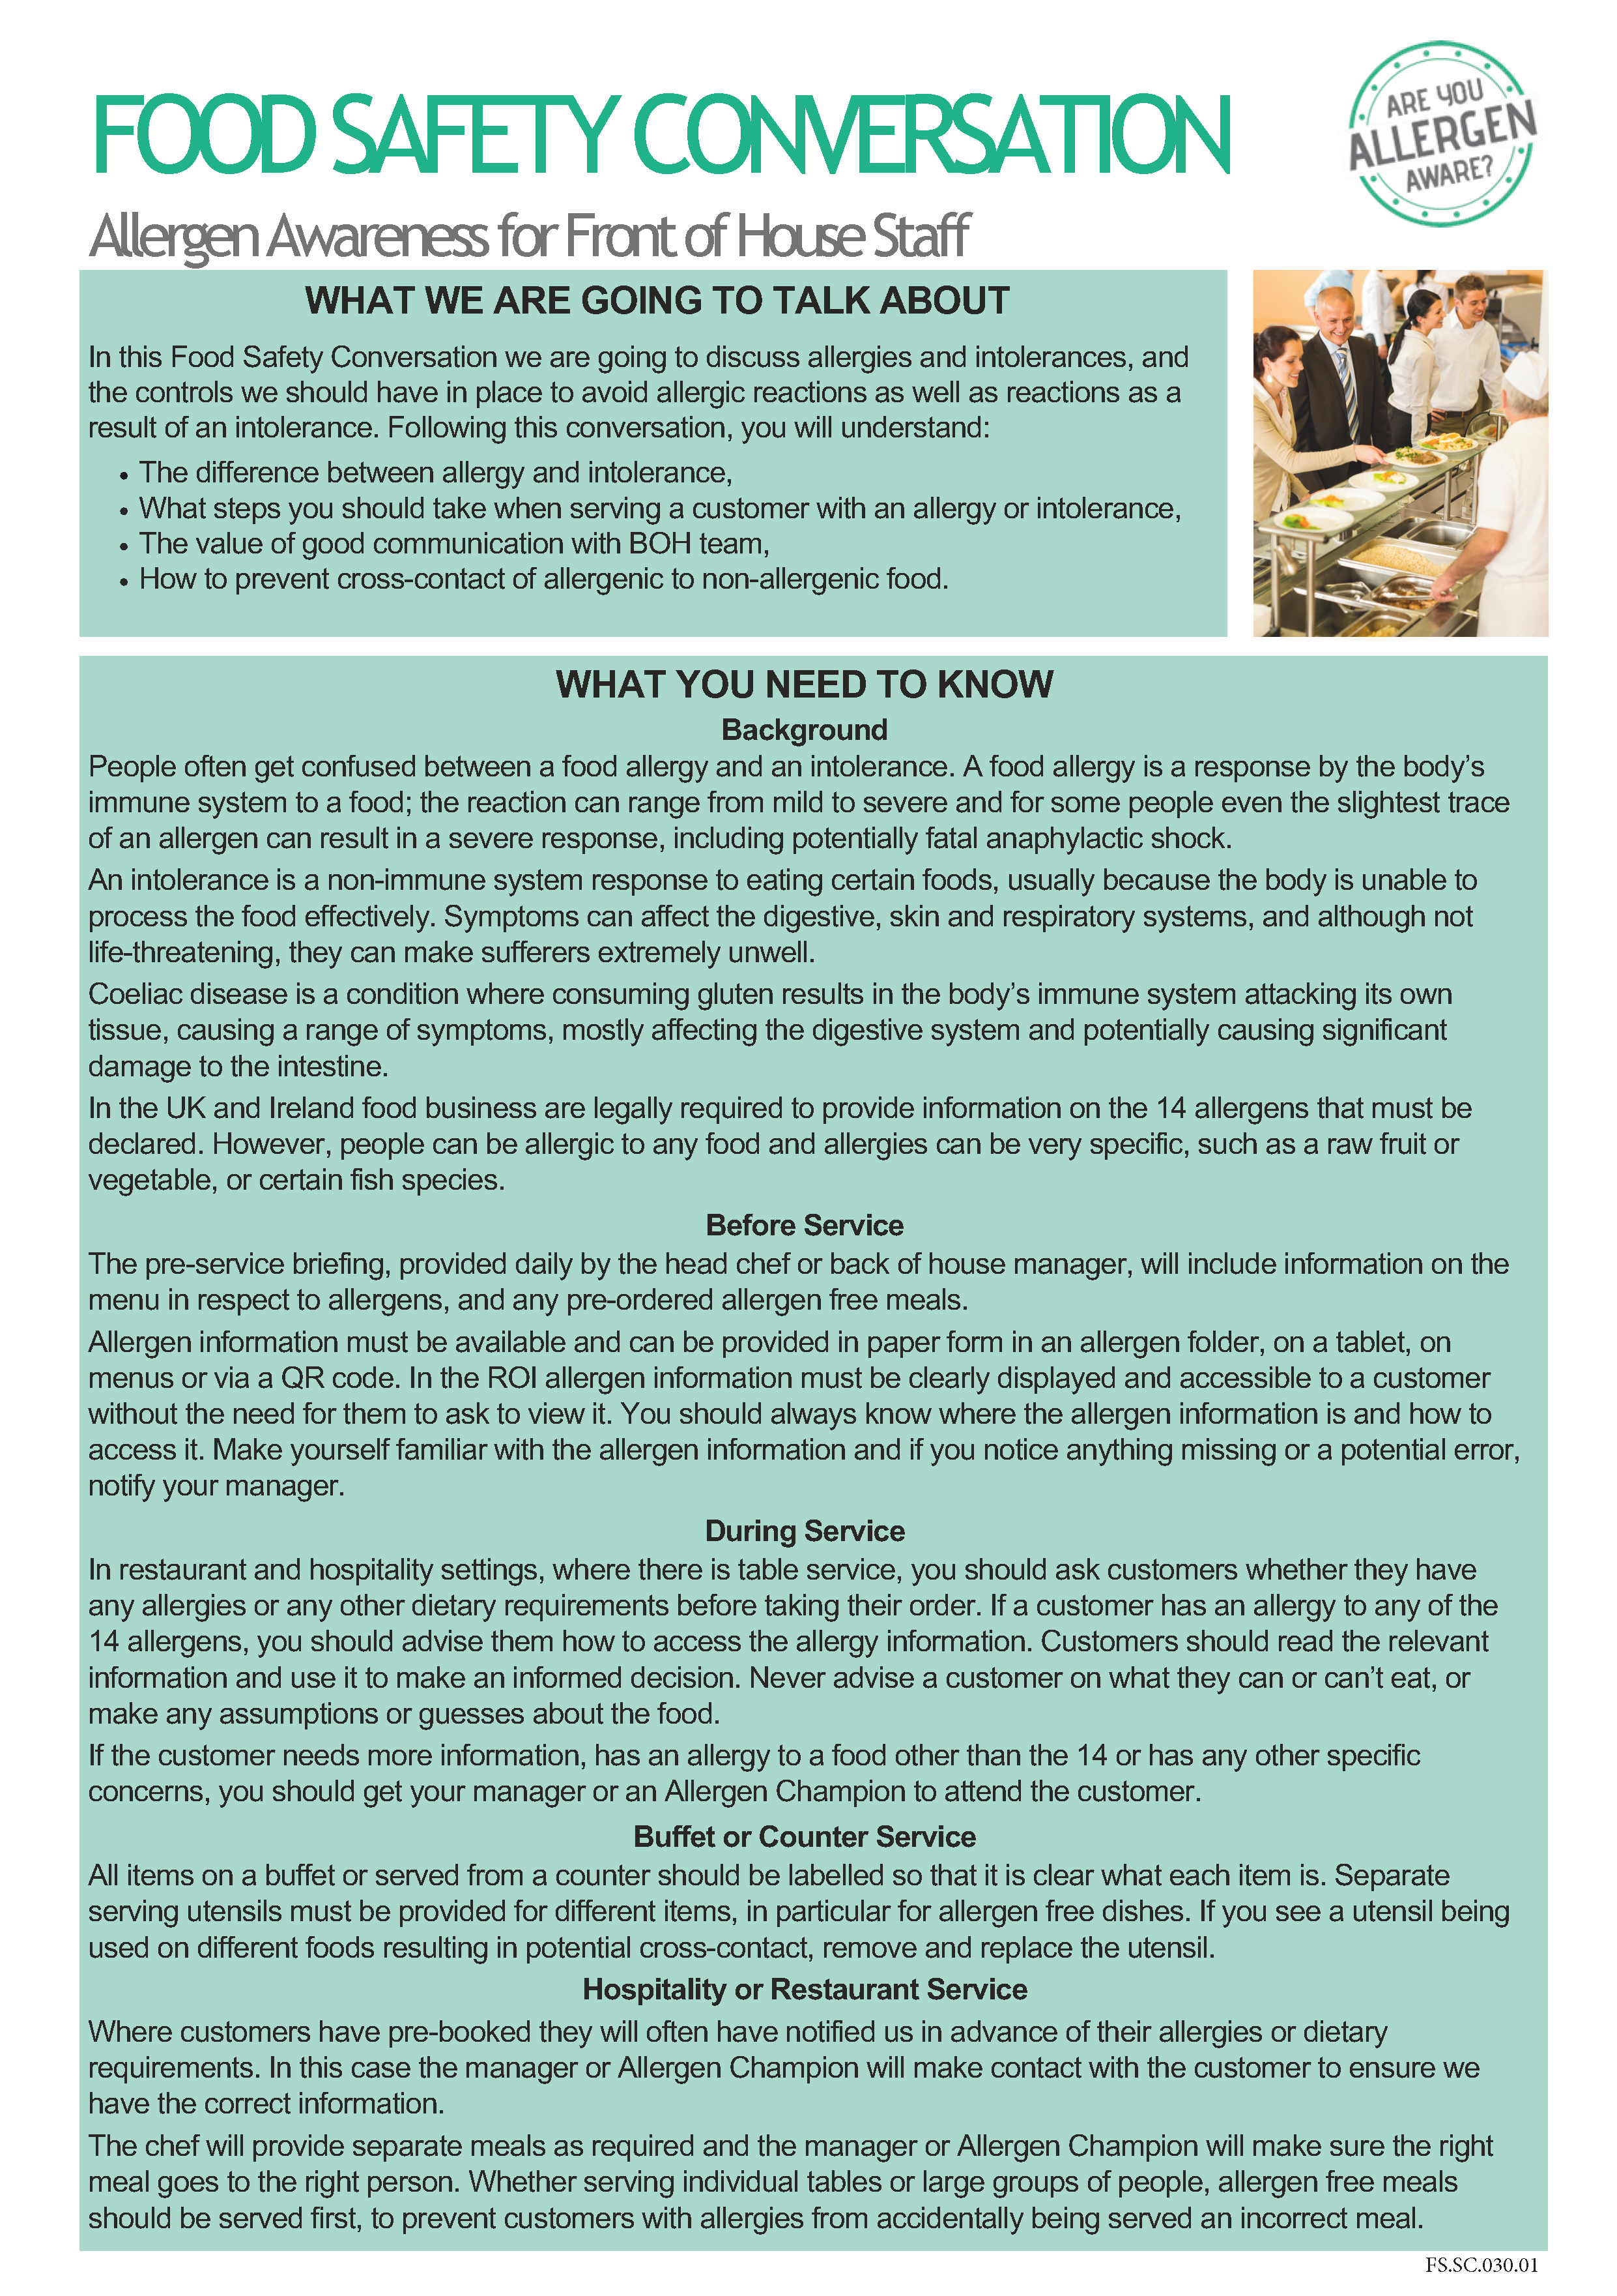

SITE SPECIFIC SAFETY INFORMATION
This page provides the site-specific information for this site.
Colleagues may take a photo of this page so that they can refer to the below information.

BE MINDFUL - Always think first before you carry out a task or activity - are there any risks or hazards and is it safe to carry on.

GET INVOLVED – Help your colleagues if they need it or if you see them in trouble.
SPEAK OUT – If you are unsure of anything ask your manager/ supervisor or if you see any unsafe environments or working activities then let them know.

FIRE & EMERGENCY
Familiarise yourself with the location of fire alarms, fire escapes, firefighting equipment and assembly points. Always follow instructions from your manager/supervisor or announcements on public address systems.
The alarm sound is: The assembly point is:
FIRST AID ARRANGEMENTS
Familiarise yourself with the location of first aid kits and first aid facilities.
First aid kit is located:
Our first aider is: Nearest A&E is:

STAFF WELFARE
Rest Area Location:
Smoking / Vaping Location:

SPILL RESPONSE
Spillages must be cleaned up immediately and wet floor signage displayed where appropriate.
Location of spill kit is:
ALLERGENS
If a customer asks you about allergens within specific dish, provide them with a copy of the Allergy Information Folder and point out the allergy information sheet for that dish so they can make an informed choice, or alternatively direct them to the QR code or tablet where information is available electronically.
Allergen information is available:
Our Allergy Champion is:
INCIDENT REPORTING
All incidents/accidents, near misses, foreign body incidents and allergy incidents must be reported as soon as possible.
Report incidents to:

Reporting forms are available in:

HSE Staff Briefing Sign-Off
Unit Name: |  | Area:
Event Name: |  | Briefing By:
By signing below, I confirm that I have been briefed on the following safety information including Fire & Emergency, Incident Reporting, Chemical Safety, Allergens, Personal Hygiene, Safe Food Handling, Cleaning and Sanitising and Safe Systems of Work relevant to my role for this venue. I understand it is my responsibility to follow instructions, to work safely and only to do work that I have been trained to do, that I am being trained on or being supervised whilst doing. I understand that I should talk to my manager or supervisor at any time if I am unsure of what to do or if I have any concerns. I also confirm that I have not been suffering from any sickness or diarrhoea in the last 48 hours.
Date | Name |  | Signature

By signing below, I confirm that I have been briefed on the following safety information including Fire & Emergency, Incident Reporting, Chemical Safety, Allergens, Personal Hygiene, Safe Food Handling, Cleaning and Sanitising and Safe Systems of Work relevant to my role for this venue. I understand it is my responsibility to follow instructions, to work safely and only to do work that I have been trained to do, that I am being trained on or being supervised whilst doing. I understand that I should talk to my manager or supervisor at any time if I am unsure of what to do or if I have any concerns. I also confirm that I have not been suffering from any sickness or diarrhoea in the last 48 hours.
Date | Name | Signature

CLEANING SCHEDULE
ITEM | PRODUCT | PPE REQUIRED | DOSE | METHOD
Floors | Multi EL10 | Nitrile/Latex-free Gloves EN374* | 2 x 20ml pumps per 5l of warm water | Sweep up debris. Apply hot solution using clean mop or long handle scrubber, paying attention to floor/wall joint, around equipment, under and behind equipment. Rinse and mop over with fresh clean water. Allow to air dry.
Work Surfaces | Oasis Pro20 or Aseptopol | Nitrile/Latex-free Gloves EN374* | 20ml via dispenser per 600ml trigger spray | Remove debris. Apply sanitiser solution with a cloth or hand sprayer. Ensure that attention is given to legs and under edges. Wipe and then re-apply sanitiser and allow a 5-minute contact time. Wipe and Rinse and allow to air dry or dry with paper towels.
Refrigerators / Freezers | Oasis Pro20 or Aseptopol | Nitrile/Latex-free Gloves EN374* | 20ml via dispenser per 600ml trigger spray | Check and organise fridges daily. Check for spillages and wipe up [spillages should be wiped up immediately].
Hot Food Display Equipment | Oasis Pro20 or Aseptopol | Nitrile/Latex-free Gloves EN374 | 20ml via dispenser per 600ml trigger spray | After use - switch off power supply and allow to cool. Remove containers and transfer to pan wash. Wash down all surfaces and rinse. Remove deposits from door runners with a stiff brush. Brush floor under appliance and clean up spillages.
Temperature Probes | Oasis Pro20, Aseptopol or Probe Wipes | Nitrile/Latex-free Gloves EN374* | 20ml via dispenser per 600ml trigger spray | Remove debris. Apply solution with a cloth or hand sprayer. Ensure that attention is given to the entire length of the probe needle, reapply solution and allow a 1-minute contact time. Rinse and allow to air dry or dry with paper towels.
Sinks and Wash Hand Basins | Oasis Pro 20 or Aseptopol | Nitrile/Latex-free Gloves EN374* | 20ml via dispenser per 600ml trigger spray | Clean with the general-purpose detergent. Remove any tide marks from the bowl and drainer with a scouring pad or cloth. Include taps, waste outlets and splash-backs in cleaning record. Rinse thoroughly with cold water. Apply sanitiser to all surfaces and leave to air dry. Ensure sufficient supply of towels and soap are maintained at the wash hand basin.
Equipment Racks and Shelving | Oasis Pro20 or Aseptopol | Nitrile/Latex-free Gloves EN374* | 20ml via dispenser per 600ml trigger spray | Remove stock and utensils/equipment from shelves and racking. Sweep debris off surfaces and sweep floor under. Clean with solution, rinse and allow to air dry. Replace stock and utensils/equipment. Ensure equipment is placed inverted as far as practicable.
Waste Bins | Multi EL10 | Nitrile/Latex-free Gloves EN374* | 2 x 20ml pumps per 5l of warm water | Empty bins frequently throughout the day. Do not allow contents to overflow. Wash out empty bin or bin liner holder with solution. Clean external casing and the lid, paying attention to underside of lid and the handle [if fitted]. Rinse and allow to air dry.

SAFETY PRECAUTIONS
- Before cleaning electrical equipment ensure it is switched off and isolated from the mains.
- Before cleaning gas appliances ensure they are turned off.
- Allow hot items to cool before cleaning.
- Follow the safety precautions shown on the Task Cards for the cleaning product being used and always wear the correct PPE, especially when handling or dispensing undiluted chemicals.

