Safety Task Card
CAT 31 | Use and Cleaning of Temperature probe
Workplace Safety Hazards
What are the hazards? |  |  | How might they be harmed?
Sharp end  Incorrect pressure for task  Cold and numb hands or fingers.  Poor lighting.  Battery power |  |  | Cuts and lacerations  Puncture wounds  Small shock
Safe System of Work
- Probe to be used by trained personnel to take temperature of simulant and food substances.
- The condition of probe to be checked before use. Damaged probe must not be used and reported to a responsible person for repair or replacement, this includes the casing to prevent any contact with the battery.
- Worn and damaged probes to be disposed of safely to prevent contact with exposed metal tip.
- Only carry probe with the tip end pointing downwards or folded back into closed position in the case of pen probes.
- When using a probe, hold the handle at top of metal probe and gently insert into the food or simulant being checked.
- User must not use excessive force to get the probe to enter the food source.
- All items to be probed must be on a stable surface. MUST not be held in the hand.
- Do not attempt to probe frozen food items directly place probe between packs if in freezer.
- Good lighting and adequate workspace to be provided in areas where probes are used.
- After use probes to be wiped with suitable disinfectant from handle to tip to avoid sharp tip of probe, before being used again checking any food residue has been removed.
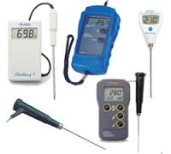
- Probes to be stored with the metal tip stowed (as in pen probes) or safely to prevent accidental contact with the tip.

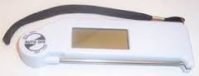

Site Specific Actions
List any actions required in addition to the above safe system of work
Type of machine used on site:

The above control measures are implemented within my unit. All relevant staff are aware of these control measures and this is recorded in the training record for this safety task card.

Unit Manager Name |  | Signed |  | Date

Safety Card Training Record
CAT retail 1 | Use and Cleaning of Cream pressurised frothing machine
I confirm that I fully understand the risks and control measures associated with the task
and that I will follow the Safe System of Work at all times.
Operative Name |  | Signature | Date

