ES07 | Portable Appliance Testing (PAT) Risk Assessment
Unit Name |  | Unit Number
Risk Assessment Completed | Date | Signed
1st review | Date | Signed
2nd review | Date | Signed
3rd review | Date | Signed

Note - Assessments must be reviewed every 3 years, whenever there is a significant change in the activity, and following any incident involving the activity. Assessments must be retained for a period of 6 years.

Part 1 – Guidance

Effective maintenance of portable electric equipment can be achieved by a combination of:
- checks by the user
- formal visual inspections by a competent person
- where necessary an electrical test, also known as a portable appliance test (PAT), by an electrically competent person
The aim of these checks is to determine whether the equipment is fully serviceable or whether remedial action is necessary to make sure it is safe to use. Managers should follow up these procedures by monitoring the effectiveness of the system and taking action where faults are found, particularly when faults are frequent.

User checks

The person using the equipment should be trained in the relevant Task Card for the equipment and encouraged to look at it before use to check for signs that it may not be in sound condition, for example:

- damage (apart from light scuffing) to the supply cable, including fraying or cuts
- damage to the plug or connector, e.g. the casing is cracking, or the pins are bent
- inadequate joints, including taped joints in the cable
- the outer sheath of the cable is not effectively secured where it enters the plug or the equipment. Evidence would be if the coloured insulation of the internal cable cores were showing
- the equipment has been subjected to conditions for which it is not suitable, e.g. it is wet or excessively contaminated
- damage to the external casing of the equipment
- loose parts or screws
- evidence of overheating (burn marks or discolouration)

These checks also apply to extension leads, plugs and sockets. A user check should be made when the equipment is taken into use and during use. Any faults should be reported to the relevant manager and the equipment taken out of use immediately. Managers should take effective steps to ensure that the equipment is not used again until it is repaired by a person competent to carry out the task (e.g. the defective equipment could be labelled as ‘faulty’ and if it has a rewireable plug this could be removed).

User checks do not need to be documented.

Document Name | Portable Electrical Equipment Risk Assessment | Document No | WS.RA.ES.07.01
Document Owner | Workplace Safety | Date of Issue | July 2022
Classification | Internal Use | Version No | 1.0

Formal Visual Check

An important part of a maintenance regime is the formal visual inspection. Such inspections are necessary because they can reveal most potentially dangerous faults. They can normally be carried out by a member of staff who has sufficient information and knowledge of what to look for and what is acceptable, and who has been given the task of carrying out the inspection (that is, they are competent to do the task).

These inspections can help to control the risks and to monitor the user checks. A competent person should carry out regular inspections that include user checks but undertaken in a more formal and systematic
manner.

As part of the visual inspection, you should also consider whether:

- the electrical equipment is being used in accordance with the manufacturer’s instructions;
- the equipment is suitable for the job;
- there has been any change of circumstances;
- the user has reported any issues.

Additional checks could include removing the plug cover to ensure:
- there are no signs of internal damage, overheating or water damage to the plug;
- the correct fuse is in use and it is a proper fuse, not a piece of wire, nail etc;
- the wires including the earth wire, where fitted, are attached to the correct terminals
- the terminal screws are tight;
- the cord grip is holding the outer part (sheath) of the cable tightly; and
- no bare wire is visible other than at the terminals.

Combined Visual Test and Electrical Test (PAT Test)

The user checks and visual inspection should reveal most potentially dangerous faults. However, some faults, such as loss of earth integrity (e.g. broken earth wire within a flexible cable), deterioration of insulation integrity, or contamination of internal and external surfaces, cannot be detected by visual examination alone. Such faults can only be reliably detected by a combined visual inspection and test, also known as a PAT test.

This should be carried out as follows:

- whenever the equipment is believed to be defective and this cannot be confirmed by visual examination;
- after any repair, modification or similar work; or
- at periods appropriate to the equipment, the manner and frequency of use and the environment.

PAT Testing Frequencies
The risk assessment contained in Part 2 should be completed to identify appropriate frequencies for visual inspections and PAT tests. For each type of equipment used on site determine the inspection frequencies based on the suggested frequencies in table 1.
Factors to consider when completing the risk assessment include:
- type of equipment – the vast majority of which will be either earthed equipment or double insulated equipment
- whether it is hand-held or not. Equipment that is held by hand or handled when switched on will present a greater degree of risk because, if it does develop a dangerous fault, the person holding it will almost certainly receive an electric shock
- manufacturer’s recommendations

Document Name | Portable Electrical Equipment Risk Assessment | Document No | WS.RA.ES.07.01
Document Owner | Workplace Safety | Date of Issue | July 2022
Classification | Internal Use | Version No | 1.0

- initial integrity and soundness of the equipment
- age of the equipment
- working environment in which the equipment is used (e.g. wet or dusty) or likelihood of mechanical damage
- frequency of use and duty cycle of the equipment
- foreseeable misuse of the equipment
- effects of any modifications or repairs to the equipment
- analysis of previous records of maintenance, formal visual inspection and PAT tests

For each item consider the range suggested. Where the factors indicate the equipment may be more likely to suffer damage, then the frequency should be increased. Where equipment is less likely to suffer damage, it can be reduced within the range.

Advice and guidance on the risk assessment can be obtained from your HSE Manager.

Record Keeping
Records of formal visual inspections and PAT tests should be kept and reviewed to consider future test frequencies. The Work Equipment Inspection Register in the Compass Workplace Safety Management System can be used for this purpose.

Continued overleaf

Document Name | Portable Electrical Equipment Risk Assessment | Document No | WS.RA.ES.07.01
Document Owner | Workplace Safety | Date of Issue | July 2022
Classification | Internal Use | Version No | 1.0

Table 1 – Suggested PAT Test Intervals (from HSE Guidance HSG107)

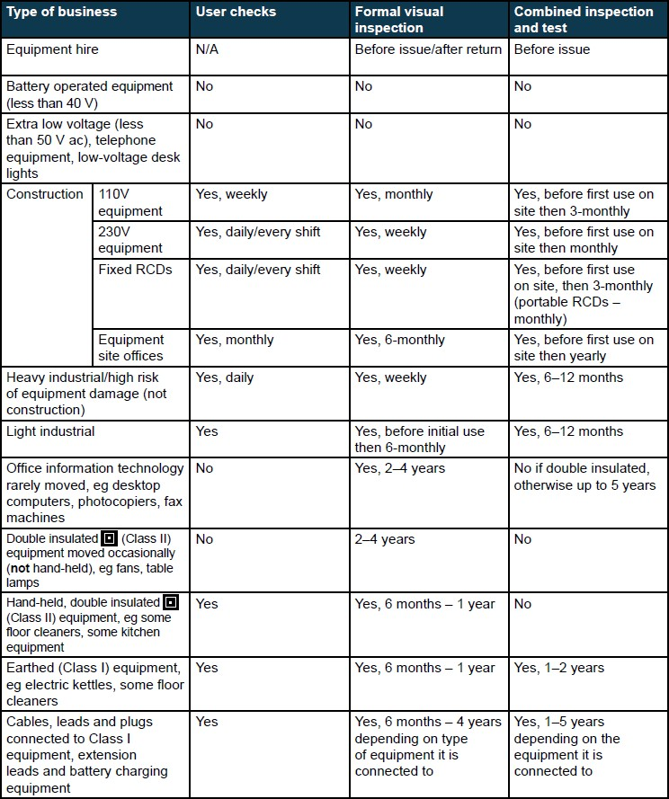

Document Name | Portable Electrical Equipment Risk Assessment | Document No | WS.RA.ES.07.01
Document Owner | Workplace Safety | Date of Issue | July 2022
Classification | Internal Use | Version No | 1.0

Compass UK & Ireland

Workplace Safety Management System

Part 2 – Risk Assessment *informed by table 1

Equipment type | Classification | Hand held Y/N | Environment used in | Users | Frequency of use | Inspection Frequency*
 |  |  |  |  |  | Visual Check | Electrical Test

Document Name | Portable Electrical Equipment Risk Assessment | Document No | WS.RA.ES.07.01
Document Owner | Workplace Safety | Date of Issue | July 2022
Classification | Internal Use | Version No | 1.0
Page 5 of 5

