ES10 | Manual Handling – Activity Filter
Unit Address
Risk Assessment Completed |  | Date | Signed
1st review |  | Date | Signed
2nd review |  | Date | Signed
3rd review |  | Date | Signed
Note - Risk assessments must be reviewed every 3 years, whenever there is a significant change in the activity, and following any incident involving the activity. Risk assessments must be retained for a period of 6 years.
Step 1 - Identify manual handling activities undertaken in the unit (tick each that applies)
For each activity, consider steps 2-4. Where the risk is not LOW, add the activity to the right-hand box.
Stacking/unstacking storage containers e.g. boxes, crates, sacks, food, consumables and cleaning products

Pushing wheeled racks e.g. roll cages, oven racks and trolleys, clearing, vending and hospitality

Handling food, drink and non-food containers e.g. casks/kegs, crates, cooking pans, service containers, oil drums, chemical barrels

Handling furniture and equipment e.g. folding dining tables (seats attached), chairs, kitchen and office equipment

Operating / using cleaning equipment e.g. floor scrubbers, mops, brushes

Handling portable equipment e.g. ladders, toasters, soup kettles, blenders

Other:
Step 2 – Lifting and Lowering
1. Can the load be grasped with both hands? | YES | NO |  | Manual handling activities involving lifting and lowering that require risk assessment (MAN10a):
2. Are the working conditions reasonable? | YES | NO
3. Can the load be lifted from a stable body position? | YES | NO
4. Does the handling involve torso twisting? | NO | YES
5. Is the handling more frequent than one lift every two minutes? | NO | YES
6. Is the handling done by a team together? | NO | YES
7. Do the weights of the load vary from start to finish? | NO | YES
8. Is the person lifting at significant risk? e.g. new or expectant mother, young worker, disability, health problem, recent injury? | NO | YES
9. From the guidelines on p3, does the weight of the load exceed the value for lifting and lowering in that zone? | NO | YES
Lifting and lowering
risk is considered LOW

Step 3 – Carrying
1. Is the load held against the body? | YES | NO |  | Manual handling activities involving carrying that require risk assessment (MAN10a):
2. Is it carried no further than 10m without resting? | NO | YES
3. Does carrying the load prevent the person from walking normally? | NO | YES
4. Does carrying the load obstruct the view of the person carrying it? | NO | YES
5. From the guidelines on p3, does the weight of the load exceed the value during carrying? | NO | YES
Carrying risk is considered LOW

Step 4 – Pushing and Pulling
1. Can the load be moved and controlled easily, for example by one hand? | YES | NO |  | Manual handling activities involving pushing and pulling that require risk assessment (MAN10b):  For pushing and pulling of Roll Cages refer to  Safety Task Card STC-COM09
2. Is the pushing and pulling force applied by the hands? | YES | NO
3. Is the torso largely upright and not twisted? | YES | NO
4. Are the hands between hip and shoulder heights? | YES | NO
5. Is the distance moved without a pause or break no more than about 20m? | YES | NO
6. Does the persons posture indicate significant force is required? Compare with diagrams on p3. | NO | YES
7.Are there extra risk factors such as slopes, uneven floors, constricted spaces or trapping hazards? | NO | YES
Pushing and pulling
risk is considered LOW

Manual handling activity filter:

Lifting and Carrying
Risk Assessment
(MAN10a)
NOT REQUIRED

Carrying
LOW

Lifting and lowering
LOW

Pushing and pulling
LOW

Pushing and Pulling
Risk Assessment
(MAN10b)
NOT REQUIRED

Manual Handling Weight Guidelines

These guidelines are not ‘safe limits’ for lifting and carrying. They use broad assumptions where, if met, the risk of injury is considered to be low. Working outside these limits is likely to increase the risk of injury.

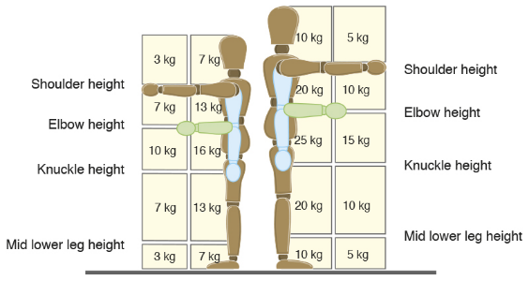

Acceptable Push/Pull Postures

