


Event Health and Safety
Chefs’ Pack
Event Name
Event Dates
Unit Name
Area Name

This pack contains all the information you need to for your Health and Safety Briefing with your team. Make sure you include all team members in the briefing. Also included is the daily Opening and Closing Checklist and all the documents required for temperature monitoring of cold and hot food display and storage.
Pack Contents:
- Refrigerator or Freezer Breakdown
- Date Labelling Guide
- Safe Use of Fire Extinguishers
- Event Food Safety Management – HACCP Summary
- Event Catering Cleaning Schedule
- Record of Opening and Closing Checks
- Record of Fridge and Freezer Checks
- Food Production Temperature Record
- Repairs Log and Event Debrief
- HSE Staff Briefing
- Hot Oil Quiz

REFRIGERATOR OR FREEZER BREAKDOWN
IMPORTANT
Do not overload refrigerators with transferred food and be very careful to maintain separation between raw and ready-to-eat food items. Airflow inside the refrigerator is very important to its efficiency.
IMMEDIATE ACTION
When a refrigerator or freezer breaks down due to mechanical or power failure, follow the steps below:
- Contact the client, the maintenance contractor or the refrigeration engineer to arrange repair
- Record the details on the Repairs Log
- Record the breakdown on the Refrigerator/Freezer Temperature Record
ACTIONS - REFRIGERATOR BREAKDOWN
Discovered within four hours:
- Check the temperature of a representative sample of food items using a sanitised probe thermometer.
- Check food from all areas of the refrigerator - top, middle and bottom shelves.
If the food temperature is… |  | then…
+8°C or below |  | transfer the food to an alternative refrigerator.
above +8°C |  | for cooked or high-risk food:  - use immediately, or  - transfer to an alternative refrigerator and serve from there  - do not place on ambient display  for raw food and low risk food:  - transfer the food to an alternative refrigerator
ACTIONS - REFRIGERATOR BREAKDOWN
More than four hours since breakdown or duration unknown
- Check the temperature of a representative sample of food items using a sanitised probe thermometer.
- Check food from all areas of the refrigerator, that is top, middle and bottom shelves.
If the food temperature is… |  | then…
+8°C or below |  | transfer the food to an alternative refrigerator.
above +8°C |  | for cooked or high-risk food:  - discard  for raw food and low risk food:  - assess the quality  - if acceptable, cook raw food thoroughly  - use immediately, or cool rapidly and store in a refrigerator
ACTIONS - FREEZER BREAKDOWN
Check the condition of the food, but do not leave lids or doors open for prolonged periods of time. Provided the freezer is kept closed, food may stay frozen for up to 24 hours.
If the food temperature is… | then…
still frozen | transfer food to an alternative freezer as quickly as possible
defrosted, but below +8°C | for cooked or high-risk food:  - complete thawing  - use immediately or transfer to refrigerator and use within 72 hours  - follow manufacturer's label instructions if shelf life is less than 72 hours. Example: "use within 24 hours of thawing".  for raw food and low risk food:  - complete thawing  - cook raw food thoroughly and use immediately, or cook and cool rapidly then store in refrigerator for up to 72 hours
above +8ºC | for cooked or high-risk food:  - discard  for raw food and low risk food:  - assess the quality  - if acceptable, cook raw food thoroughly  - use immediately, or cool rapidly and store in a refrigerator for up to 72 hours

DATE LABELING GUIDANCE
IMPORTANT
THE GUIDANCE BELOW IS HOW TO CORRECTLY COMPLETE THE FOOD LABELS
IN LINE WITH COMPANY POLICY.
COMPLETING THE LABEL CORRECTLY:
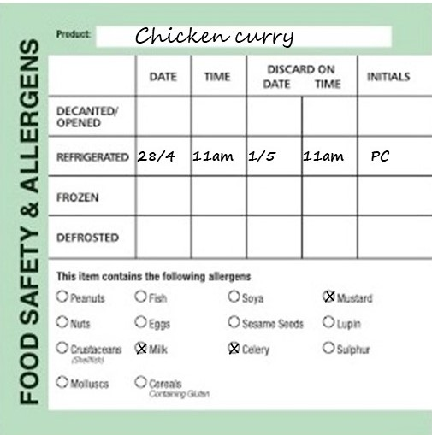
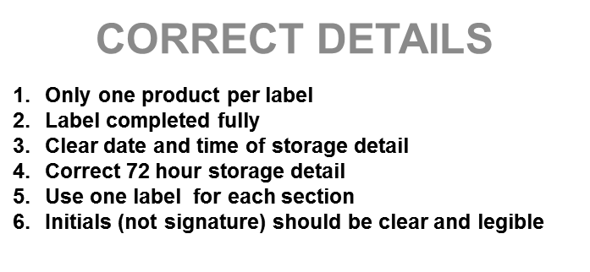

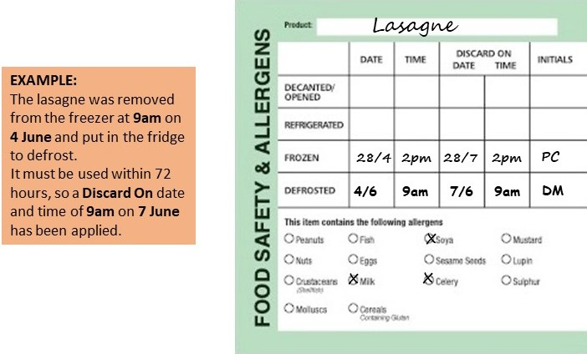

SHELF LIFE INFORMATION – DISCARD ON DATE AND TIME:
- Decanted dry foods – manufacturer’s original ‘Best Before’ date, unless otherwise instructed by the manufacturer e.g. once opened refrigerate and use within 4 weeks.
- Unit produced refrigerated foods – date and time of production plus 72 hours.
- Purchased refrigerated foods – date and time of opening plus 72 hours unless manufacturer’s instructions are different. (Always follow any manufacturer’s specific instructions relating to shelf life)
- Sandwiches and filled rolls, yoghurt and fruit pots – day of production plus 1 day.
- Unit produced bakery goods –day of production plus 6 days (this would include scones, flapjacks, brownies etc. Any products with fresh cream should be date and time of production plus 72 hours.
- Unit frozen foods – no more than 6 months forward, including date of production/freezing. If freezing bought in chilled products this must be done at least 3 days prior to the manufacturers use by date.
- Defrosting foods – label with date and time of defrost (date/time taken out of freezer and put into fridge) then a ‘Discard on’ date and time of plus 72 hours
- Unit produced vacuum packed refrigerated foods – date and time the food was packed plus 168 hours (7 days)

SAFE USE OF FIRE EXTINGUISHERS
When attempting to deal with a fire, the correct type of fire extinguisher should be used as specified below;
Personal safety should be observed at all times whilst attempting to extinguish a fire.
- Ensure the alarm has been raised
- Always make sure the main electric/gas supply has been isolated before attempting to extinguish the fire
- Ensure all employees and customers are evacuated from the immediate area
- When attempting to extinguish the fire make sure you have a clear escape route behind you whilst fighting the fire in front of you
- Only use one extinguisher. If once the extinguisher has depleted the fire is not extinguished evacuate the area and wait for the fire brigade
TYPES OF EXTINGUISHERS AVAILABLE
CO₂ (Black Label)
For electrical fires.
Direct the black nozzle towards the direction of the base of the fire prior to deploying the CO₂.
DO NOT TOUCH ANY PART OF THE BLACK NOZZLE
HIGH PRESSURE EXTINGUISHER – DO NOT spray at lightweight materials such as paper or dustbins.

FOAM (Cream Label)
For combustibles or burning liquids. Spray over the top of the fire in order to lay a blanket of foam over the combustible or burning liquid.
DO NOT point into the fire.
Always isolate the power source (electricity/gas) before use.

DRY POWDER (Blue Label)
Safe for use on all fires, except Class F fires (those involving cooking oils and fats, such as deep fat fryers).
This extinguisher should not be used in confined spaces.

WET CHEMICAL (Yellow Label)
The specialist wet chemical extinguishers are ideal for Class F fires, involving cooking oils and fats, such as deep fat fryers.
Apply the wet chemical using the extended applicator in slow circular movements, which give a gentle, yet highly effective application. Apply the fine spray onto the burning fat until the surface of the burning cooking oil changes into a soapy like substance, this prevents re-ignition. The gentle application helps prevent hot oil splashing onto the user.

FIRE BLANKETS
To be used to smother small fires. (DO NOT attempt to use on deep fat fryers, please use the WET CHEMICAL extinguisher for this purpose).
Can be used to save a person whose clothes have caught fire, always force them to the ground and then roll them in the blanket using the “Stop, drop and roll” technique.
You will not be able to make effective use of the blanket while they remain on their feet, and the burns will be much worse to the upper body and head.
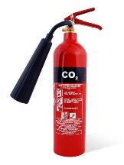 | 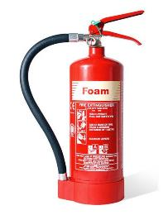 | 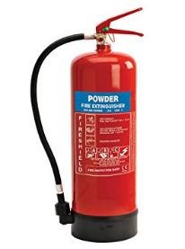 | 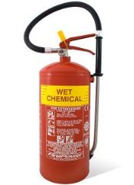 | 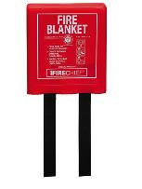

EVENT FOOD SAFETY MANAGEMENT - HACCP SUMMARY
PROCESS STEP | HAZARD | CONTROLS | MONITORING | CORRECTIVE ACTIONS
PLANNING FOOD SERVICE | Microbiological – inherent contamination  Physical contamination  Chemical contamination | Ensure adequate equipment and facilities for storage, preparation, production and service  Plan menus in advance | Check that facilities and equipment are in good order and well maintained  Review menus | Report repair & maintenance issues  Revise storage, prep & service as required
PURCHASE & FOOD DELIVERY | Microbiological – inherent contamination, bacterial growth, cross-contamination  Physical contamination  Chemical contamination | Use authorised suppliers  Check food deliveries on receipt  Temperature limits: chilled 8°C, frozen -15°C  Use a dedicated probe thermometer to check the temperature of all chilled and frozen food deliveries.  Visual inspection | Supplier audits and records  Check and record temperature of all chilled and frozen deliveries  Check and record condition of food and packaging | Reject deliveries of chilled food above 8°C and frozen foods above -15ºC  Reject any foods with expired shelf life  Reject foods with damaged packaging
CHILLED FOOD STORAGE | Microbiological – inherent contamination, bacterial growth, cross-contamination  Physical contamination  Chemical contamination | Food stored at 5°C or below  Raw and cooked foods kept separate  Food covered and labelled  Stock rotation – food used within shelf life dates  - Sandwiches/rolls – day of production plus 1 day  - Unit prepared food – 72 hours  - Opened product – manufacturer instructions or 72hrs  Use a dedicated probe thermometer and food simulant when checking the temperature of storage areas | Check and record refrigerated food temperatures twice daily using a food simulant  Visually check and record refrigerator food storage daily | Follow procedure for refrigerator breakdown in Chefs Event Pack  Discard any foods with expired shelf life
FROZEN FOOD STORAGE | Microbiological – inherent contamination, bacterial growth, cross-contamination  Physical contamination  Chemical contamination | Food stored -18°C or below.  Raw and cooked food kept separate  Food covered and labelled  Stock rotation – food used within shelf life dates  - Purchased product – manufacturer instructions  - Frozen in unit – use within 6 months | Check and record freezer temperatures daily by between-pack method  Visually check and record freezer food storage daily | Follow procedure for freezer breakdown in Chefs Event Pack  Discard any foods with expired shelf life
DRY FOOD STORAGE | Microbiological – inherent contamination, bacterial growth, cross-contamination  Physical contamination  Chemical contamination | Cover, wrap or package/contain all foods  Maintain separation of raw/unwashed foods from other product  Ensure all foods are labelled  Stock rotation – food used within shelf life dates | Visually check storage areas daily for correct storage, stock rotation, shelf life, pest activity and cleanliness | Review cleaning procedures  Discard any foods with expired shelf life
FOOD PREPARATION | Microbiological – bacterial growth, cross-contamination  Physical contamination  Chemical contamination | Observe personal hygiene standards  Hand washing  Sanitise equipment and surfaces  Separate raw and cooked food preparation  Avoid holding foods at ambient temperature for long periods | Supervise preparation procedures  Adhere to cleaning schedules | Revise cleaning and food handling practices as required
DEFROSTING FOOD | Microbiological – bacterial growth, cross-contamination  Physical contamination  Chemical contamination | Defrost in a refrigerator  Defrost in a container of adequate size to prevent juices from leaking.  Separate raw and cooked/ready to eat foods  Ensure adequate product labelling | Check foods are completely defrosted before using | Do not prepare food until fully defrosted  Take care not to exceed shelf life date.

EVENT FOOD SAFETY MANAGEMENT - HACCP SUMMARY
PROCESS STEP | HAZARD | CONTROLS | MONITORING | CORRECTIVE ACTIONS
COOKING | Microbiological – bacterial survival,  Physical contamination  Chemical contamination | Core temperature of at least 75°C must be achieved  Whole meat cuts, such as steaks, and some fish, such as salmon, may be cooked to lower than 75°C  Sanitise the probe thermometer before each use | Ensure food temperatures are checked and recorded on completion of cooking  Where foods are cooked to less than 75°C this must be recorded on the temperature record | Continue cooking until 75°C is achieved
CHILLING/FREEZING | Microbiological – bacterial survival and growth, cross-contamination  Physical contamination  Chemical contamination | Rapid chilling with blast chiller, where available  Commence blast chilling within 30 minutes of cooking  and continue until core temperature of 5°C is achieved.  Where no blast chiller is available, cool to ambient within 90 minutes and transfer to refrigerator.  If to be frozen, transfer to freezer immediately.  Ensure product is adequately labelled  Shelf life chilled – 72 hours  Shelf life frozen – 6 months | Check and record food temperatures and timings  Check food labels are adequate and show shelf life | Continue with rapid chill until 5°C is attained.  Adjust process to assist with rapid temperature reduction e.g. reduce thickness and bulk of foods, increase surface area
REHEATING | Microbiological – bacterial survival and growth, cross-contamination  Physical contamination  Chemical contamination | Core temperature of at least 75°C must be reached  Never reheat foods more than once | Check and record food temperatures on completion of reheating | Continue heating until 75°C is achieved
HOT HOLDING & SERVICE | Microbiological – bacterial growth, cross-contamination  Physical contamination  Chemical contamination | Display/serve hot food at 63°C or hotter  Protect food on display from contamination risk  Use within 2 hours if no hot holding  Provide appropriate clean serving utensils | Check and record hot holding and service temperatures of food at commencement and during hot holding/display  Visually check and supervise food service standards. | Hot food at less than 63°C for more than 2 hours must be discarded
COLD FOOD SERVICE | Microbiological – bacterial growth, cross-contamination  Physical contamination  Chemical contamination | Display/serve cold food at 8°C or less  Protect food on display from contamination risk  Use within 4 hours if above 8°C  Provide appropriate clean serving utensils | Check and record cold food service temperatures of food at commencement and during display  Visually check and supervise food service standards | Cold food at above 8°C for more than 4 hours must be discarded
USE OF VACUUM PACKING MACHINE | Microbiological – inherent contamination, cross-contamination  Physical contamination  Chemical contamination | Clean and sanitise machine before and after each use  Observe personal hygiene standards  Dedicated use for cooked and ready-to-eat foods or for raw use only.  Signage to be displayed “For cooked and ready to eat foods only” or “For raw products only”  Cleaning schedule method and sign off to be displayed  Ensure food is adequately labelled once packed  Shelf life if to be stored chilled – 7 days  Shelf life if to be stored frozen – 6 months | Visually check condition of equipment  Check and record cleaning  Supervise use, ensuring there is no cross-use | Ensure cleaning and use processes are supervised and enforced  Revise cleaning processes as required
IMPORTANT: Always report repair and maintenance issues immediately

NOTE: Full HACCP is held in the Head Chef’s office.
Compass Food Safety Management System, including A to Z guidance and all Event packs can be accessed on the Compass HSE website on an on-line computer in the office.

Event Catering Cleaning Schedule

ITEM | PRODUCT | PPE REQUIRED | DOSE RATE | METHOD
Floors | Multi EL10 | Nitrile/Latex-free Gloves EN374* | 2 x 20ml pumps per 5l of warm water | Sweep up debris. Apply hot solution using clean mop or long handle scrubber, paying attention to floor/wall joins, around equipment and under and behind equipment. Rinse and mop with fresh clean water. Allow to air dry.
Work Surfaces/ Benches | Multi EL10 | Nitrile/Latex-free Gloves EN374* | 20ml via dispenser per 600ml trigger spray | Remove debris. Apply solution with a cloth or hand sprayer. Ensure that attention is given to legs and under edges. Rinse and allow to air dry or dry with paper towels.
Cutting Boards | Aseptopol or  Oasis  Pro20 | Nitrile/Latex-free Gloves EN374* | 20ml via dispenser per 600ml trigger spray | Remove debris. Apply sanitiser solution onto moistened board and scrub. Wipe surface and rinse. Allow to air dry.  Can be routinely washed in dishwasher if suitable, but additional weekly clean with sanitiser solution is required.  Cutting boards should be racked vertically with cutting surfaces separated after cleaning and sanitising.
Refrigerators / Blast Chillers | Aseptopol or  Oasis  Pro20 | Nitrile/Latex-free Gloves EN374* | 20ml via dispenser per 600ml trigger spray | Check and organise fridges daily. Check for spillages and wipe up [spillages should be wiped up immediately].
Deep Freezers | Aseptopol or  Oasis  Pro20 | Nitrile/Latex-free Gloves EN374* | 20ml via dispenser per 600ml trigger spray | Check and organise freezers daily. Wipe down external surfaces and door seals. [Wipe up spillages immediately. Do not allow to freeze]
Can Opener | Aseptopol | Nitrile/Latex-free Gloves EN374* | 20ml via dispenser per 600ml trigger spray | Remove from bench mounting. Soak in hot general-purpose detergent solution. Scrub cutter blade and assembly with a brush. Check for uneven blade wear or loose blade mount and report to supervisor as necessary. Scrub the base plate mount at the table. Rinse and air dry.
Fryer | Multi EL10 | Nitrile/Latex-free Gloves EN374* | 2 x 20ml pumps per 5l of warm water | After use - switch off appliance and allow oil to cool. Remove food particles with fine wire mesh web. Wipe outside of fryer to remove spilt oil. Wash frying baskets in general purpose detergent. Dry and replace. Top up oil to required level if necessary.
SAFETY PRECAUTIONS
- Before cleaning electrical machinery ensure it is switched off and isolated from the mains.
- Before cleaning gas appliances ensure they are turned off. Take care when cleaning hot items.
- Follow all safety precautions shown in COSHH Product Task Cards for the cleaning product being used and wear the correct PPE as advised especially when handling or dispensing concentrated chemicals.

Event Catering Cleaning Schedule

ITEM | PRODUCT | PPE REQUIRED | DOSE RATE | METHOD
Tea/Coffee Boiling Urns | Multi EL 10 | Nitrile Latex free Gloves EN374* | 2 x 20ml pumps per 5l of warm water | Ensure appliance is switched off. Fill with solution and leave to soak for 10 to 15 minutes. Scrub out and drain. Rinse thoroughly and allow to air dry.
Bain Marie and Hot Cupboards | Aseptopol or  Oasis Pro20 | Nitrile/Latex-free Gloves EN374* | 20ml via dispenser per 600ml trigger spray | After use - Switch off power supply and allow to cool. Remove containers and transfer to pan wash. Where a water bath is incorporated, drain to waste and clean out the bath. Wash down all surfaces and rinse. Remove deposits from door runners with a stiff brush. Brush floor under appliance and clean up spillages.
Equipment Racks and Shelving | Aseptopol or  Oasis Pro20 | Nitrile/Latex-free Gloves EN374* | 20ml via dispenser per 600ml trigger spray | Remove stock and utensils/equipment from shelves and racking. Sweep debris off surfaces and sweep floor underneath. Clean with solution, rinse and allow to air dry. Replace stock and utensils/equipment. Ensure equipment is stored inverted as far as practicable.
Sinks and Wash Hand Basins | Aseptopol or  Oasis Pro20 | Nitrile/Latex-free Gloves EN374* | 20ml via dispenser per 600ml trigger spray | Clean with the general-purpose detergent. Remove any tide marks from the bowl and drainer with a scouring pad or cloth. Include taps, waste outlets and splashbacks in cleaning programme. Rinse thoroughly with cold water. Apply sanitiser to all surfaces and leave to air dry.  Top up supply of towels and soap maintained at the wash hand basin as required.
Temperature Probes | Aseptopol,  Oasis Pro20 or Probe Wipes | Nitrile/Latex-free Gloves EN374* | 20ml via dispenser per 600ml trigger spray | Remove debris. Apply solution with a cloth. Ensure that attention is given to the full length of the probe needle. Rinse and allow to air dry or dry with paper towels.
Paper Towel & Soap Dispensers | Aseptopol or  Oasis Pro20 | Nitrile/Latex-free Gloves EN374* | 20ml via dispenser per 600ml trigger spray | Remove debris. Apply solution with a cloth or hand sprayer. Rinse and allow to air dry or dry with paper towels.
SAFETY PRECAUTIONS
- Before cleaning electrical machinery ensure it is switched off and isolated from the mains.
- Before cleaning gas appliances ensure they are turned off. Take care when cleaning hot items.
- Follow all safety precautions shown in COSHH Product Task Cards for the cleaning product being used and wear the correct PPE as advised especially when handling or dispensing concentrated chemicals.

RECORD OF OPENING AND CLOSING CHECKS
Event Name: | Area Name:

OPENING checklist to be completed at the start of every shift
 | Date | Date | Date
Is the area free of any evidence of pests?
Is the kitchen clean and tidy and are all food contact surfaces sanitised?
Do you have a working probe?
Do you have sanitiser spray and is it labelled correctly? (Ensure all staff are aware of the contact time: 1 minute)
Do hand wash basins have running warm water, soap and paper towels?
Is all equipment in good working order?
Is the area free of slip, trip and fall hazards, such as leaking equipment, trailing cables, unguarded edges?
Are all fire exit routes and doors free from obstructions and are they accessible?
Are your team in the correct uniform, including footwear, and supplied with relevant PPE as needed?
Have all staff members been fully briefed?
Do you have the relevant allergen information for all dishes being served?
Menu is compliant with special client requests where it is stipulated prior to service as part of the catering instruction / event order? (If not applicable mark N/A)

CLOSING checklist to be completed at the end of every shift
 | Date | Date | Date
Is all food stored correctly and within date?
Is the kitchen clean and tidy and are all food contact surfaces sanitised?
Is all equipment switched off except for fridges and freezers?
Have all maintenance issues been reported to your manager or the maintenance team?
Has all waste been removed to the relevant waste areas?
Have all chemicals been stored away safely?
Have all food temperature records been completed for the day?

Corrective Actions or Comments to be recorded below

RECORD OF FRIDGE AND FREEZER TEMPERATURE CHECKS

Event Name: |  |  |  |  | Area Name:
Fridge Number  and Date | Temperature ^{O}C |  |  |  | Comments and Corrective Actions
Fridge 1 | AM | Initial | PM | Initial | Log any out-of-range issues and record what action was taken to rectify these. Record any temperature re-checks.
Fridge 2 | AM | Initial | PM | Initial
Fridge 3 | AM | Initial | PM | Initial
Fridge 4 | AM | Initial | PM | Initial

Freezer 1 | AM | Initial
Freezer 2 | AM | Initial
CHECKED BY: | DATE:
Temp range | Storage: +1ºC to +5ºC Critical Limit +8ºC  Service and display: +1ºC to + 8ºC  Freezers: -18ºC to +23ºC Critical Limit -15ºC
Manager to check the record form and sign | Retain for 6 months

FOOD PRODUCTION TEMPERATURE RECORD

Event Name: |  |  |  |  |  |  | Event Date:
DATE | PRODUCTION DATE  (Copy production date from the product label if applicable) | FOOD ITEM | COOKING+75°C  RE-HEATING +75°C  (82ºC in Scotland)  (Temperature only to be recorded at Final Cook Time) |  |  |  | HOT HOLD  +63°C  (Ensure temperatures are recorded 90 minutes after final cook time) |  |  | SERVICE  Hot min +63°C  Chilled max +8 °C |  |  | COMMENTS  (If serving rare cuts of meat or fish ensure this is highlighted in this column)
DATE |  | FOOD ITEM | Time | Temp | Init | Tick if reheated | Time | Temp | Init | Time | Temp | Init

For whole cuts of meat required “rare” and fish dishes which may be cooked to a lower temperature, highlight this in the comments section. Never undercook rolled, minced, diced meat or poultry.

CHECKED BY: | DATE:
Head Chef to check the record form and sign before filing record. Retain for 6 months
RECORD OF HOT FOOD TEMPERATURE CHECKS

Event Name: |  |  |  |  |  |  | Event Date:
DATE | PRODUCTION DATE  (Copy production date from the product label if applicable) | FOOD ITEM | COOKING+75°C  RE-HEATING +75°C  (82ºC in Scotland)  (Temperature only to be recorded at Final Cook Time) |  |  |  | HOT HOLD  +63°C  (Ensure temperatures are recorded 90 minutes after final cook time) |  |  | SERVICE  Hot min +63°C  Chilled max +8 °C |  |  | COMMENTS  (If serving rare cuts of meat or fish ensure this is highlighted in this column)
DATE |  | FOOD ITEM | Time | Temp | Init | Tick if reheated | Time | Temp | Init | Time | Temp | Init

For whole cuts of meat required “rare” and fish dishes which may be cooked to a lower temperature, highlight this in the comments section. Never undercook rolled, minced, diced meat or poultry.

CHECKED BY: | DATE:
Head Chef to check the record form and sign before filing record. Retain for 6 months
RECORD OF HOT FOOD TEMPERATURE CHECKS

Event Name: |  |  |  |  |  |  | Event Date:
DATE | PRODUCTION DATE  (Copy production date from the product label if applicable) | FOOD ITEM | COOKING+75°C  RE-HEATING +75°C  (82ºC in Scotland)  (Temperature only to be recorded at Final Cook Time) |  |  |  | HOT HOLD  +63°C  (Ensure temperatures are recorded 90 minutes after final cook time) |  |  | SERVICE  Hot min +63°C  Chilled max +8 °C |  |  | COMMENTS  (If serving rare cuts of meat or fish ensure this is highlighted in this column)
DATE |  | FOOD ITEM | Time | Temp | Init | Tick if reheated | Time | Temp | Init | Time | Temp | Init

For whole cuts of meat required “rare” and fish dishes which may be cooked to a lower temperature, highlight this in the comments section. Never undercook rolled, minced, diced meat or poultry.

CHECKED BY: | DATE:
Head Chef to check the record form and sign before filing record. Retain for 6 months

REPAIRS LOG

Event Name: |  | Area:
Date | Fault/Problem | Reported |  | Action Taken | Date Completed
Date | Fault/Problem | By | To | Action Taken | Date Completed

EVENT DEBRIEF

Event Name: | Area Name:
Is equipment sufficient and working?
Is the layout and design satisfactory?
List suggested improvement
Is there sufficient storage in fridges and for non-refrigerated food
Is the menu appropriate for the outlet size and the available equipment
Please provide any additional comments

HSE Staff Briefing

All HSE information in this pack must be communicated to and understood by each individual colleague before they commence work at a Compass catering unit.

Health & Safety Information
ELECTRICAL SAFETY
Check electrical equipment before use - do not use if there is obvious damage, such as burn marks on cables, sockets or plugs,
damage to the cord, visible coloured wires, bent plug pins, and cracked plug or socket casings.
Never touch electrical equipment or sockets with wet hands. Switch electrical equipment off after use and before cleaning.


FIRE & EMERGENCY
Familiarise yourself with the location of fire alarms, fire escapes, firefighting equipment, and assembly points.
Always follow instructions from your manager/supervisor or announcements on public address systems.
INCIDENTS
All incidents that result in injury, and all Near Misses must be reported to your manager. Familiarise yourself with the location of first aid kits and first aid facilities.
PPE
Personal Protective Equipment, such as goggles, gloves, safety shoes, and oven cloths, is provided to reduce risks of injury and must be used/worn where provided. Report any damaged or missing PPE to your manager/supervisor.
MANUAL HANDLING
Only carry out manual handling tasks that are within your capabilities. If you need assistance, ask a colleague or your supervisor/manager. Manual handling aids, such as trolleys, sack trucks and roll cages should be used wherever available.
SLIPS, TRIPS & FALLS
Spillages must be cleaned up immediately and
wet floor signage displayed where appropriate. Keep walkways and workspaces clear of obstructions. Avoid rushing or running and report any damaged floor surfaces or poor lighting to your supervisor/manager.
COSHH
Only use chemicals you have been trained to use and follow instructions on dilution, use, contact times and PPE to be worn. Always wear goggles and gloves when handling concentrated chemicals. Never mix chemicals or decant them into containers such as glasses or cups.


BURNS & SCALDS
Take care and stay focused when working with hot materials and equipment and when carrying hot
foods and liquids. Avoid using oven shelves above eye level and use oven cloths when taking items out of ovens and hot cupboards. Tilt containers back slightly when removing covered items from ovens/steamers to allow condensation to filter off Let the posters know if you put hot items in the pot wash area.
VIOLENCE AT WORK
If you feel threatened or intimidated at any time, or if you observe any aggressive or inappropriate behaviour, report this to your manager immediately and ensure you know how to raise the alarm.
CUTS & SHARPS
Always use the correct knife for the task and keep
your fingers clear of the blade. Concentrate and
do not allow yourself to get distracted. Stop if
someone needs to talk to you.
Use a dustpan and brush if cleaning broken glass or crockery and dispose of in the designated broken crockery bin, or wrap securely in cardboard before disposing in the general waste bin.
WORKPLACE EQUIPMENT
Check equipment before you use it to make sure it is safe to use. Report any damage to your supervisor or manager immediately and do not use damaged or faulty equipment. Do not attempt to carry out any repairs yourself.
ADDITIONAL UNIT / SITE HAZARDS
Use the space below to add in unit or site hazards that are not covered in this document and that the person should be made aware of.
















Food Safety
ALLERGENS AND INTOLERANCES
- If a customer asks you about allergens within specific dish, provide them with a copy of the Allergy Information Folder and point out the allergy information sheet for that dish so they can make an informed choice, or alternatively direct them to the QR code or tablet where information is available electronically.
- If a guest has an allergy outside of the 14 allergens or if nothing on the menu is suitable for them, notify your supervisor, the head/lead chef or the Allergen Champion.
- Never guess and never make a recommendation but allow the customer to make an informed decision.
- Always follow recipe specification and do not add or substitute any ingredients in a dish.
- Avoid allergen cross-contact by regularly washing your hands, following correct cleaning procedures and by having dedicated equipment and utensils.
- Make sure all communication between the kitchen team and front of house team is clear.
- In hospitality areas, customers with allergies or intolerances should be served first.
- If you are unsure of any aspect, ask your supervisor, head/lead chef or Allergen Champion immediately.
Celery
Cereals Containing Crustaceans
Gluten
Eggs
Fish
Lupin
Milk
Molluscs
Mustard
Peanuts
Sesame
Soyabeans
Sulphur Dioxide
& Sulphites
Tree Nuts
Providing our customers with good quality and safe food is our passion at Compass Group and therefore Food Safety is vital to our operation. Please ensure you adhere to the below at all times.

PERSONAL HYGIENE
- Wash your hands thoroughly before handling ready to eat food, after using the toilet, after handling raw foods, after handling unwashed fruit and vegetables, after handling raw food packaging or waste, before starting work, after every break, after eating and after blowing your nose.
- Keep yourself clean and wear clean clothing.
- You must wear a hat or hairnet. Long hair must be tied back.
- Tell your supervisor, before commencing work, of any skin, nose, throat, stomach or bowel trouble or infected wound.
- If you have been experiencing diarrhea and vomiting in the last 48hrs you must not be working.
- Cuts and sores must be covered with a waterproof, high visibility dressing such as a blue plaster.
- Always eat and drink away from a food room and never cough or sneeze over food.
- Avoid unnecessary handling of food and use utensils where possible.
- With the exception of plain wedding rings and plain sleeper earrings, jewellery must not be worn in any food preparation areas.


SAFE FOOD HANDLING
- Deliveries must be temperature and shelf-life checked, inspected for damaged packaging, leaks etc.
- If in Ireland all meat and meat products, milk and eggs must be traceability checked and batch codes logged.
- Perishable food must be stored at 8ºC (5ºC in Ireland) or below and frozen food at -18ºC or below.
- All food must be covered and dated.
- Cook protein foods thoroughly to a core temperature of 75ºC and hot hold all food, in particular protein foods and rice, at a temperature above 63ºC or cool within 90mins and refrigerate.
- Always reheat food until it is piping hot 75ºC of above (82ºC in Scotland) and food must only be reheated once.
- Prepare food as close to service time as possible and minimise the amount of time food is out of temperature control.
- Keep the handling, preparation, storage of raw meat / unwashed fruit & vegetables and ready to eat food strictly separate to prevent cross-contamination. Always use separate equipment, utensils, chopping boards and cloths for raw food.
- All fruit, salad and vegetables served raw must be thoroughly washed.
- Drinks, bar fruit and ice are considered to be food and general food hygiene requirements apply when storing, preparing, handling and serving them.


CLEANING & SANITISING
- Always clean as you go and only use the approved cleaning chemicals and sanitisers.
- Use the 2-stage cleaning process to clean work surfaces, sinks and equipment after preparing raw foods and unwashed fruit and before preparing ready to eat foods.
- Follow the correct cleaning product instructions and where appropriate use the prescribed contact times. Standard contact
time for our sanitisers is 1 minute but you should always confirm this with the team on site.
- Wash food equipment used in the preparation of raw foods separately from equipment used to prepare ready to eat foods.
- Ensure clean food equipment and crockery cannot become contaminated during storage from splashes during ancillary cleaning activities.
- Make sure that cleaning equipment used for raw food preparation areas is designated as such and not used to clean ready to eat areas, this includes, sanitiser spray bottles.
- Make sure ice wells and ice buckets are cleaned and sanitised before use.

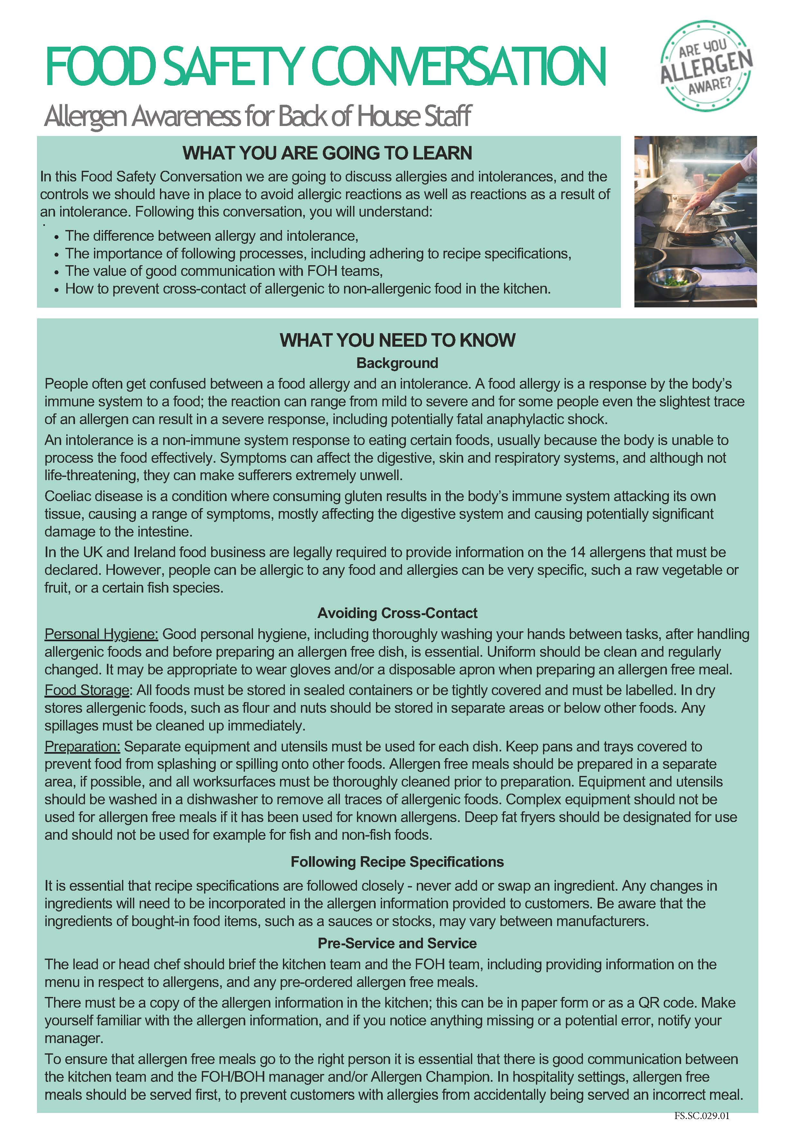
FS.F.086.01

LY.FS.F.001.08

Site Specific Safety Information
This page provides the site-specific information for this site.
Colleagues may take a photo of this page so that they can refer to the below information.



BE MINDFUL - Always think first before you carry out a task or activity - are there any risks or hazards and is it safe to carry on.

GET INVOLVED – Help your colleagues if they need it or if you see them in trouble.

SPEAK OUT – If you are unsure of anything ask your manager/ supervisor or if you see any unsafe environments or working activities then let them know.

FIRE & EMERGENCY
Familiarise yourself with the location of fire alarms, fire escapes, firefighting equipment and assembly points. Always follow instructions from your manager/supervisor or announcements on public address systems.
The alarm sound is: The assembly point is:

FIRST AID ARRANGEMENTS
Familiarise yourself with the location of first aid kits and first aid facilities.
First aid kit is located:
Our first aider is: Nearest A&E is:

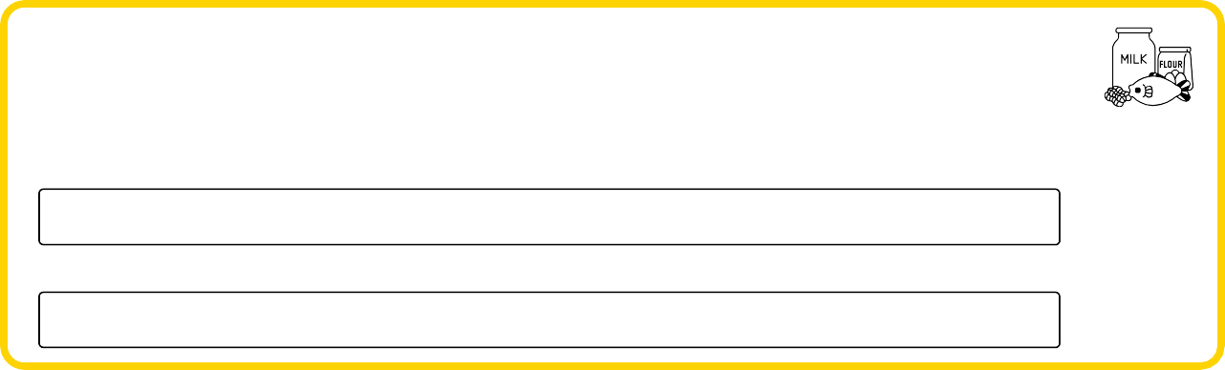
STAFF WELFARE
Rest Area Location:
Smoking / Vaping Location:

SPILL RESPONSE
Spillages must be cleaned up immediately and wet floor signage displayed where appropriate.
Location of spill kit is:
ALLERGENS
If a customer asks you about allergens within specific dish, provide them with a copy of the Allergy Information Folder and point out the allergy information sheet for that dish so they can make an informed choice, or alternatively direct them to the QR code or tablet where information is available electronically.
Allergen information is available:
Our Allergy Champion is:
INCIDENT REPORTING
All incidents/accidents, near misses, foreign body incidents and allergy incidents must be reported as soon as possible.
Report incidents to:

Reporting forms are available in:

FS.F.086.01




HSE Staff Briefing Sign-Off

Unit Name: |  | Area:
Event Name: |  | Briefing By:
By signing below, I confirm that I have been briefed on the following safety information including Fire & Emergency, Incident Reporting, Chemical Safety, Allergens, Personal Hygiene, Safe Food Handling, Cleaning and Sanitising and Safe Systems of Work relevant to my role for this venue. I understand it is my responsibility to follow instructions, to work safely and only to do work that I have been trained to do, that I am being trained on or being supervised whilst doing. I understand that I should talk to my manager or supervisor at any time if I am unsure of what to do or if I have any concerns. I also confirm that I have not been suffering from any sickness or diarrhoea in the last 48 hours.
Date | Name |  | Signature

This completed pack is to be securely retained for 6 years with all unit training records and information
FS.F.086.01

Hot Oil Quiz
Instructions: To be completed by those using or cleaning Deep Fat Fryers.
Ref. STCCS 07/08 |  | Task/Activity: Use and Cleaning of Deep Fat Fryers
Event Name: |  |  |  | Date:
Employee Name: |  |  | Employee Signature:
 | QUESTION |  |  | ANSWER
1 | What is the safe maximum temperature of oil to be manually drained or filtered from a deep fat fryer?
2 | How long does a deep fat fryer take (from cold) to heat the oil to this temperature?
3 | What is the normal operating temperature of a deep fat fryer?
4 | How long (from cold) does it take for the oil to heat to the normal operating temperature?
5 | How long does it take for oil to cool from operating temperature to the safe temperature for manual draining?
6 | What do you do if hot oil touches the skin?
7 | What do you do if a foreign object falls into the oil?
8 | What do you do if water or ice particles get into the oil?
 | WHAT IS YOUR SCORE FOR THE HOT OIL QUIZ?  Score 8 – you are authorised to use and clean the deep fat fryer once you are trained in the safe system of work.  If any of the answers are wrong - you are not yet competent to use or clean the deep fat fryer and must retake the quiz after further training in the safe system of work |  |  | YOUR SCORE
ADDITIONAL INFORMATION
The power output of an electrical deep fryer is equivalent to 6 - 8 electric kettles.
If you burned 35% to 40% percent of your body skin area, this would leave you fighting for your life.
35% to 40% percent of your total body skin area is on your legs.

FS.F.086.01

Hot Oil Quiz
Instructions: To be completed by those using or cleaning Deep Fat Fryers
Ref. STCCS 07/08 |  | Task/Activity: Use and Cleaning of Deep Fat Fryers
Event Name: |  |  |  | Date:
Employee Name: |  |  | Employee Signature:
 | QUESTION |  |  | ANSWER
1 | What is the safe maximum temperature of oil to be manually drained or filtered from a deep fat fryer?
2 | How long does a deep fat fryer take (from cold) to heat the oil to this temperature?
3 | What is the normal operating temperature of a deep fat fryer?
4 | How long (from cold) does it take for the oil to heat to the normal operating temperature?
5 | How long does it take for oil to cool from operating temperature to the safe temperature for manual draining?
6 | What do you do if hot oil touches the skin?
7 | What do you do if a foreign object falls into the oil?
8 | What do you do if water or ice particles get into the oil?
 | WHAT IS YOUR SCORE FOR THE HOT OIL QUIZ?  Score 8 – you are authorised to use and clean the deep fat fryer once you are trained in the safe system of work.  If any of the answers are wrong - you are not yet competent to use or clean the deep fat fryer and must retake the quiz after further training in the safe system of work |  |  | YOUR SCORE
ADDITIONAL INFORMATION
The power output of an electrical deep fryer is equivalent to 6 - 8 electric kettles.
If you burned 35% to 40% percent of your body skin area, this would leave you fighting for your life.
35% to 40% percent of your total body skin area is on your legs.
FS.F.086.01

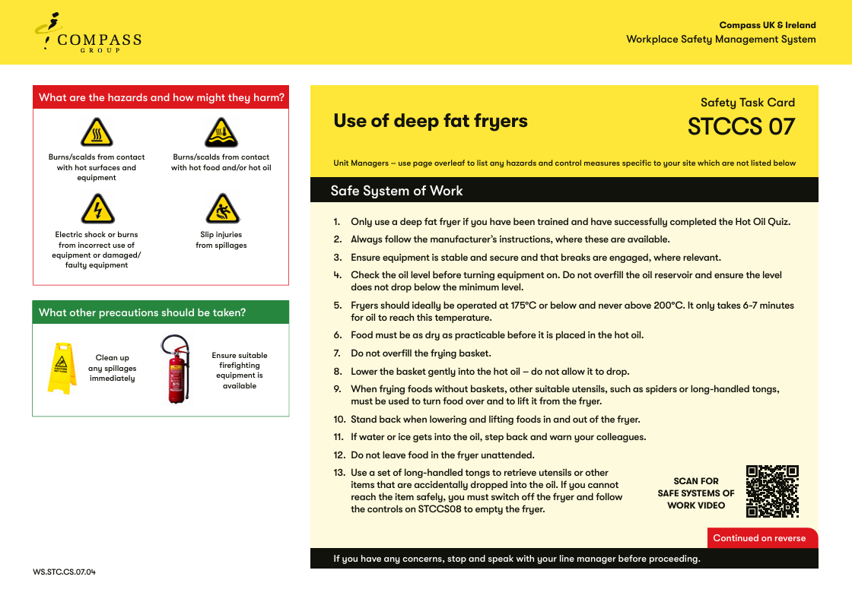

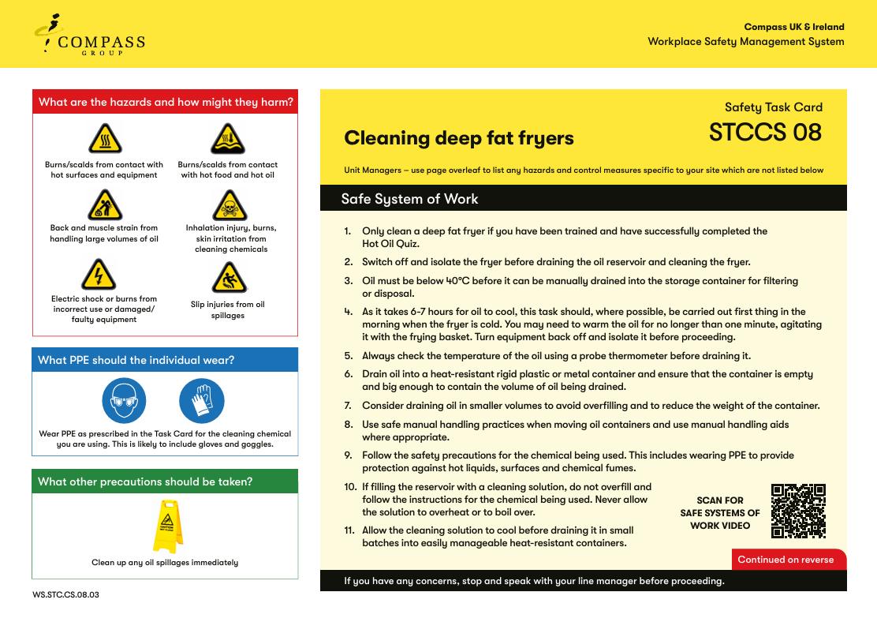

NOTE:
It only takes 6-7 minutes for oil to heat an operating temperature of 180ºC, but it takes around 7 hours for oil to cool to a safe temperature for draining.
To treat hot oil burns, run under cold water for at least. Do not apply ice or iced water under any circumstances.
.
FS.F.086.01
LY.FS.F.001.08

