FLOOR SAFETY RISK ASSESSMENT

Unit: |  | Assessed By:
Date of Assessment: |  | Date of Next Review:

Purpose

A significant number of accidents recorded each year by the Company involve slips, trips and falls. They result in many minor and some very serious injuries to both employees and customers.

The purpose of this assessment is to help you to identify floor safety risks and to take preventive measures to reduce risk where necessary. It is Company Policy to provide employees with personal protective equipment (PPE) as a last resort measure’ where the risk remains high after all other preventive measures have been taken. PPE, may include safety footwear

Instructions

Part 1 of the assessment seeks to identify types of floor surfaces that are present within your site and assess their slip risk category – Low, Possible or High. Look at all floor areas in the unit and record the information in the Table on page 3 of this assessment document.

Part 2 of the assessment seeks to identify other floor safety hazards in and around the unit. Consider the factors shown in the left-hand column and complete the information requested in the shaded boxes; judge whether you consider that there is a significant hazard present and what action could be taken to reduce the risk of injury. Indicate in the right-hand column when remedial action has been completed or if there is a reason why action cannot be taken and a risk remains.

The assessment must be signed and dated by the Site/Unit Manager and must be reviewed annually or more frequently if there are significant changes in the floor structure or condition, and following any slip, trip and fall type accident or near miss.

SLIP RISK TABLE

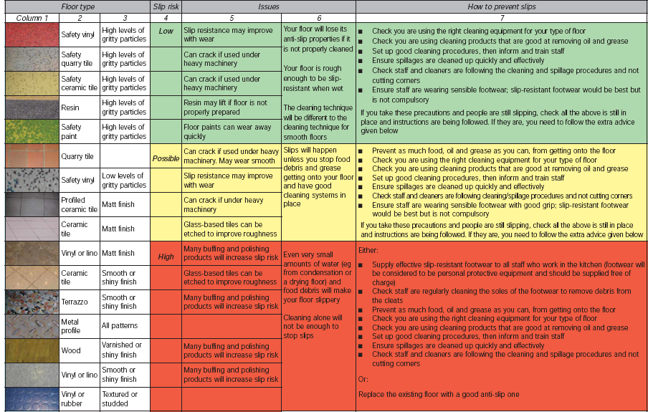
The above table is taken from the HSE document “Stop slips in kitchens – a good practice guide”

Part 1 – Identification of Types of Floor Surfaces and Level of Slip Risk

Refer to the Slip Risk Table on page 2 above and identify the types of floor surface in your unit and their location on site. Record this information in columns 1 and 2 in the table below and show the level of slip risk for each area of floor by ticking the box in column 3 - Low, Possible or High – as you feel applies.

Then refer to ‘How to prevent slips’ in column 7 of the Slip Risk Table on page 2 above and take all the precautions shown for the applicable slip risk level for each area of floor identified in your unit. Confirm that the slip prevention measures have been taken by writing Yes or No in column 4 below. Where a ‘No’ answer has been given record the action(s) to be taken in column 5 below. When the actions are competed, record the date in column 6.

1 | 2 | 3 |  |  | 4 | 5 | 6
Location | Type of floor surface | Slip risk  (Tick applicable column) |  |  | Slip prevention measures in place?  Yes / No  (See column 7 in Slip risk table) | If ‘No’  Action(s) to be taken | Date action completed
Location | Type of floor surface | Low | Possible | High |  | If ‘No’  Action(s) to be taken | Date action completed
e.g. Main kitchen | Quarry tile |  |  |  | No | Use a more effective floor cleaning product to remove grease on floor near fryer | 19 Oct 08

t 2 – Other Floor Hazards

Part 2 – Other Floor Hazards

Hazard | Hazard Present?  Yes / No | Recommended Action | Action Taken  Yes / No | Completion date & any comments
Uneven floor surfaces or poorly marked changes in level. Identify areas: |  | Request in writing to Client or responsible person to remedy uneven floor area.
 |  | If not reasonably practicable to remove change in floor level, arrange for appropriate warning signs to be displayed or hazard marking to be put in place.
Poorly maintained floor surfaces. Identify areas: |  | Request in writing to Client or responsible person to repair defective floor surface.
Inadequately lit areas of the floor. Identify areas: |  | Request in writing to Client or responsible person to improve the level of lighting.
Areas of the floor obstructed by stored articles and equipment:  Identify areas: |  | Review storage arrangements to remove obstructions.
 |  | Request in writing to Client or responsible person to provide additional storage space.
Wet/greasy floor surface due to leaking equipment. Identify items of equipment that leak: |  | Request in writing to Client or responsible person to repair leaking equipment.
Slippery surfaces due to having just been cleaned (by Company employees or by other persons). Identify areas: |  | Review cleaning procedures to ensure that they are carried out at an appropriate time and floor is allowed to dry before access is permitted.
 |  | Ensure that “Wet Floor” signs are appropriately displayed.

Hazard | Hazard Present?  Yes / No | Possible Management Action | Action Taken  Yes / No | Completion date & any comments
Inherently wet/greasy floor surfaces, e.g. pot wash area. Identify where: |  | Examine working procedures to identify if improvements can be made to reduce wetting of the floor
 |  | Request in writing to Client or responsible person to improve the surface floor finish.
 |  | Consider provision of with slip resistant footwear.
Slippery surfaces due to food debris and spillages. |  | Improve working procedures to reduce spillages.
Slippery surfaces due to food debris and spillages. |  | Retrain employees not to overfill containers of liquids.
Slippery surfaces due to food debris and spillages. |  | Retrain employees in “clean as you go” procedures.
Slippery surfaces due to food debris and spillages. |  | Ensure that “Wet Floor” signs are appropriately displayed.
Employee tasks mainly involve working externally in conditions of inclement weather. Identify which tasks & employees at risk: |  | Consider provision of safety footwear with protective toecaps and slip resistant soles.
Where safety shoes are not provided employees are wearing sensible footwear. |  | Remind employees to wear sensible footwear.  Footwear should fit well, have low heels and stay on the feet.  Avoid footwear, such as open-toed shoes, sandals, flip-flops, high heels and shoes with smooth soles.
Footwear worn by employees in poor condition and the sole not kept clean. |  | Remind employees of the need to maintain footwear, particularly the soles, clean and in good condition.

Unit Managers Signature:
Date assessment completed:

