Safety Task Card
COM 04 | Use of roll cages
Workplace Safety Hazards
What are the hazards? |  |  | How might they be harmed?
Manual Handling  Uneven or sloping surfaces  Overbalancing cages  Trapping hands between cages and fixed structures  Trapping feet under castors  Cages falling off vehicle tail lifts.  Damaged/protruding metal points/wire  Collision with pedestrians |  |  | Back, muscle and upper limb strains  Impact injuries  Crushing injuries  Possible fracture of bones  Cuts, lacerations and puncture wounds
Safe System of Work
The majority of roll cages will be owned by the delivery company, and therefore selection of the type of roll cage and type of wheel will largely be unable to be influenced. Similarly, the loading of the cage will have been completed by the supplying company and therefore some parts of this Safe System Of Work / Control Measures will only relate to the handling of the cage once delivered to the site.
- Cages only to be handled by trained employees and those who have completed the Introduction to Hand Protection Safety Conversation (SC_01)
- Where cages are purchased by the Company, they must be suitable for the intended use, have large diameter, good quality nylon or polyurethane wheels positioned for stability, with handles away from the edges and with clearly marked load height limits. Purchase them only from an approved supplier.
- Where cages are owned by the Company, they must be maintained regularly in accordance with manufacturer’s instructions, paying particular attention to the casters and wheels. Records of maintenance should be retained.
- Employees to stand well clear of the rear of vehicles when cages are being unloaded by delivery personnel.
- Cages to be visually checked before use, and in particular, wheels to be checked to ensure they are clean of debris and free running. Goods to be off loaded onto another cage that is in good condition from any cages that are considered unsuitable for use. Badly loaded or overloaded cages should also be off loaded either partially or completely as appropriate onto another cage before being moved.
- Defective cages to be removed from use, isolated and labelled “Do Not Use” until repaired.
- When cages are persistently overloaded, badly loaded or in poor condition on delivery to the unit, a Supplier Complaint must be sent to Purchasing Dept. to rectify the situation.
- Heavier goods to be stacked at the bottom of the cage to ensure stability.
- Multi-shelved roll cages to be loaded from the bottom upwards with heavier goods on the bottom shelf.

- Cages not to be loaded above the load line or above the level where an operator can see over the load.
- Where provided, opening gates on cages must be securely in place before moving. Where they are not provided, where necessary, straps should be used to pull the sides together and help prevent the load from falling through the open sides.
- Only one cage to be handled at a time, using the handles, if provided.
- Wheels should be aligned with the direction of travel before moving the roll cage.
- In most situations, cages should be pushed rather than pulled.
- Where cages are to be moved in busy pedestrian areas, cages should be pulled rather than pushed to reduce the risk of collisions, or assistance should obtained from another person.
- When moving roll cages in close proximity to pedestrians a verbal warning should be given by the person pulling the cage who must slow down and be prepared to stop where it is apparent that the pedestrian may not have heard the verbal warning or be unaware of the roll cage.
- Ensure the pathway is clear.
- Roll cages to be moved no faster than walking speed.
- Wherever possible, routes with uneven surfaces, ramps or steps should be avoided. If this is not possible, or when a cage is heavily loaded, assistance to be obtained from another person.
- Defective floor surfaces along cage routes to be reported to the responsible person without delay.
- Employees must not ride on or in cages as they can easily overbalance.
- Rigger Gloves are to be worn at all times when handling roll cages and re-enforced toe-capped safety shoes to be worn when handling roll cages forms a significant part of an employee’s daily duties.
- If operating cage in outside area a hi vis vest or jacket to be worn to BS EN471
- Implement the Safe System of Work/Control Measures in Goods Receipt and Storage Risk Assessment, Ref. ES10a/b and the manual handling safety precautions.
- Mandatory PPE Requirement –cut resistant gloves level 3
Ensure all Shelving is secure when erecting

Wheels to be checked to ensure they are clean of debris and free and running

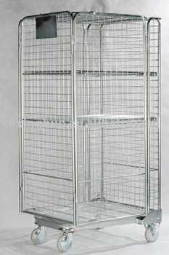
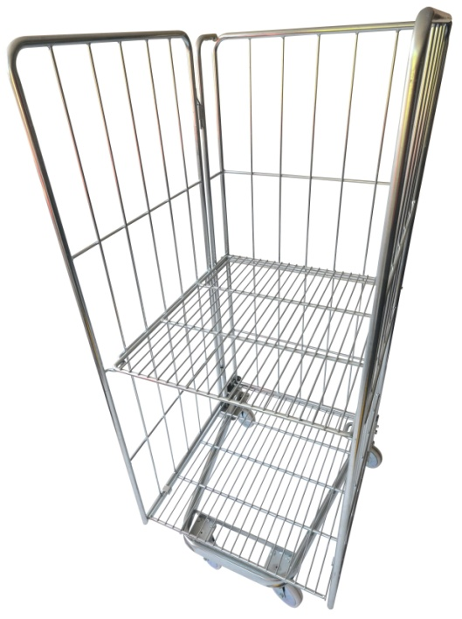
Where provided, opening gates on cages must be securely in place before moving.

Where they are not provided, where necessary, straps should be used to pull the sides together and help prevent the load from falling through the open sides.

Site Specific Actions
List any actions required in addition to the above safe system of work
PPE to be worn while handling waste:

The above control measures are implemented within my unit. All relevant staff are aware of these control measures and this is recorded in the training record for this safety task card.
Unit Manager Name |  | Signed |  | Date
Safety Card Training Record
COM 04 | Use of roll cages
I confirm that I fully understand the risks and control measures associated with the task
and that I will follow the Safe System of Work at all times.
Operative Name |  | Signature |  | Date

