This order form is to be emailed to hse@compass-group.co.uk once completed. Please note there is a minimum order of 5 badges per delivery.
Order Details
Number of Badges  (Minimum of 5 at £2.00 each) |  | Delivered To  (Name)
Unit Number  (For Cross Charge) |  | PO Number
Delivery Address
Authorised By  (Name) |  | Position  (Unit Manager or Above)

Sample of Badge
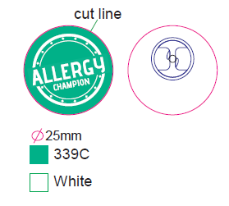
Size: 25mm
Type: Metal Dia Printed Epoxy

Office use only
Date Order Received: |  | Cross Charge Recorded:
Order Sent By: |  | Date Order Sent:

